FA Confirmation Attendance &
Study Abroad Manual
(ImageNow Full-Client Only)

Written By: Vonda Lee
April 23, 2015

Table of Contents
Introduction 3
Printing Documents 4
Capture Profiles 4
Accepting Certain Documents 4
FA Print to WF 5
Processing Documents in FALP Conf Attd & Stdy Abrd Workflow Queue 8
Processing Documents in FALP Conf Attd & Stdy Abrd Incompletes Workflow Queue 12
Drag and Drop Feature 15
Drop as a New Page 15
Drop as a New Document 16

Introduction

This document will assist you with routing, linking, and processing a document in the loan processing confirmation attendance and study abroad section of the FA Financial Aid workflow process. There are two (2) workflow queues divided into two (2) sections:

- FALP Processing
This workflow queue will include all loan processing documents imported into ImageNow via scan, email, and fax. These documents are awaiting processing.
  - FALP Conf Attd & Stdy Abrd
- FALP Review
This workflow queue is where processed incomplete documents are routed and ready for review.
  - FALP Conf Attd & Stdy Abrd Incompletes

This following workflow queues will be accessible from the FALP Processing workflow to route documents to:

- FALP Route
This workflow queue will route documents to/from the processing and review workflow queues.
- FA Ready to Archive
This workflow queue will route all documents processed to ARCHIVE.
- FALP Delete Pending
This workflow queue will include documents that need to be deleted from the system; only Supervisors will have access to process and delete documents in this workflow queue.
- FALP Re-Route
This workflow queue will route documents where the document type has been to the appropriate workflow queue.

In addition to processing and routing documents, you can import documents into ImageNow via printing using the DRAG and DROP feature. (*Note: There is a virtual printer called ImageNow Printer that can be selected when printing a document.)

Printing Documents

Capture Profiles

There is one (1) capture profile for printing:
- FA Print to WF
This capture printing profile is used when printing a document and requires the user to be logged into BANNER for a particular student 800#.

Accepting Certain Documents

When receiving any of the following document types for students, go to BANNER's RRAAREQ form and mark the student’s record with the specific codes listed below, relative to the document received:

- Amended Taxes AMTAX
- Birth Certificate BCERT
- Consortium Agreement CONSAG
- Driver’s License DRIVE
- Marriage Certificate MCERT
- Medical Records – Parent MEDICP
- Medical Records – Student MEDICS
- NC Reach Application NREACH
- OSFA Scholarship Application OSFA
- Parent Statement STATMP
- Receipts RECEIP
- Student Statement STATMT
- Verification of Utilization of UCAE Services UCAE

FA Print to WF
This capture printing profile is used when printing a document and requires the user to be logged into BANNER for a particular student 800#.

- Open the document to be imported into ImageNow in an application like MS Word, Adobe PDF, etc.
- Select the PRINT button to print the document.
- Select the IMAGENOW PRINTER option.
- Select the PRINT button.
- An IMAGENOW PRINT window is displayed, as shown below:
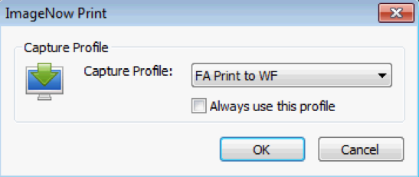
- Ensure the ALWAYS USE THIS PROFILE box is checked.
- Select the OK button.

- A PROPOSED KEYS window will display, as shown below:
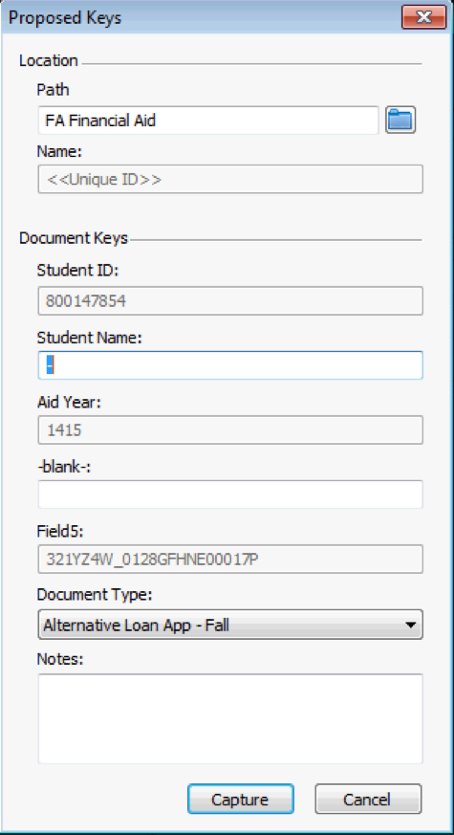
*Note: The Student Name will not be populated from Banner automatically; it will contain a “-“ in the STUDENT NAME box as shown above. The student’s name will be automatically populated before the document is routed to the departmental area workflow queues.
- Select the appropriate DOCUMENT TYPE in the drop-down list.
- Select the CAPTURE button.

- A CREATE SHORTCUT window will display, as shown below. The student’s folder is created from this screen. (*Note: If a student’s folder already exists this window will not be displayed.)
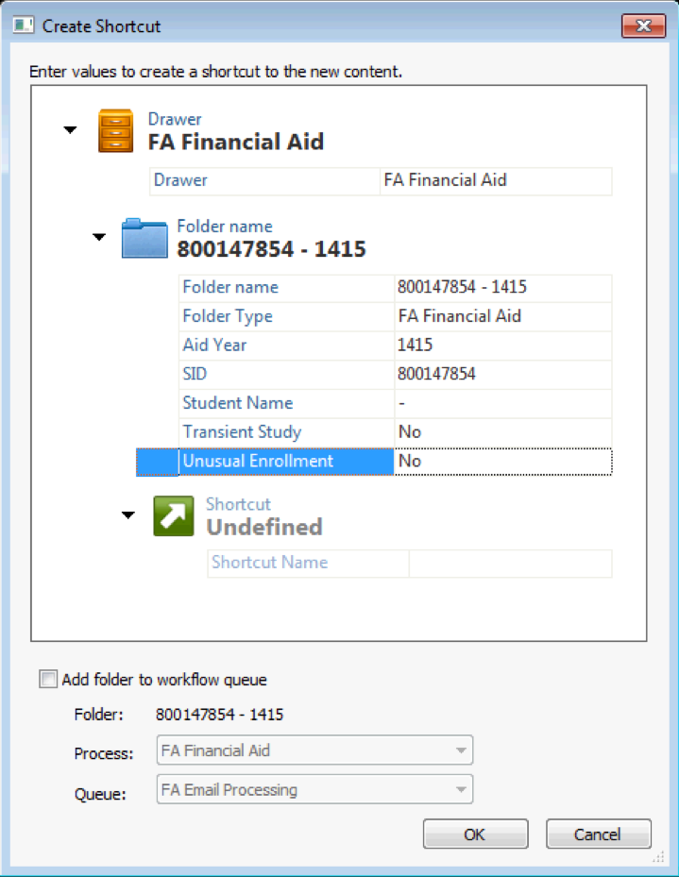
*Note: The Student Name will not be populated from Banner automatically; it will contain a “-“ in the STUDENT NAME box as shown above. The student’s name will be automatically populated before the document is routed to the departmental area workflow queues.
- Select the appropriate Transient Study (required) and Unusual Enrollment (required) values.
- Select the OK button and the document will be routed to the appropriate workflow queue for the document type you selected.

Processing Documents in FALP Conf Attd & Stdy Abrd Workflow Queue

- Go to the FALP Conf Attd & Stdy Abrd workflow queue, as shown below:
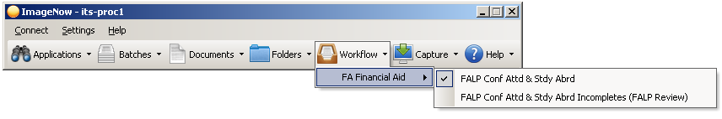
- Open the first document by double-clicking the document item in the ImageNow Explorer window grid.

- Verify the document keys for the selected student as shown below:
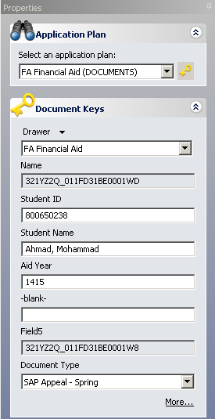
- Perform your due diligence.
- If the document is linked to the wrong student:
  - Identify the student ID and name and login to BANNER. Go to one of the following BANNER forms using the student’s 800# and Aid Year, if applicable:

- RBAPBUD
- RHACOMM
- RNANA*
- ROARMAN
- ROASTAT
- RPAAWRD
- RRAAREQ
- SFAWDRL

  - Link the document to Banner by clicking the link icon; the document key fields will be populated with the Banner information.
  - If necessary, select the appropriate DOCUMENT TYPE in the drop-down list.
- Click the ROUTE FORWARD link or icon.
- A CREATE SHORTCUT window will display as shown below. This window will create the student’s folder. (*Note: If the student’s folder already exists, this window will not be displayed.)
*Note: The Student Name will not be populated from Banner automatically; it will contain a “-“ in the STUDENT NAME box as shown above. The student’s name will be automatically populated before the document is routed to the departmental area workflow queues.

- Select the appropriate Transient Study (required) and Unusual Enrollment (required) values.
- Select the OK button.
- A ROUTE FORWARD window will display, as show below:
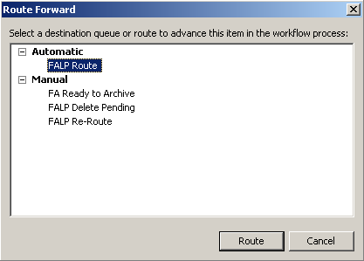
- If the document type was changed or you had to re-link the document, select the FALP Re-ROUTE workflow queue and the document will be routed to the appropriate workflow queue for the document type you selected.
- Else if the document is INCOMPLETE, select the FALP ROUTE workflow queue and the document will be routed to the appropriate FALP Review (Incompletes) workflow queue for review.
- Else, select the FA Ready to Archive workflow queue and the document will be routed to ARCHIVE.
- Select the ROUTE button.
- The next document in the grid will open in an ImageNow Viewer.
- Repeat steps 2 thru 14 for the remaining documents.

Processing Documents in FALP Conf Attd & Stdy Abrd Incompletes Workflow Queue

- Go to the FALP Conf Attd & Stdy Abrd Incompletes workflow queues, as shown below:
- Open the first document by double-clicking the document item in the ImageNow Explorer window grid.

- Verify the document keys for the selected student, as shown below:

- Perform your due diligence.
- To return the document to the corresponding processing workflow queue, click the ROUTE BACK link or icon .
- If processing is completed, click the ROUTE FORWARD link or icon to ARCHIVE the document.

Drag and Drop Feature

Using the Drag and Drop feature, a user can select a document from the desktop and drop the document into a particular ImageNow workflow queue or document.

Drop as a New Page

- Open a document by double-clicking the document item in the ImageNow Explorer window grid.
- Ensure the THUMBNAILS view is evoked.
- Drag and drop a document from your desktop or selected drive into the whitespace in the THUMBNAILS view as show below:
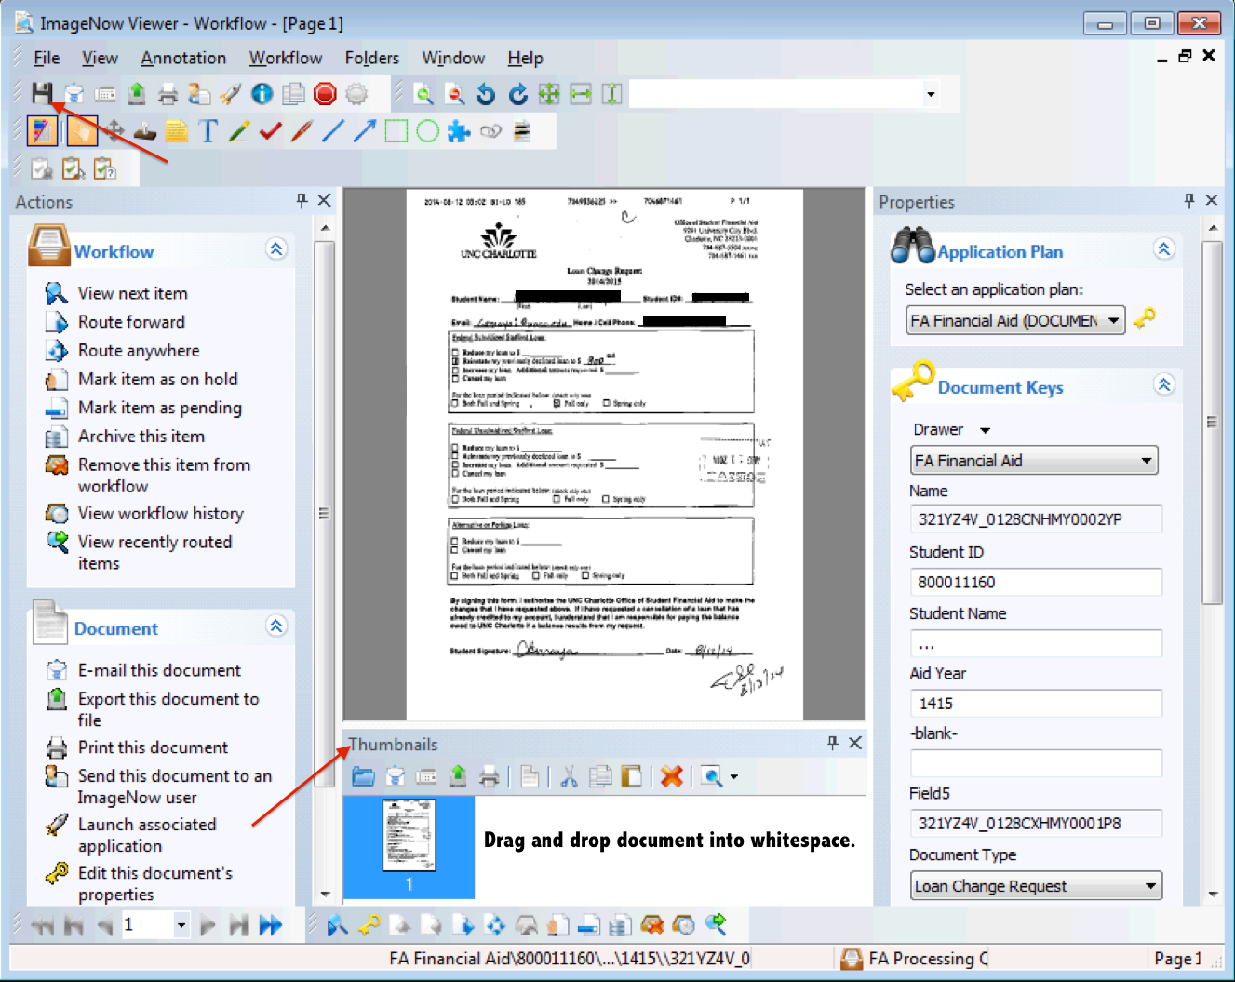
- Click the Save icon to save the added document as a new page.

Drop as a New Document

- In the ImageNow Explorer window, drag and drop a document from your desktop, or selected drive, into the whitespace in the grid as show below:
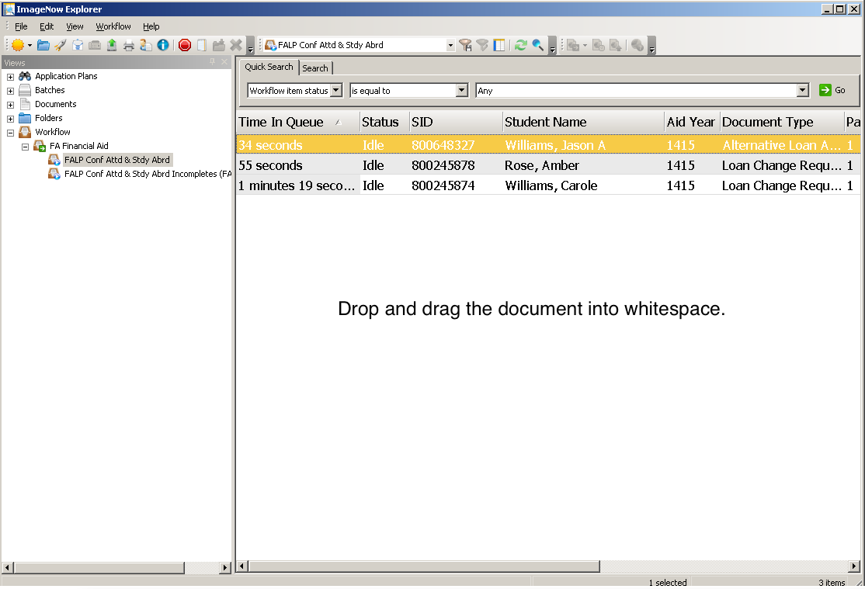

- A New Document window will display, as shown below:
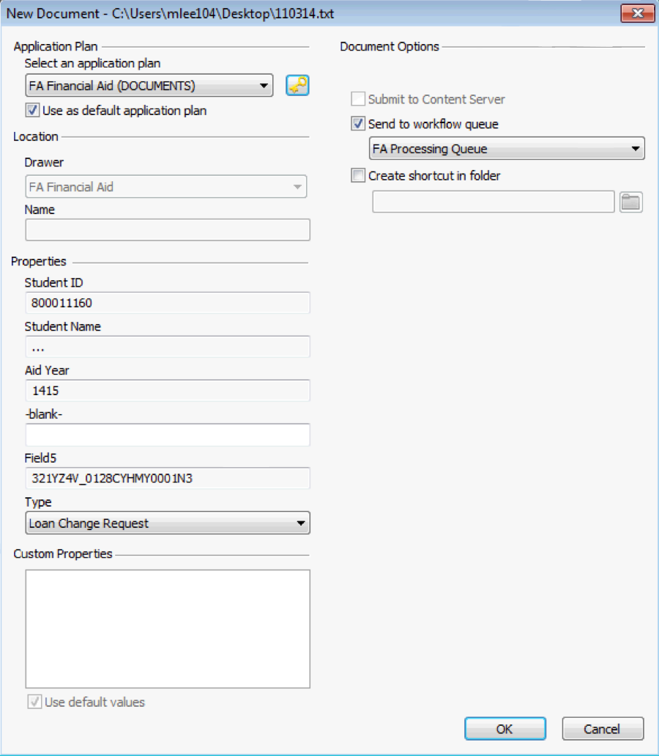

- Login to BANNER and go to one of the following BANNER forms using the student’s 800# and Aid Year, if applicable:

- RBAPBUD
- RHACOMM
- RNANA*
- ROARMAN
- ROASTAT
- RPAAWRD
- RRAAREQ
- SFAWDRL

- Link the document to Banner by clicking the link icon; the document key fields will be populated with the Banner information.
- Select the appropriate DOCUMENT TYPE in the drop-down list.
- Select the OK button.
- A CREATE SHORTCUT window will display, as shown below. This window will create the student’s folder. (*Note: If a student’s folder already exists, this window will not be displayed.)

*Note: The Student Name will not be populated from Banner automatically; it will contain a “-“ in the STUDENT NAME box as shown above. The student’s name will be automatically populated before the document is routed to the departmental area workflow queues.
- Select the appropriate Transient Study (required) and Unusual Enrollment (required) values.
- Select the OK button.
- Next, select the ROUTE FORWARD link or icon and the ROUTE FORWARD window will display, as show below:
- Select the FALP Re-ROUTE workflow queue.
- Select the ROUTE button and the document will be routed to the appropriate workflow queue for the document type you selected.

