FA SAP Committee Review Process Manual
(WebNow Only)

ImageNow FA SAP Committee Review Process:

- The FA SAP Review Committee will access the document task via the email and logging into WebNow/ImageNow to add comments on the decision of the FA SAP Appeal.
- The FA SAP Review Committee will access My Assigned Tasks view and review the desired appeal form and based on all the comments entered by the Committee, then the final FA SAP Committee Review member will either APPROVE or DENY the FA SAP Appeal. The task REASON field needs to be populated with on of the following values:
- APPROVED
- DENIED
- Next, the final SAP Committee Review approver will complete the task by clicking the COMPLETE button.

ImageNow FA SAP Committee Review Processing Instructions using the Email Link:

- The FA SAP Committee Review member will click on the link in the New Task Created (FA SAP Committee Review) email (see Appendix A) and login to WebNow.
- The document and TASKS panel will appear displaying all comments about the student’s appeal, see below:

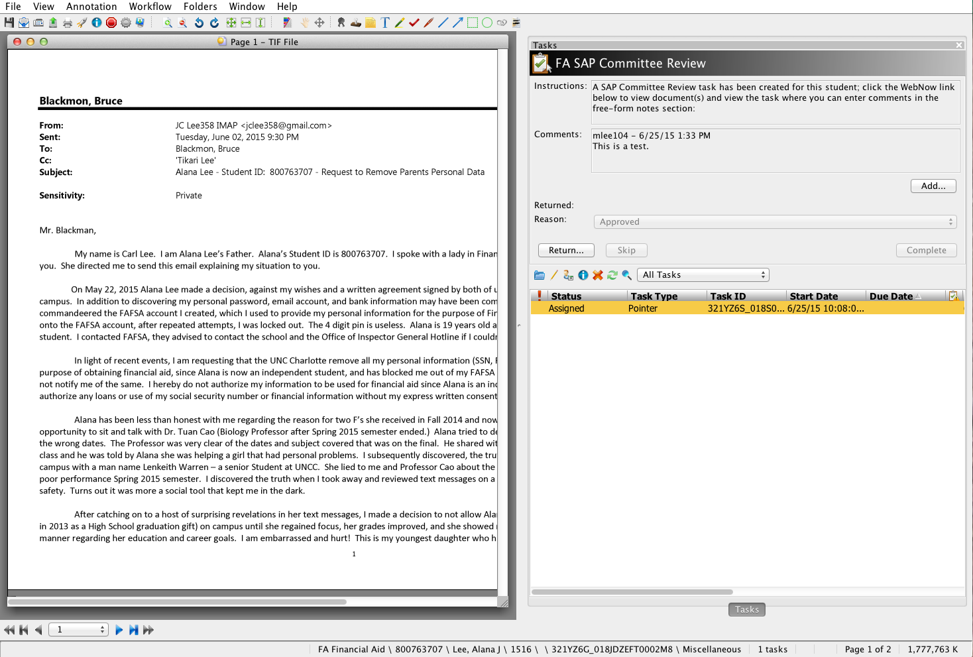

- The FA SAP Committee Review member can review other Committee member’s comments in the COMMENTS window.

- Click the ADD button to add comments regarding the appeal request. A task comments window will appear as seen below:

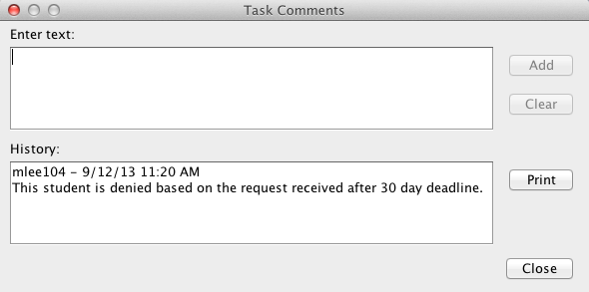
- Start entering in free-form comments and press the ADD button when done. Then press the CLOSE button to save and exit the task comments window.
- Close the tab in the browser to exit the ImageNow project task.

ImageNow FA SAP Committee Review Processing Instructions using WebNow:
(*NOTE: If you are unable to click the link in the email, this is another way to access the student’s appeal request information and enter in comments for your decision; basically the same view in the client version if you want use it.)

- The FA SAP Committee Review member will login to WebNow using their NinerNet credentials by clicking on the link, https://imagenow.uncc.edu and the following screen will appear:

- After logging in to WebNow, setup your user preference defaults by clicking on the OPTIONS drop-down menu and selecting Explorer Options as seen below:
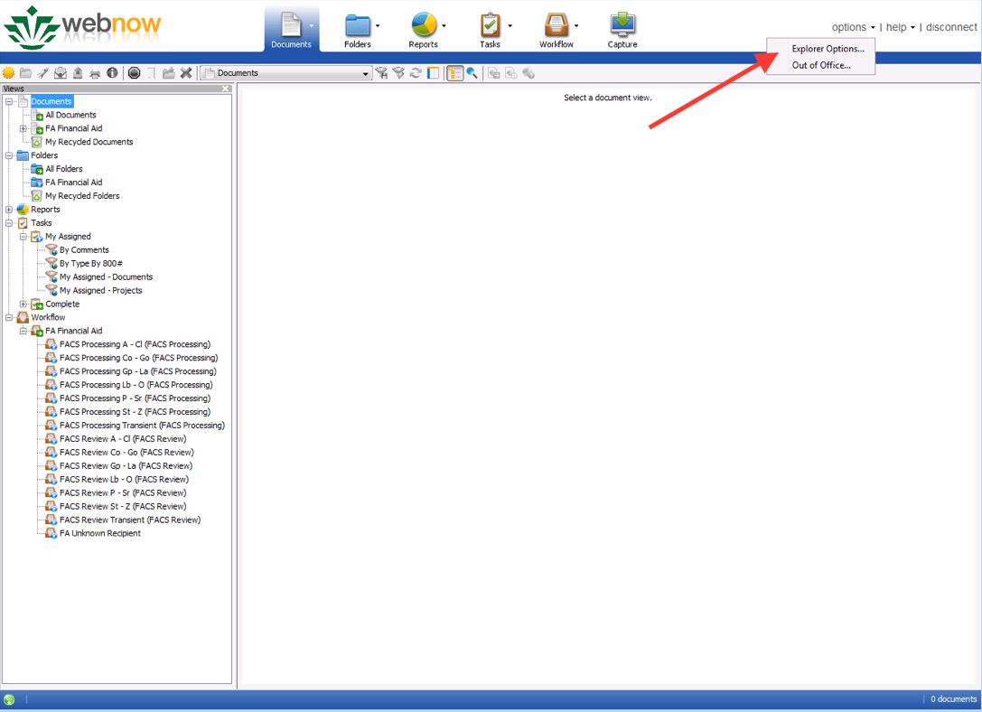
- An Explorer Options window will appear; here you can setup user preferences under the GENERAL, GRID COLUMN HEADINGS, GRID OPTIONS, TASKS, and TOOLBAR. Click on each one and explore your options.

- Next, click on the TOOLBAR option and set the below DEFAULT ACTIONS and INITIAL STATE as seen below:
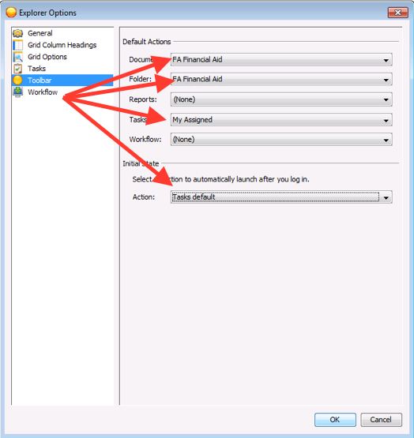
- Press the OK button to save your user preferences. Disconnect and logon again to see the changes take effect.

- After logging into WebNow again, the FA SAP Committee Review document view will appear as seen below:

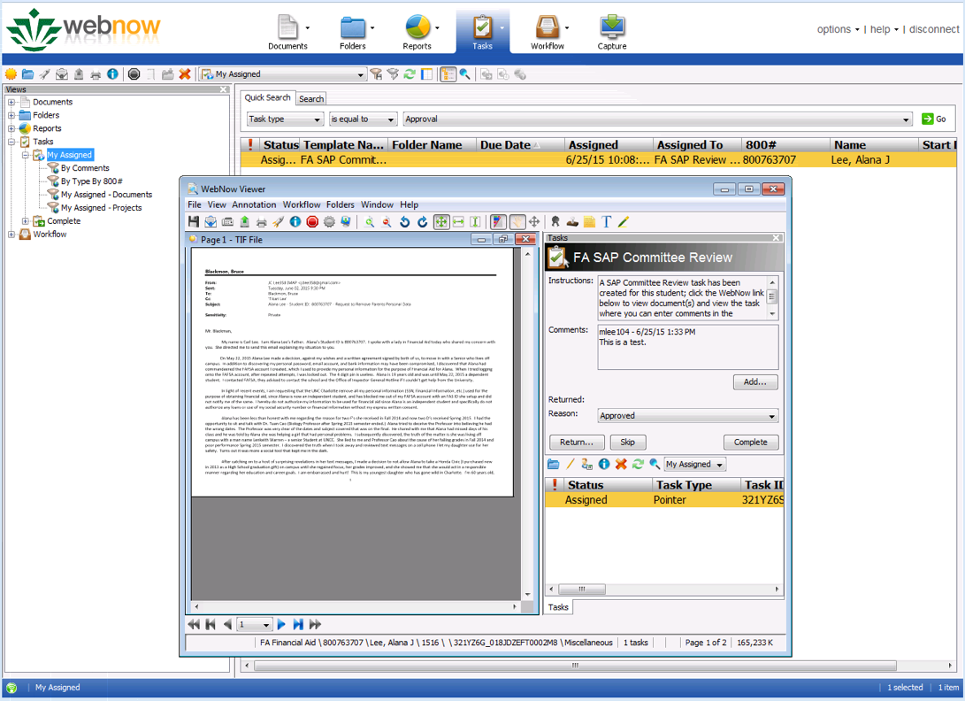

- To add comments, double-click on the task in the list. Click the ADD button to add comments regarding the waiver request. A task comments window will appear as seen below:

- Start entering in free-form comments and press the ADD button when done. Then press the CLOSE button to save and exit the task comments window. Your comments will be listed in the COMMENTS section.
- Close the WebNow Viewer window to return to the My Assigned view.

Appendix A

