RED Student Educational Awards (SEA) Form User Manual

Written By: Vonda Lee
December 2, 16

Use this form to submit financial information for Student Educational Awards (e.g., scholarships, fellowships, grant funded stipends, travel awards) that cover expenses related to the cost of education. These awards will be processed by the Office of Student Financial Aid except for Travel Awards, awards to non-U.S. citizens/residents, participant stipends where enrollment is not required and awards to students enrolled for fewer than 3 credit hours, which will be processed by Financial Services. All awards entered through this system must be educational in nature, including participant stipends. All awards, except for participant stipends where enrollment is not required, will be processed as financial aid that is included in the recipient's Cost of Attendance calculation. If a Student Educational Award requires a Direct Pay Request (DPR), then a DPR will automatically be generated and sent to Travel and Complex Payments.
- Information can be submitted for several students at once, if those students are receiving the same award (the award term, amount, purpose and fund must be the same for each recipient).
- If you choose "Other Term" for the Award Term, you must indicate the award's effective term in the Comments box at the bottom of this form. Otherwise, all awards will be processed once the recipient has registered for classes and meets the minimum hour requirement defined by the award.
- If you choose "Other Educational Fees / Expenses" from the Award purpose, you must specify what fees or expenses the award will cover.
- If you choose “Participant Stipend” from the Award purpose, you must designate if enrollment is required. If you choose "No – Doesn’t Require Enrollment", the request could automatically be denied for the following reasons:
  - The recipient(s) are enrolled, with credit hours, during the awarded term. In this case, you must resubmit with "Yes – Requires Enrollment", for the denied recipients. The stipend will then be awarded as financial aid that is included in the Cost of Attendance calculation.
  - They are enrolled, without credit hours, BUT the required vendor setup forms have not been previously provided. In this case, you must provide the required vendor setup forms (see: “How to set up a vendor”), and then resubmit for the denied recipients.
- If you are funding the award with a Grant Fund (5X), you must attach a document from the Principal Investigator authorizing the award. If this is not provided, Grants and Contracts will deny the award.
- You will receive a confirmation email once you submit the award. Make sure to review this email for errors. Once the submitted awards have been processed, you will receive an automated email notification.
- To revise awards:
  - If the recipient's award submission has NOT been fully processed (meaning the submitter HAS NOT received an email notification stating the award has been completed), please forward the original confirmation email to the respective fund approver to be canceled. Contact information is at the bottom of the original confirmation email.
  - If the recipient's award submission has been fully processed (meaning the submitter HAS received an email notification stating the award has been completed), please submit a new award for a negative dollar amount reflecting the value to reduce the initial award. You must include a detailed explanation in the Award Comments section that includes the "Lot ID" of the original award and the reason for the change.

- Click the link Student Educational Award Form at the top of the right-hand panel on the Research and Economic Development main webpage, https://research.uncc.edu and the entry form will display as shown below:

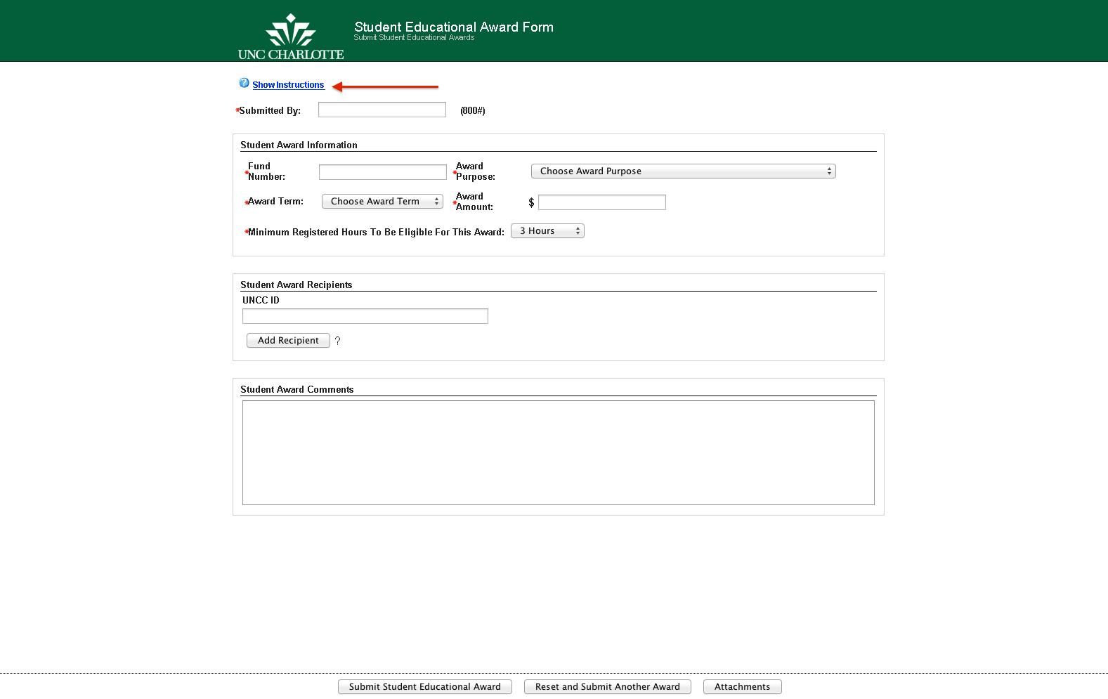

- Click on the link, Show Instructions, to display the form instructions.

- Click on the link, Hide Instructions, to hide the form instructions, as shown below:

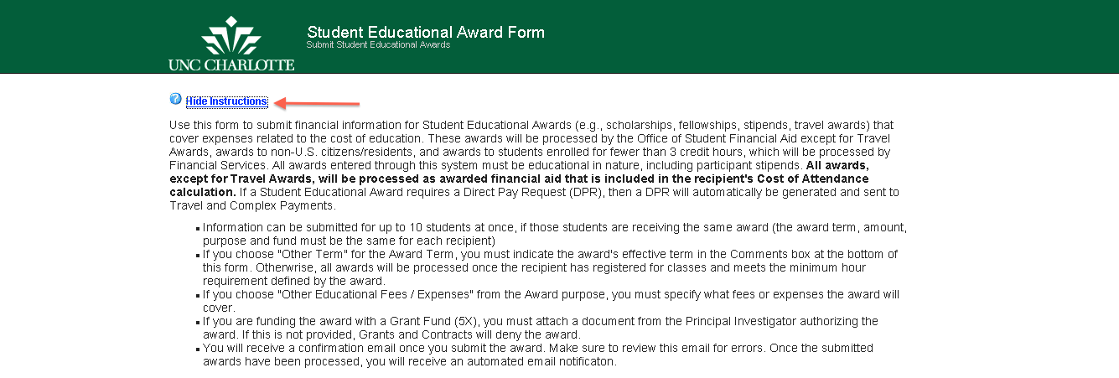

- New! Enter the Submitted By (800#) (UNCC ID Number) of the person submitting the form. (*Note: Once you press the TAB key the Initiator’s name will appear.)
- New! Enter a valid Fund Number for the award. *Note: a check mark denotes a valid fund number as shown below.
- New! Select the Award Term by clicking the drop-down list, as shown below:

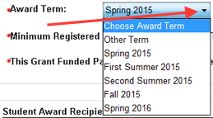

If you choose Other Term, a pop-up message will be displayed as shown below, reminding you to enter the award's effective term in the Student Award Comments section at the bottom of this form. Otherwise, all awards will be processed once the recipient has registered for classes in the Award Term indicated.

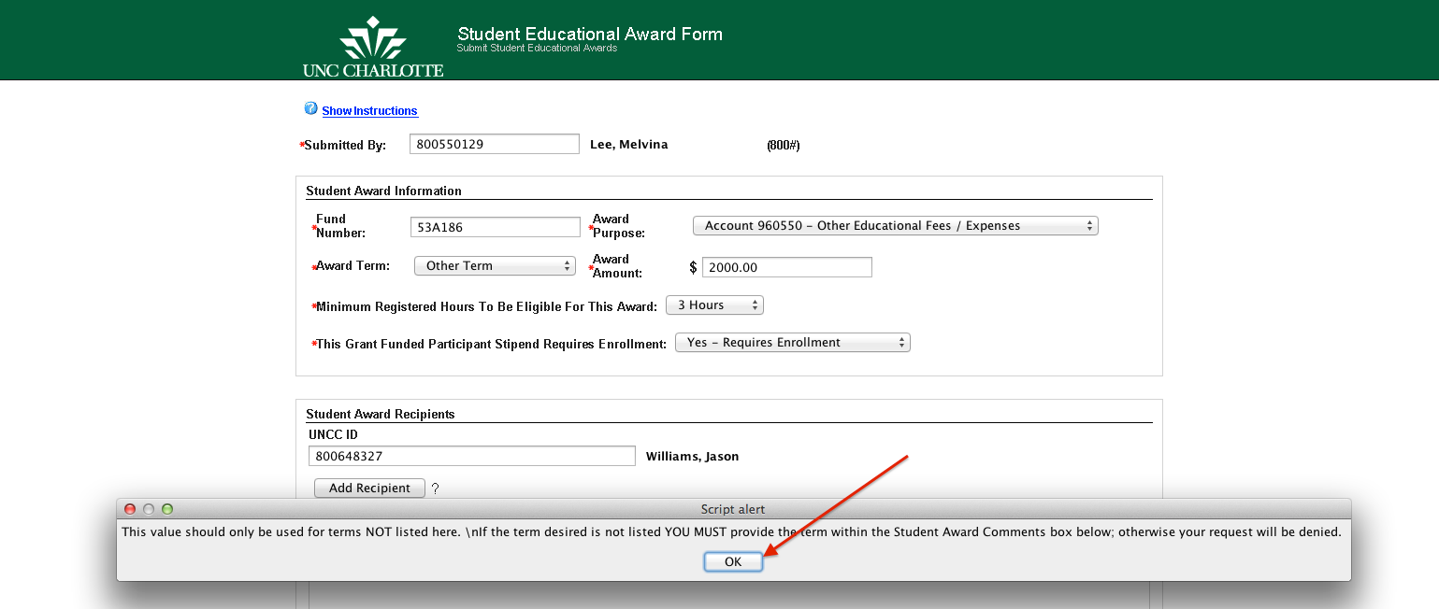

- Select the Award Purpose by clicking the drop-down list, as shown below:

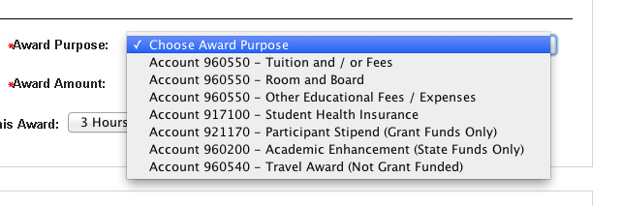

*Note: If you select Award Purpose Other Educational Fees/Expenses, a pop-up message will be displayed requiring you to specify the fees/expenses being covered in the Student Award Comments.

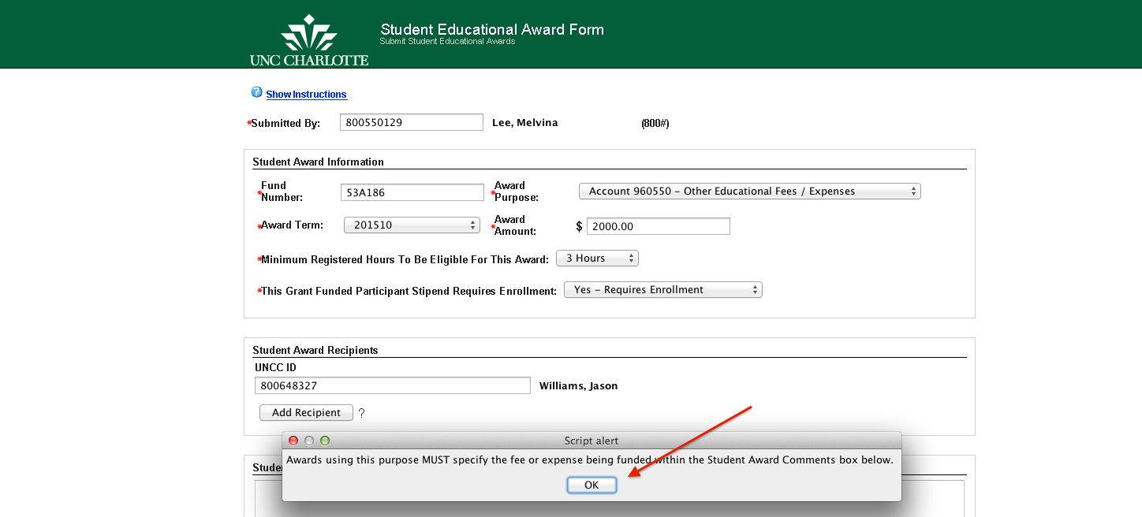

*Note: New! If you select Award Purpose Participant Stipend (Grant Funds Only), then a couple of new selection parameters may be displayed. One selection asking if this grant funded participant stipend requires enrollment, and the other asking for the address type if no enrollment is required. For example, if a high school student were attending an educational event/class for the summer, then you would select NO – Doesn’t Require Enrollment.

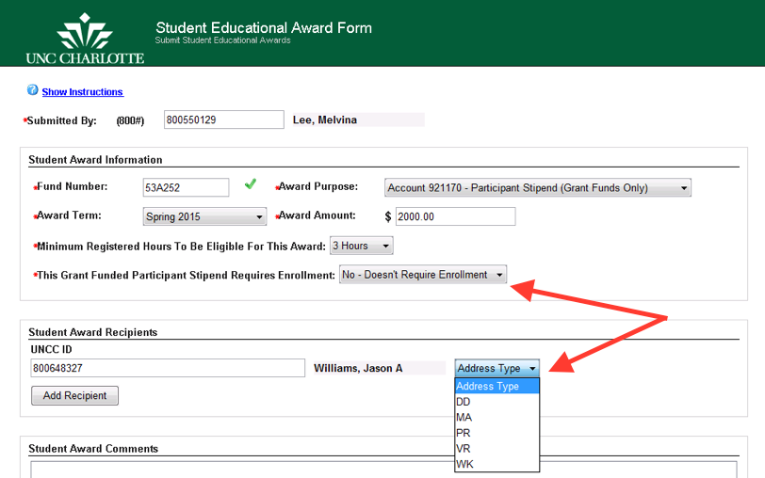

- Enter an Award Amount. The cents amount is optional (ex. 250.00 or 250, -250.00 or -250). If a negative amount is entered, a pop-up message will be displayed as shown below, reminding you to explain the nature of the award revision in the Student Award Comments section at the bottom of this form.

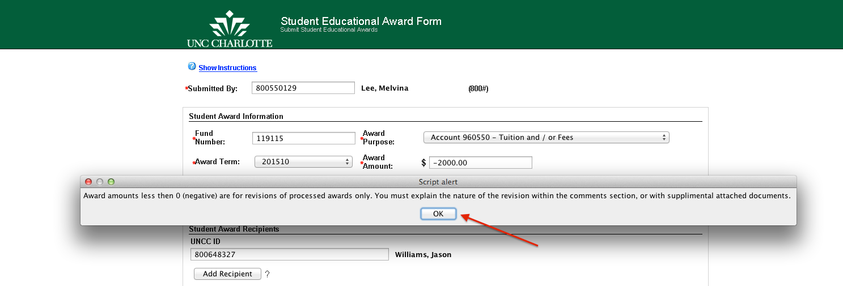
(*Note: See Revisions section in this document for submitting revised forms.)

- Select the Minimum Registered Hours To Be Eligible For This Award by clicking the drop-down list, as shown below:

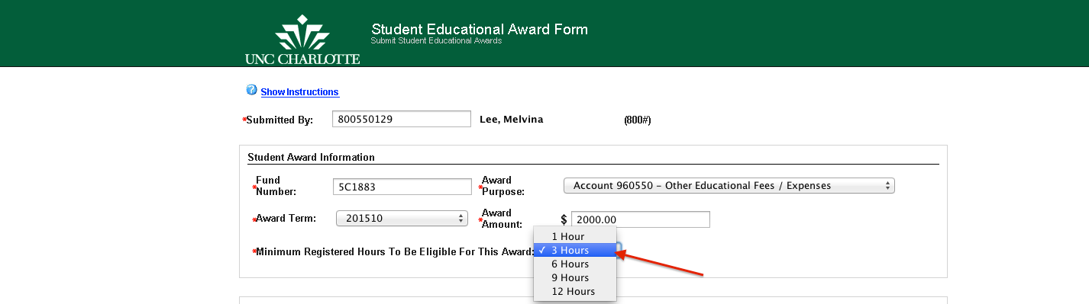
*Note: The default Minimum Registered Hours To Be Eligible For This Award is 3 hours. New! This option should be used ONLY if a Grant Fund has restrictions on the number of registered credit hours for an award for a recipient. If no restrictions, credit hours can be changed to 1 Hour. All other fund sources selected will be processed right away.

- New! Enter at least one Student Award Recipient UNCC ID Number and click the Add Recipient button to add additional student UNCC ID Numbers. You can enter in an unlimited number of student UNCC ID Numbers, if the students are to receive the same award term, amount, purpose, and fund entered. You can also remove the last Student Award Recipient by clicking the Remove Recipient button.

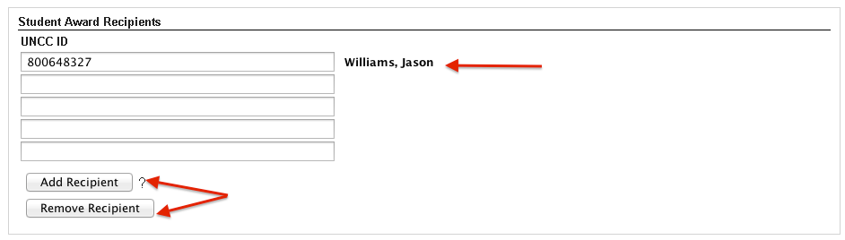
*Note: The student’s name will display once you enter in a valid 800# and press the TAB key. ****Suggestion, click the Add Recipient button for the number of students receiving the award all at one time, then enter in each 800# and press the TAB key to see the student’s name appear.

- Enter any additional information in the Student Award Comments. Entry is optional unless ”Other Term” is selected in the Award Term or “Other Educational Fees/Expenses is selected in the Award Purpose.
- You can attach any supporting documentation to the form by clicking the Attachments button.

- Click the Submit Student Educational Award button to submit the ImageNow SEA Form; a confirmation screen will be displayed as shown below:

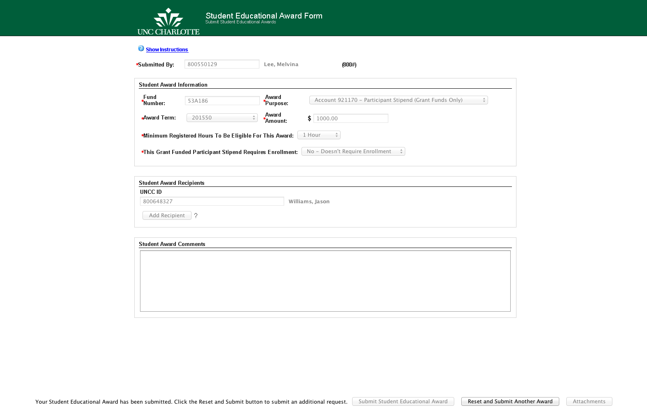

- Click the Reset and Submit Another Award button to submit another form for a student educational award.
- To exit the form, close the browser or tab.

- The following Email notifications will be sent to the Submitted By user.

  - Confirmation Email informing the Initiator, Fund Manager, and Principal Investigator (if grant funded) that the form submission has been received. This email will detail all award and department contact information, as shown below. Minimum Credit Hours, Enrollment Required, and Lot ID have been added to the email notification.

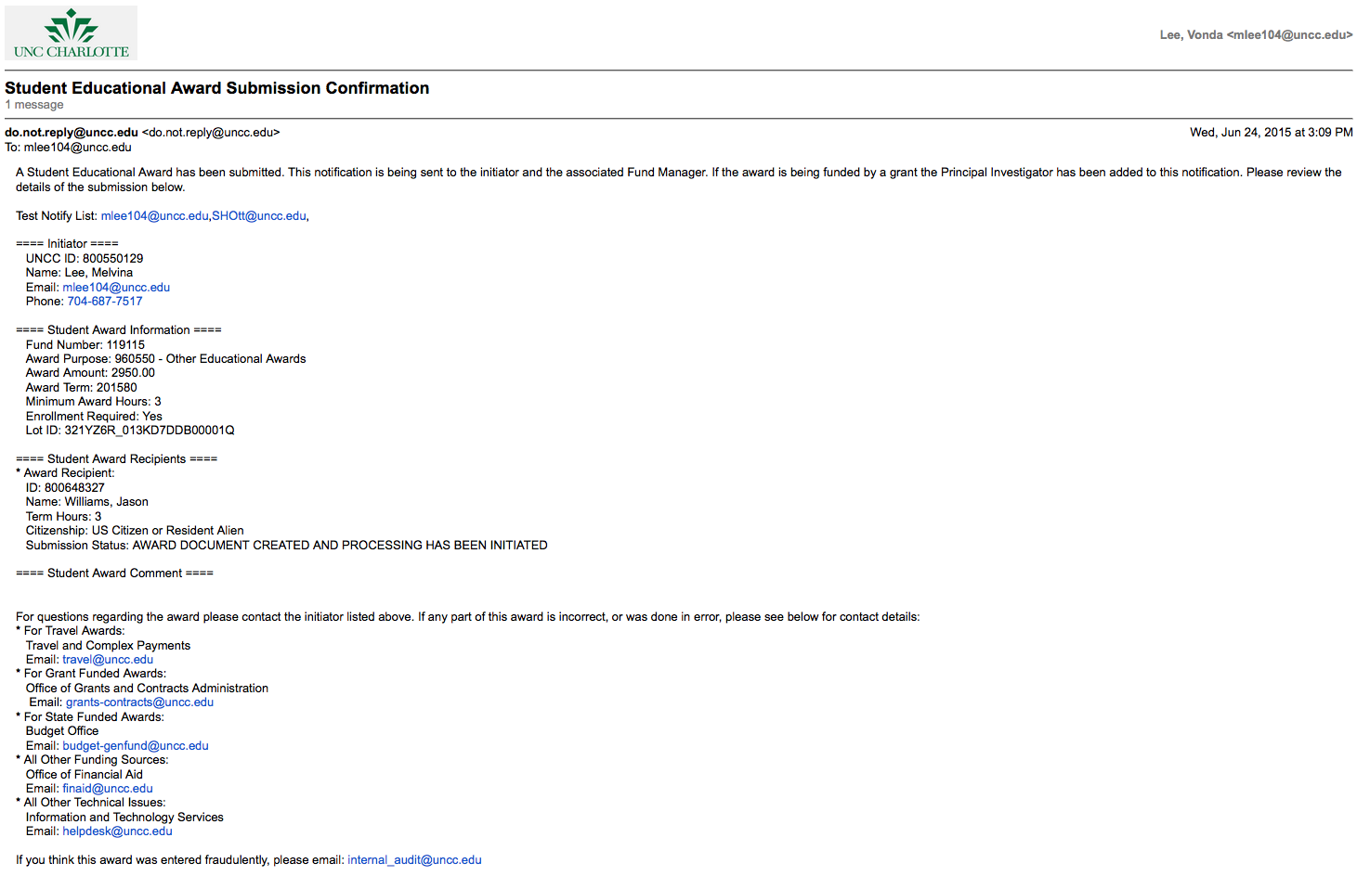
*Note: Make sure to review this email for errors and submission status of each recipient. Only invalid student IDs will be canceled and must be resubmitted; all other valid student IDs will be processed with the submission.

  - Confirmation Email informing the Initiator the submitted award has been approved and processed, as shown below:

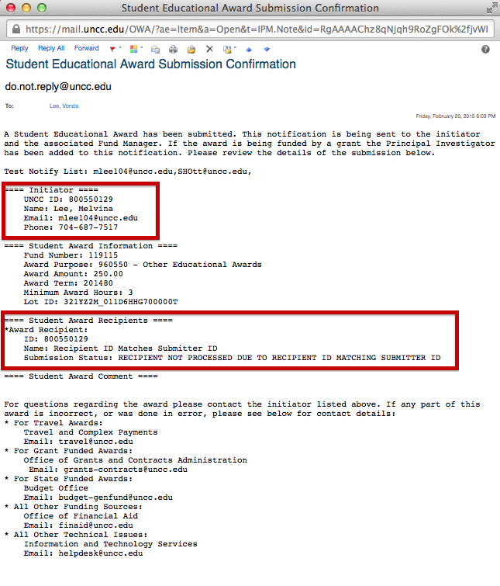
*Note: The Initiator and award recipient cannot be the same person.

  - New! Confirmation Email informing the Initiator the submitted award has been approved and processed, as shown below:

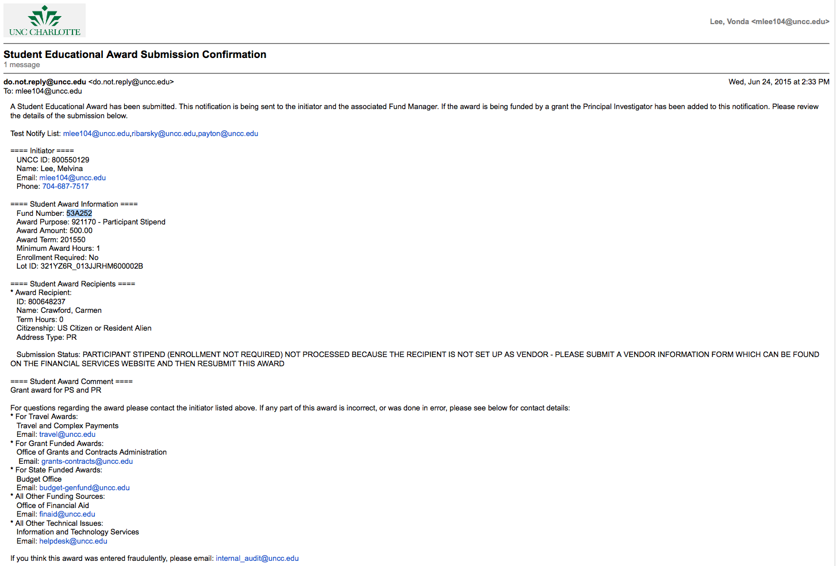*Note: If the student is not setup as a vendor, the award will not be processed until a VENDOR INFORMATION FORM is completed. This form can be found on the Financial Services Form website, http://finance.uncc.edu/resources/forms.

  - Confirmation Email informing the Initiator the submitted award has been approved and processed, as shown below:

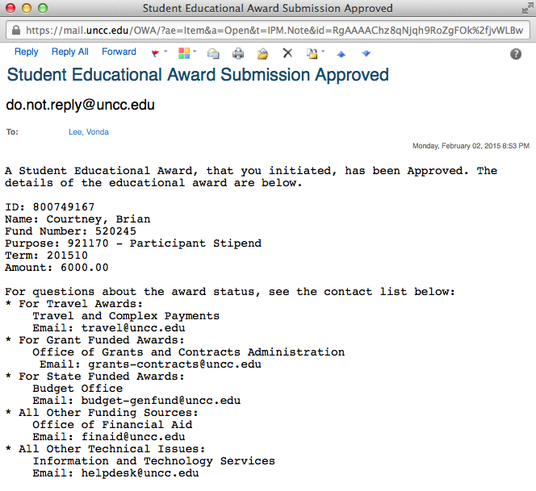

  - Confirmation Email informing the Initiator the submitted award has been denied, as shown below:

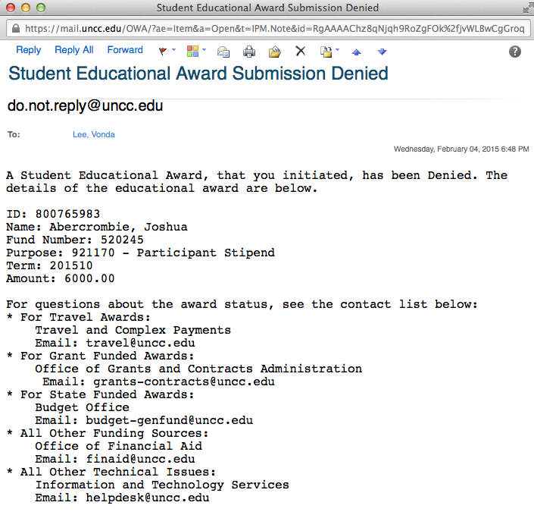

  - Confirmation Email informing the Initiator the submitted award has been canceled, as shown below:

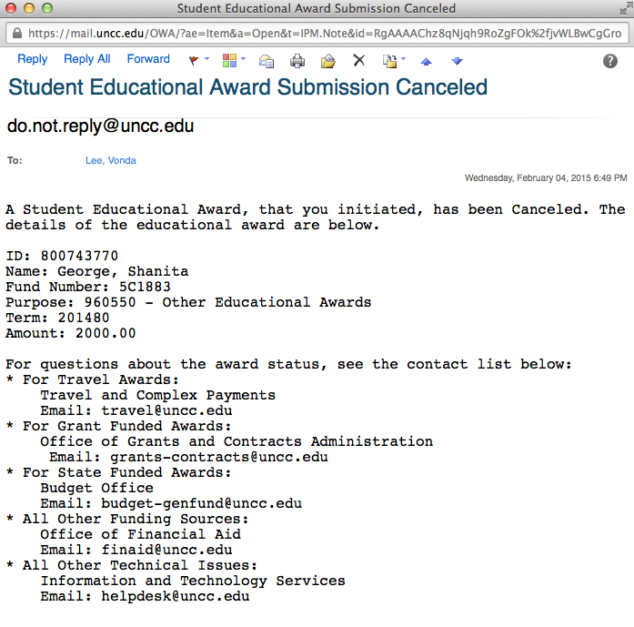

  - Confirmation Email informing the Initiator the submitted award has been approved and processed as a Direct Pay Request (DPR), as shown below:

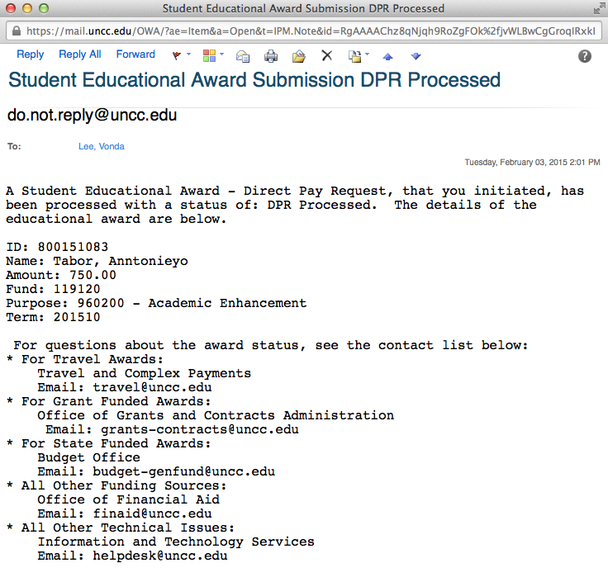

  - Confirmation Email informing the Initiator the submitted award has an invalid fund error, as shown below:

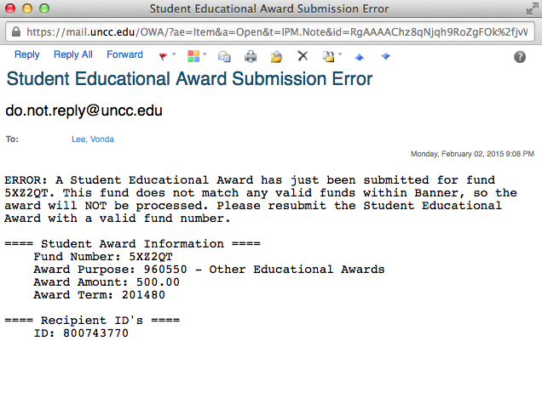
*Note: You will have to resubmit the Student Educational Award with a valid fund number.

Cancelations– cancelling a Student Educational Award Form in process

For a SEA form submission that is NOT fully processed, thus the Initiator has not received an email notification stating that the award has been completed, please forward the original email submission confirmation to the respective fund approvers below requesting the award to be canceled:

- For Travel Awards:
Travel and Complex Payments
Email: travel@uncc.edu
- For Grant Funded Awards:
Office of Grants and Contracts Administration
Email: grants-contracts@uncc.edu
- For State Funded Awards:
Budget Office
Email: budget-genfund@uncc.edu
- All Other Funding Sources:
Office of Financial Aid
Email: finaid@uncc.edu
Please attach any supplemental documentation containing details of the award to ensure cancellation of the correct award.

Revisions – Submitting a revised Student Educational Award Form that is fully processed

For a SEA form submission that has been processed, thus the Initiator has received an email notification stating that the award has been approved and processed, please submit a revised award that reduces the award value for a particular student.

To reduce an award, please submit a new award with a negative dollar value reflecting the value to reduce the initial award. If you are reducing an award, please include detailed information in the Comments section of the form to reflect the Lot ID of the original award and reason for change. Also attached any supplemental documentation, if necessary.

For example:
 | Award Amount | Form Comments
Original Student Educational Award | 2500.00
Revised Student Educational Award | -1000.00 | Enter the Lot ID of initial award and reason for change.
Corrected Student Educational Award after initiating the revised award. | 1500.00

To increase the value of a Student Educational Award, please submit another award with the increased value and purpose.

Appendix

- Browser Bookmark URL – http://imagenow.uncc.edu/imagenowforms/fs?form=Student_Educational_Award_Form
- Contact IT Service Desk for any technical issues with the online form, Java, or browser:
  - Call 704-687-5500 (7-5500)
  - HelpDesk Online
  - Email help@uncc.edu

