RED Student Educational Awards (SEA) Report User Manual

Written By: Vonda Lee
March 26, 2015

You can now generate a report for Student Educational Awards (e.g., scholarships, fellowships, stipends, travel awards) to be processed or being processed by the Office of Student Financial Aid or Financial Services. This report will give the Initiator the ability to review the status of submitted awards. The report column called CURRENT STATUS will display information in detail if the award has been processed or is being processed by the particular Fund Specialist’s (Budget, Financial Aid, Grants & Contracts, or Travel & Complex Payments) area.

The following is a list of report selection criteria:
- Term (Multiple Selection Option)
- Award Status
- Status
- Initiator
- Student UNCC ID (SID)
- Fund Number
- Report Output

You can enter in a combination of the above parameters to generate a custom report. Also, you can select between two report output options: HTML or Excel.

*Note for Chrome users: When using the "Excel" report output type, please save the resulting WFServlet.ibfs file with an xlsx extension so the report will open in Excel.

Award data for reporting is stored in ODS and will be refreshed to match production twice a day—at noon and again at 3:00 am. To get update information, please generate your reports accordingly.

Generating the Report:

- Go to the Research and Economic Development main webpage, https://research.uncc.edu.
- Click the Student Educational Award Report link at the top of the right-hand panel. The Report Express Login screen will display as shown below:

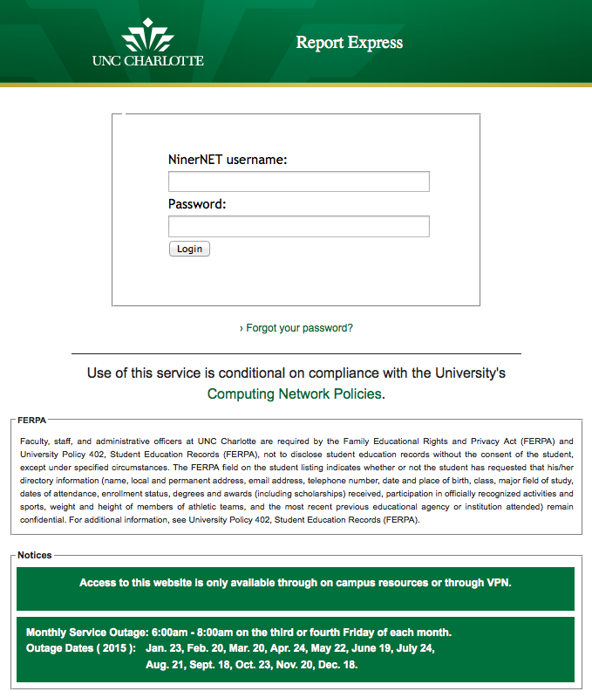
- Login using your NinerNet credentials.

- Click on the tab, ImageNow, at the top of the screen to view the list of available reports, as shown below:

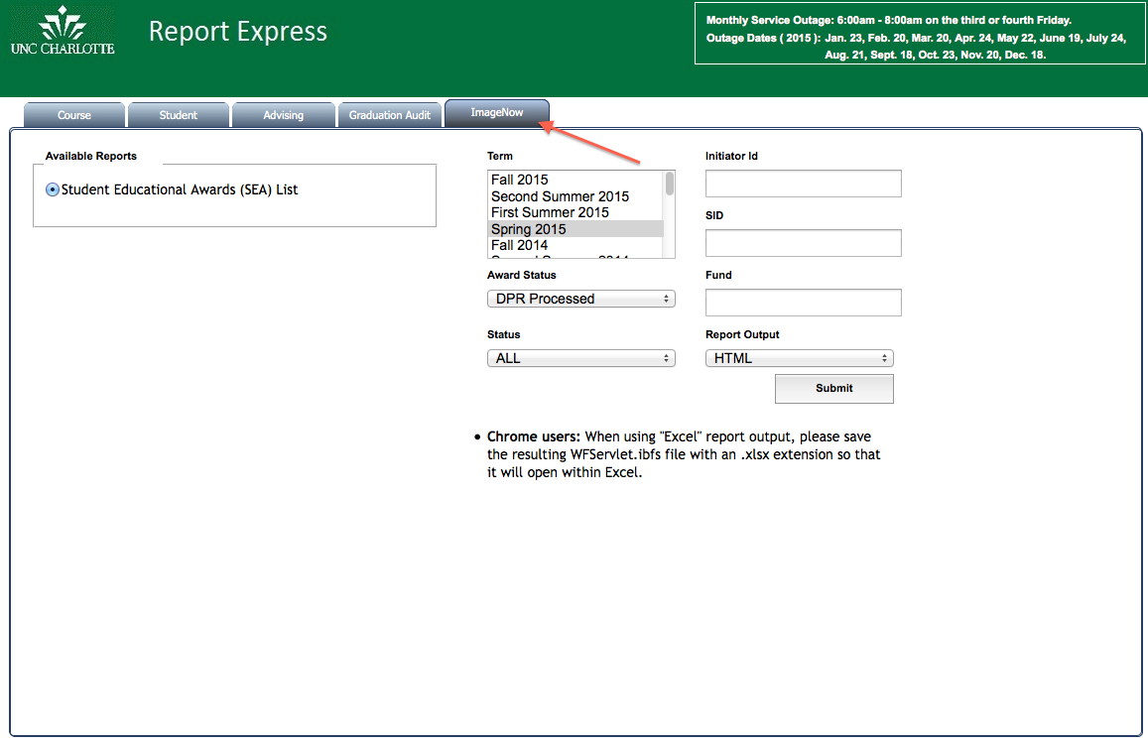

- Select the Term(s) for your report. Use the CTRL or COMMAND keyboard key to select multiple terms. *Note: If you do not select a term, the default selection will be used for your report.
- Select the Award Status; the default selection is ALL, However you can select:
  - Approved
  - Denied
  - Canceled
  - DPR Processed
  - Other (Note: This option will display all awards not yet processed and waiting in the Fund Specialist’s processing workflow queue.)

- Select a Report Output type, either HTML or Excel. If you select HTML, it will display the report within the browser. If you select Excel, it will download the file where you can open in MS Excel application, as shown below:

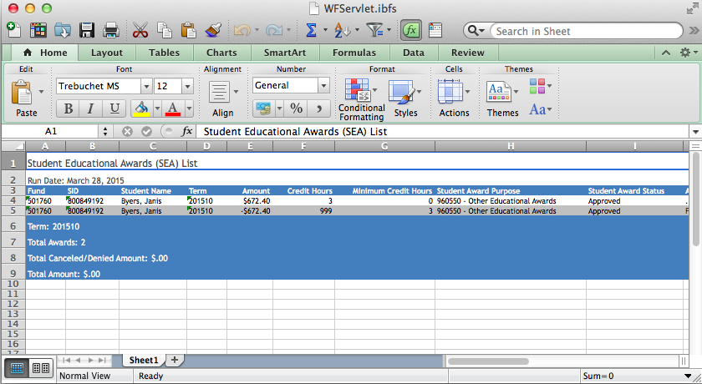

To generate a specific report, enter one or more of the following parameters:

- Enter an Initiator ID (800#) to generate a report with activity for the person who submitted the award form.
- Enter a SID (Student’s UNCC ID) to display a particular student’s award information.

- Enter a Fund to display particular Fund’s award information.

*Note: You can enter a partial fund number, etc. “5”, to generate a report for all Grant funded awards, as shown below:

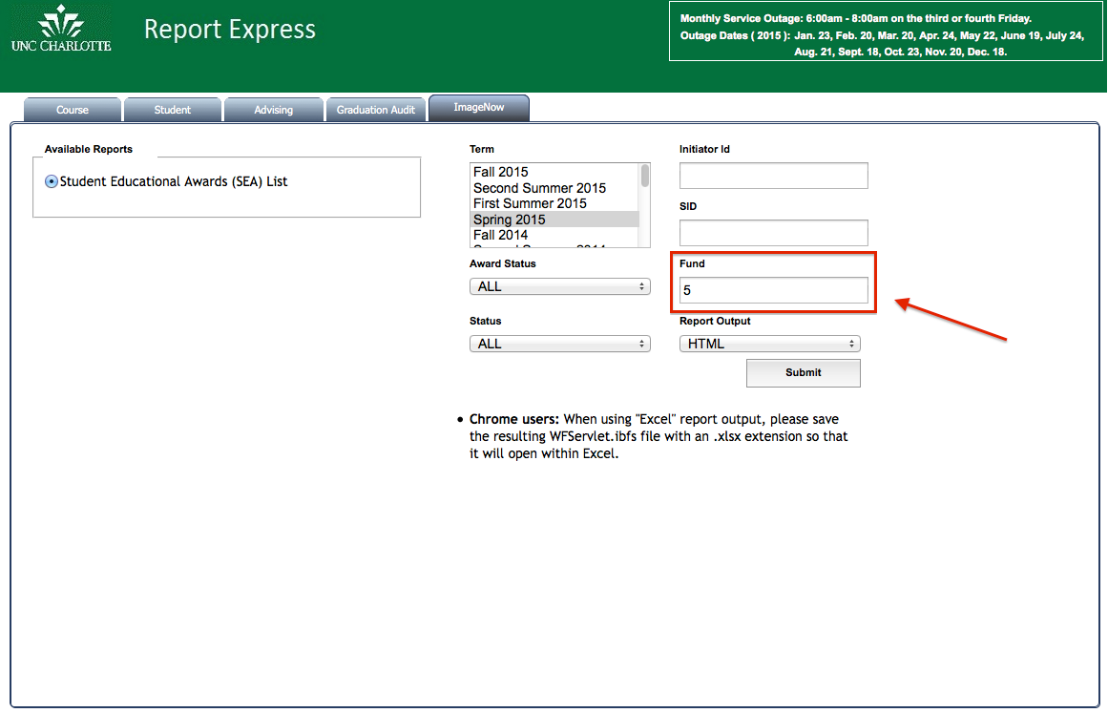

- Click the SUBMIT button to generate the report. If you selected HTML report output type, a new browser window or tab will open displaying the report you requested, as shown below:

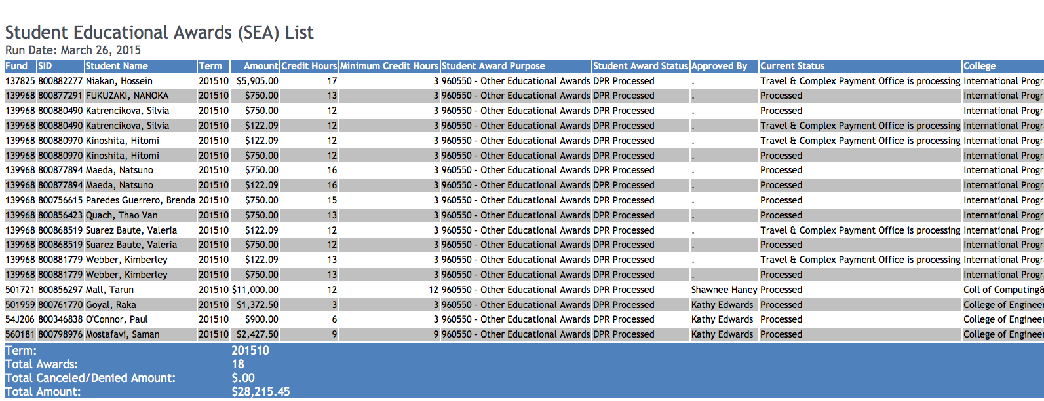
- To exit Report Express or the generated report, close the tab or browser.

Appendix

- Browser Bookmark URL – http://reportexpress.uncc.edu/
- Contact IT Service Desk for any technical issues with Report Express or your browser:
  - Call 704-687-5500 (7-5500)
  - HelpDesk Online
  - Email help@uncc.edu

