RED Student Educational Award (SEA) Workflow Process Manual

Written By: Vonda Lee
February 7, 2015

Table of Contents
Notification of New Document in the Processing workflow queue: 3
Processing Documents in the Processing workflow queue: 7
Changing Award Forms in the Processing workflow queue: 12
Processing Documents in the On Hold workflow queue: 15
Processing Historical Documents in the Processing workflow queue: 17
Processing Documents in the Error workflow queue: 22
Searching for Documents: 26

Notification of New Document in the Processing workflow queue:

- A Budget, Grants & Contracts, or Financial Aid Specialist will receive an email notification stating a new document is in the workflow queue for processing, as shown below:

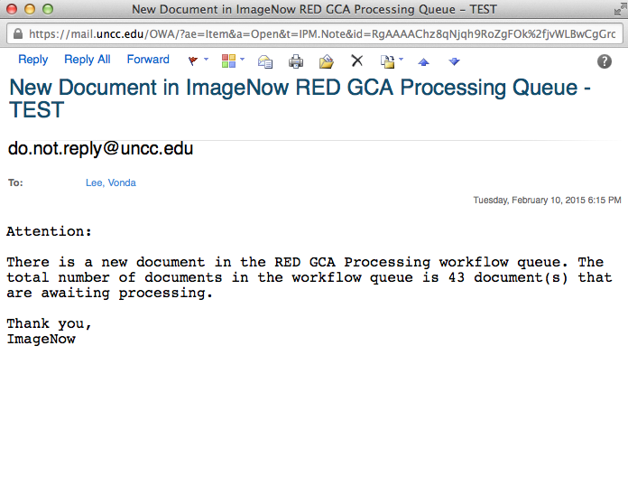

- Login to ImageNow or WebNow using your NinerNet credentials and press the CONNECT button as shown below:
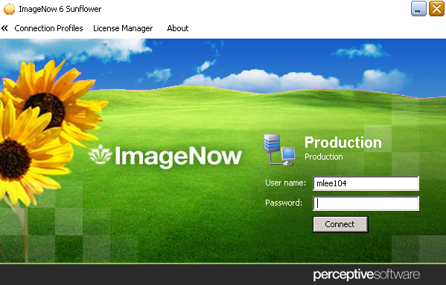

- Proceed to the workflow queue identified in the email notification, as shown below:

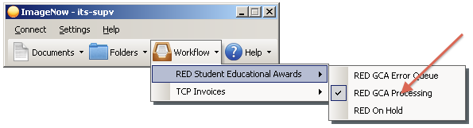

- An ImageNow Explorer window will display a list of award documents to be processed by the Specialist, as shown below:

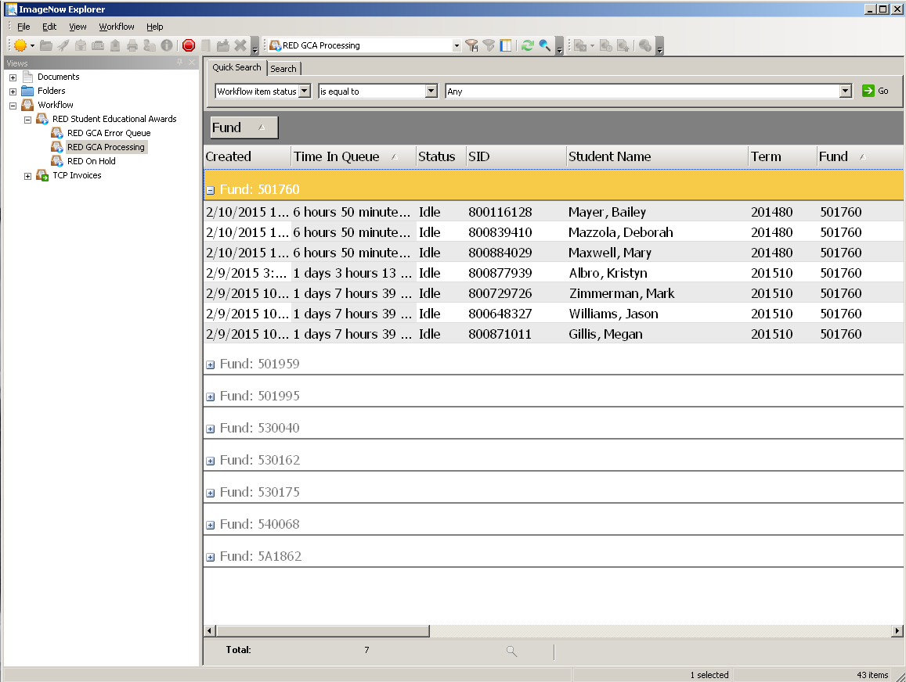

*Note: The document list (shown on the previous page) is grouped and sorted by FUND and TIME IN QUEUE for Grants & Contracts Administration only.

Other department workflow document lists will not be grouped and will be sorted by TIME IN QUEUE.

- The award documents in the list are ready for approval and processing.
- There will also be email notifications in the departmental email inboxes regarding student award form changes and cancelations. It is very important to check that email account on an hourly or daily basis. The email accounts are:
- For Travel Awards:
Travel and Complex Payments
Email: travel@uncc.edu
- For Grant Funded Awards:
Office of Grants and Contracts Administration
Email: grants-contracts@uncc.edu
- For State Funded Awards:
Budget Office
Email: budget-genfund@uncc.edu
- All Other Funding Sources:
Office of Financial Aid
Email: finaid@uncc.edu

Processing Documents in the Processing workflow queue:

- The Budget, Grants & Contracts, or Financial Aid Specialist will select a document and double-click to open the document, as shown below:

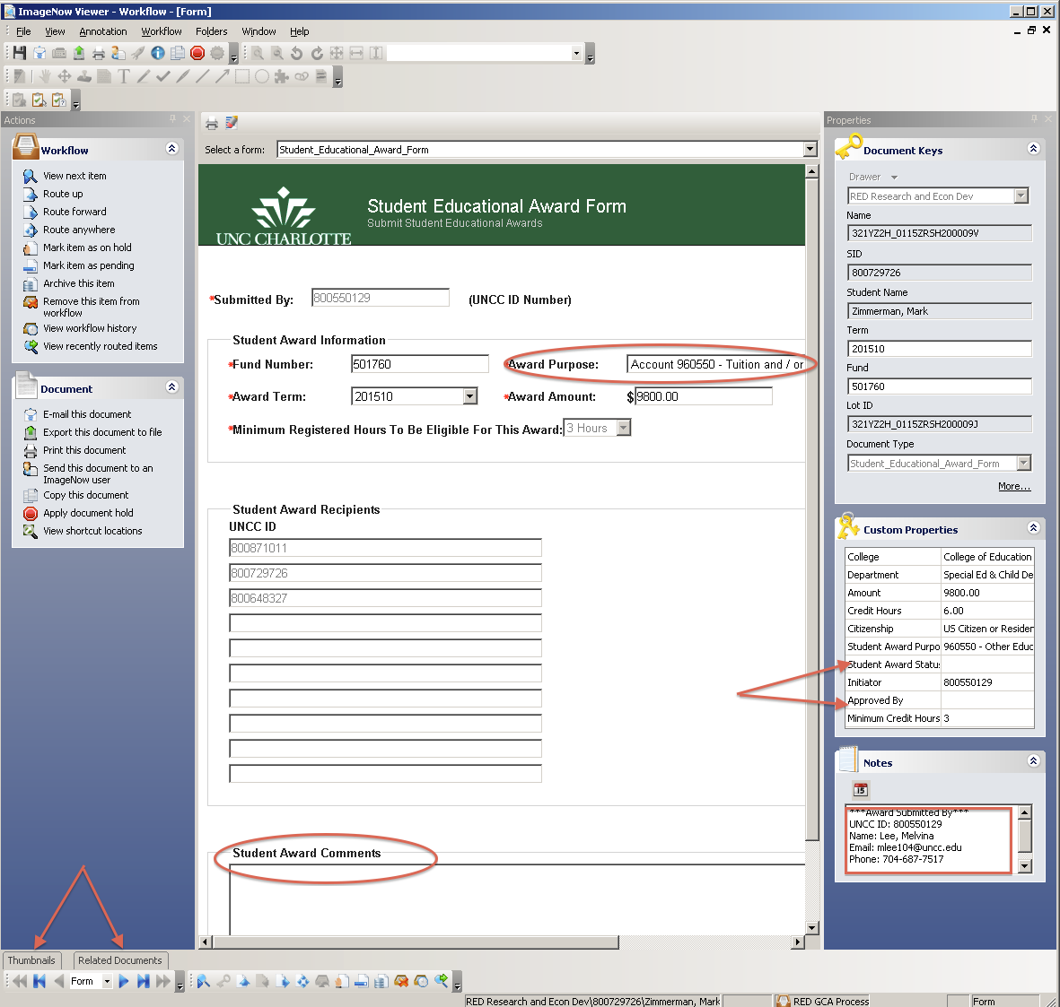
*Note: You should review the form details, document keys, custom properties, and information in the NOTES field.

- Ensure that the THUMBNAIL and RELATED DOCUMENTS views are evoked. See below.

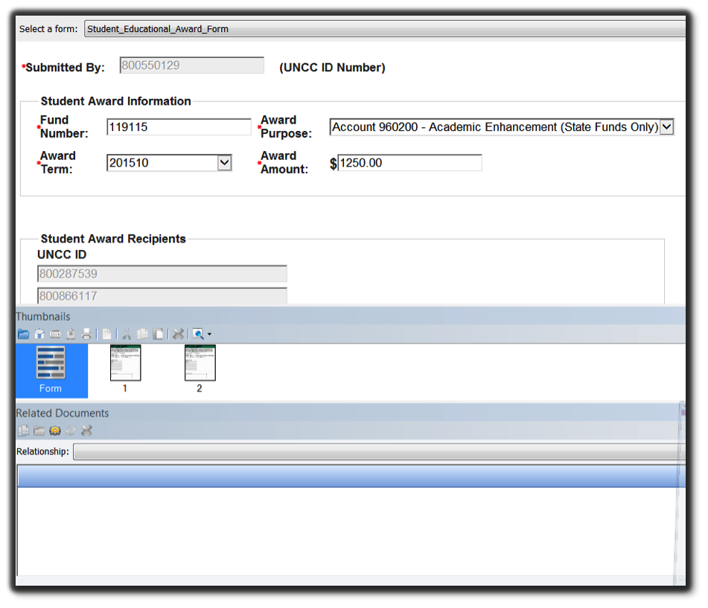

- To view any attachments that may have been submitted with the award, check the THUMBNAILS view. In addition to Form and Page 1, any additional pages will be displayed. *Note: Not all documents will have attachments.

- Check the RELATED DOCUMENTS view for duplicate award submissions using the RED Student ID – Duplicates relationship key. A list of documents will be displayed in the RELATED DOCUMENTS section, if applicable, as shown below.
- To view other awards associated with the current award, select the relationship key, RED Lot ID. A list of documents will be displayed in the RELATED DOCUMENTS section, if applicable, as shown below.

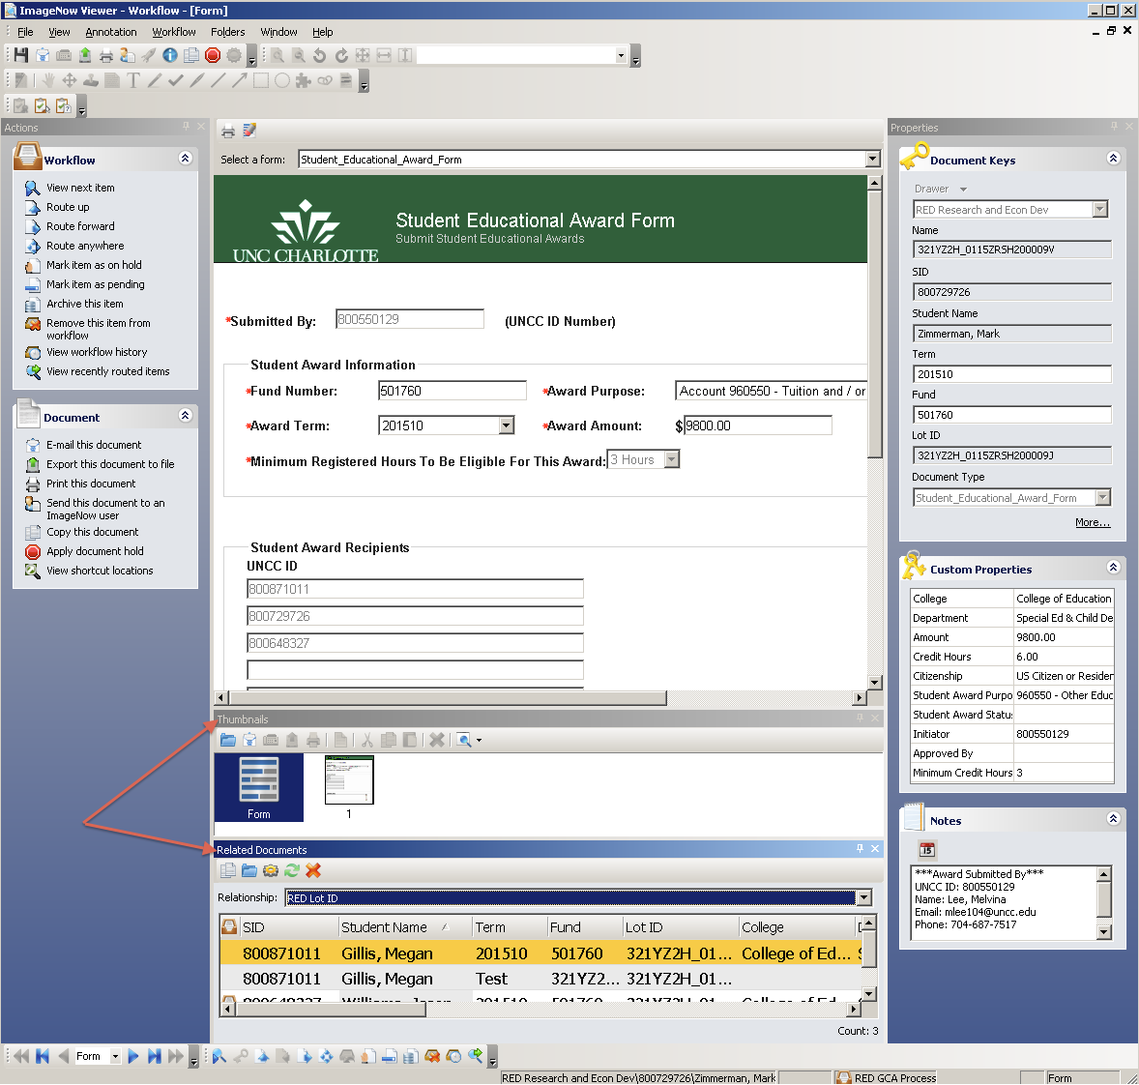

- Review the following:
  - Document keys
  - Custom properties
  - Form Award Purpose, Comments, and the Award Submitted By
  - Any information in the NOTES field
- Verify the Term is valid. If the term is equal to Other:
  - Look in the comments section of the form for the valid term.
  - Enter that value in the document key field called Term.
- Verify that the Credit Hours field is greater than 0. If the Credit Hours field is equal to a negative one (-1), the SEA Initiator did not enter a valid term on the award form. If this happens:
  - Lookup the Credit Hours in Banner for the term of the student listed.
  - Enter that Banner credit hours value in the custom property field called Credit Hours.
- Once all departmental due diligence is completed, the Specialist will change the following custom properties:
  - Student Award Status:
    - Approved – award meets all grant, state, or other source fund requirements.
    - Denied – award does not meet all grant, state, or other source fund requirements.
    - Canceled – award was submitted in error.
  - Approved By – enter the NinerNet credentials that approved, canceled, or denied the award.
- Attached any additional supplemental documentation that you received regarding this award, if applicable, by using the drag-drop feature.

- Route the document forward by clicking the ROUTE FORWARD link or icon. The window below is displayed:
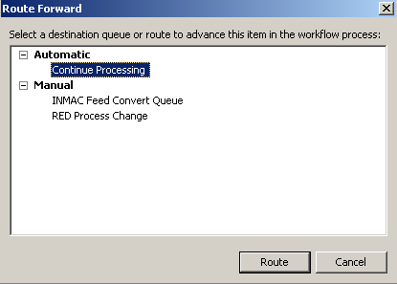
- Select Continue Processing workflow queue. Based on the criteria, the document will either be routed to archive, Financial Aid, Travel, Tax, or Error queues.
- If the award document has been DENIED or CANCELED, the document will be routed to archive and the Initiator will receive an email notification.

Changing Award Forms in the Processing workflow queue:

- The Budget, Grants & Contracts, or Financial Aid Specialist has the ability to change the Student Award Information on the actual form in the ImageNow Viewer, as shown below:

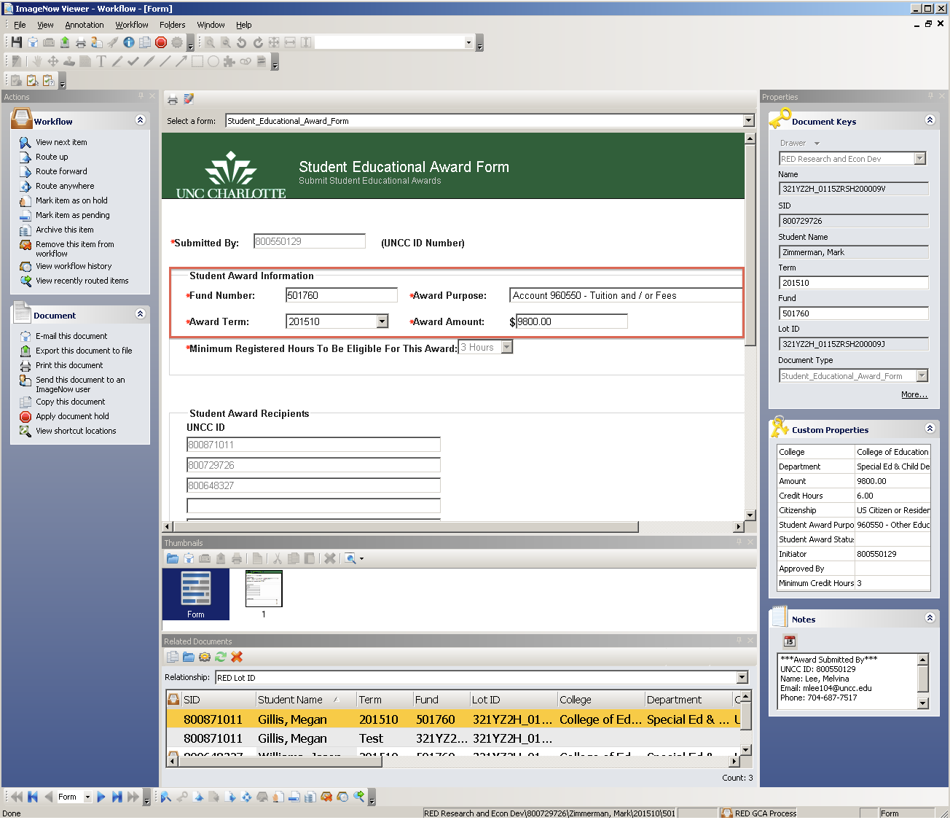

- Position the cursor on any of the fields within the Student Award Information section of the form. Change the value of the field. Some fields within the section may have a drop-down menu. You will need to select a value in the list to populate the field.
- Attached any additional supplemental documentation you received regarding changing this award (such as an email), by using the drag-drop feature.
- Click the SAVE icon to save all changes.
- Route the document forward by clicking the ROUTE FORWARD link or icon. The window below will be displayed:

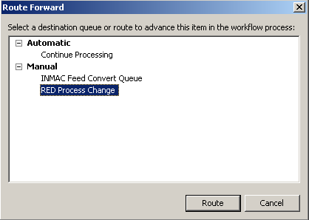
- Select RED PROCESS CHANGE workflow queue. The document will be routed to a workflow queue that will re-index the document keys and custom properties.

- The revised document will be routed back to the appropriate PROCESSING workflow queue for further processing.
- Refer to the Processing Documents in the Processing Workflow Queue section of this document for further processing of the award document.

Processing Documents in the On Hold workflow queue:

If a student has 0 credit hours entered for an award term, the document will be displayed in the RED On Hold workflow queue. These documents will reside in the queue until the student registers for classes or meets the restricted credit hours for that grant, state, or other source fund requirements. Once a student has registered or met the requirements, then the document will be automatically routed to the respective processing workflow queues.

- A Budget, Grants & Contracts, Financial Aid, or Travel Specialist has the ability to cancel any awards in the RED On Hold workflow queue. In the ImageNow Explorer view, the documents are grouped by FUND as shown below:

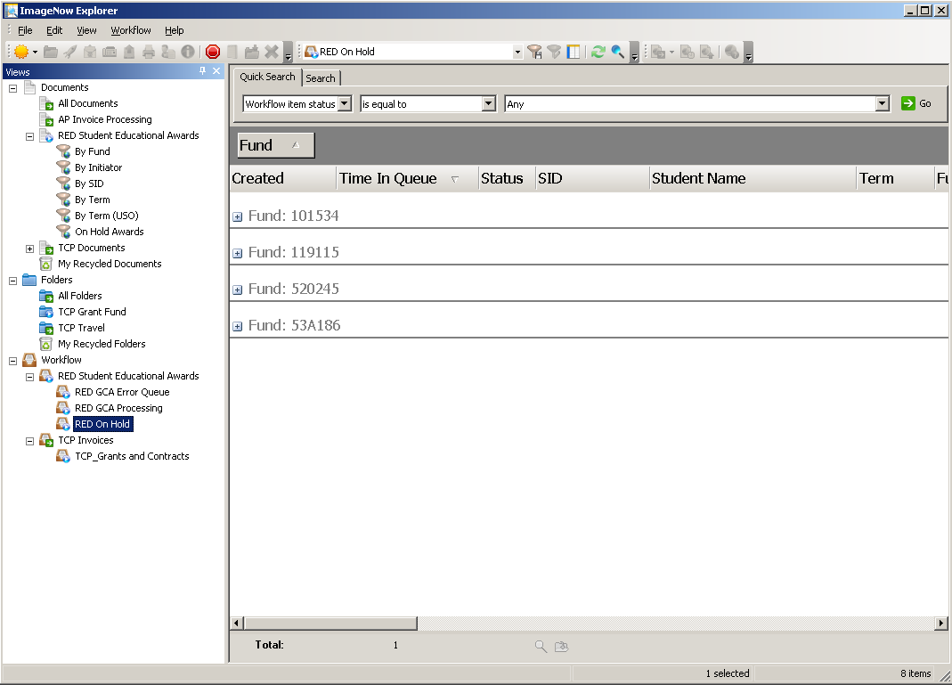

- Expand the desired FUND by clicking the “+” sign to display all the documents within that particular fund.
- Open the selected document and attach any supplemental documentation to support the cancelling of the document. The drag-drop feature can be used to accomplish this.
- Once all departmental due diligence is completed, the Specialist will change the following custom properties:
  - Student Award Status to Canceled due to the award was submitted in error.
  - Approved By - enter the NinerNet credentials that canceled the award.
- Route the document forward by clicking the ROUTE FORWARD link or icon. The window below is displayed:

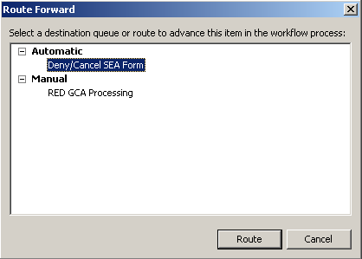
- Select Deny/Cancel SEA Form workflow queue. The document will be routed to archive. The SEA Initiator will receive an email notification that the document has been canceled.

Processing Historical Documents in the Processing workflow queue:

The documents created and processed using the legacy system will have a document type of Student Award. Documents processed in the new ImageNow system will have a document type of Student_Educational_Award_Form.

If a historical document needs to be re-processed, do the following:

- Search for the historical document in the document view called RED Student Educational Awards. There are three (3) document view filters to assist in the search:
  - By Fund
  - By SID (Student ID)
  - By Term
- Click a document view filter.
- Enter in the appropriate criteria for the selected document view filter. Click the OK button.

- For example, the document view filter By SID is selected. The ImageNow Explorer window will display a list of documents for the Student ID entered, grouped by Term, as shown below:

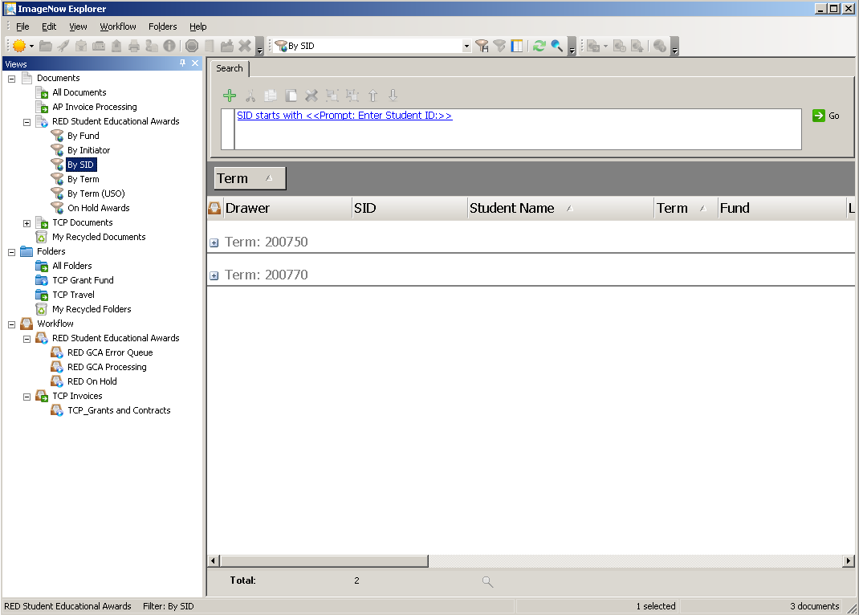
- Expand the desired TERM by clicking the “+” sign to display all the documents within that particular term for the selected Student ID.

- Open the desired document and click the link labeled WORKFLOW in the header of the document. Then select the ADD TO WORKFLOW option, as shown below:

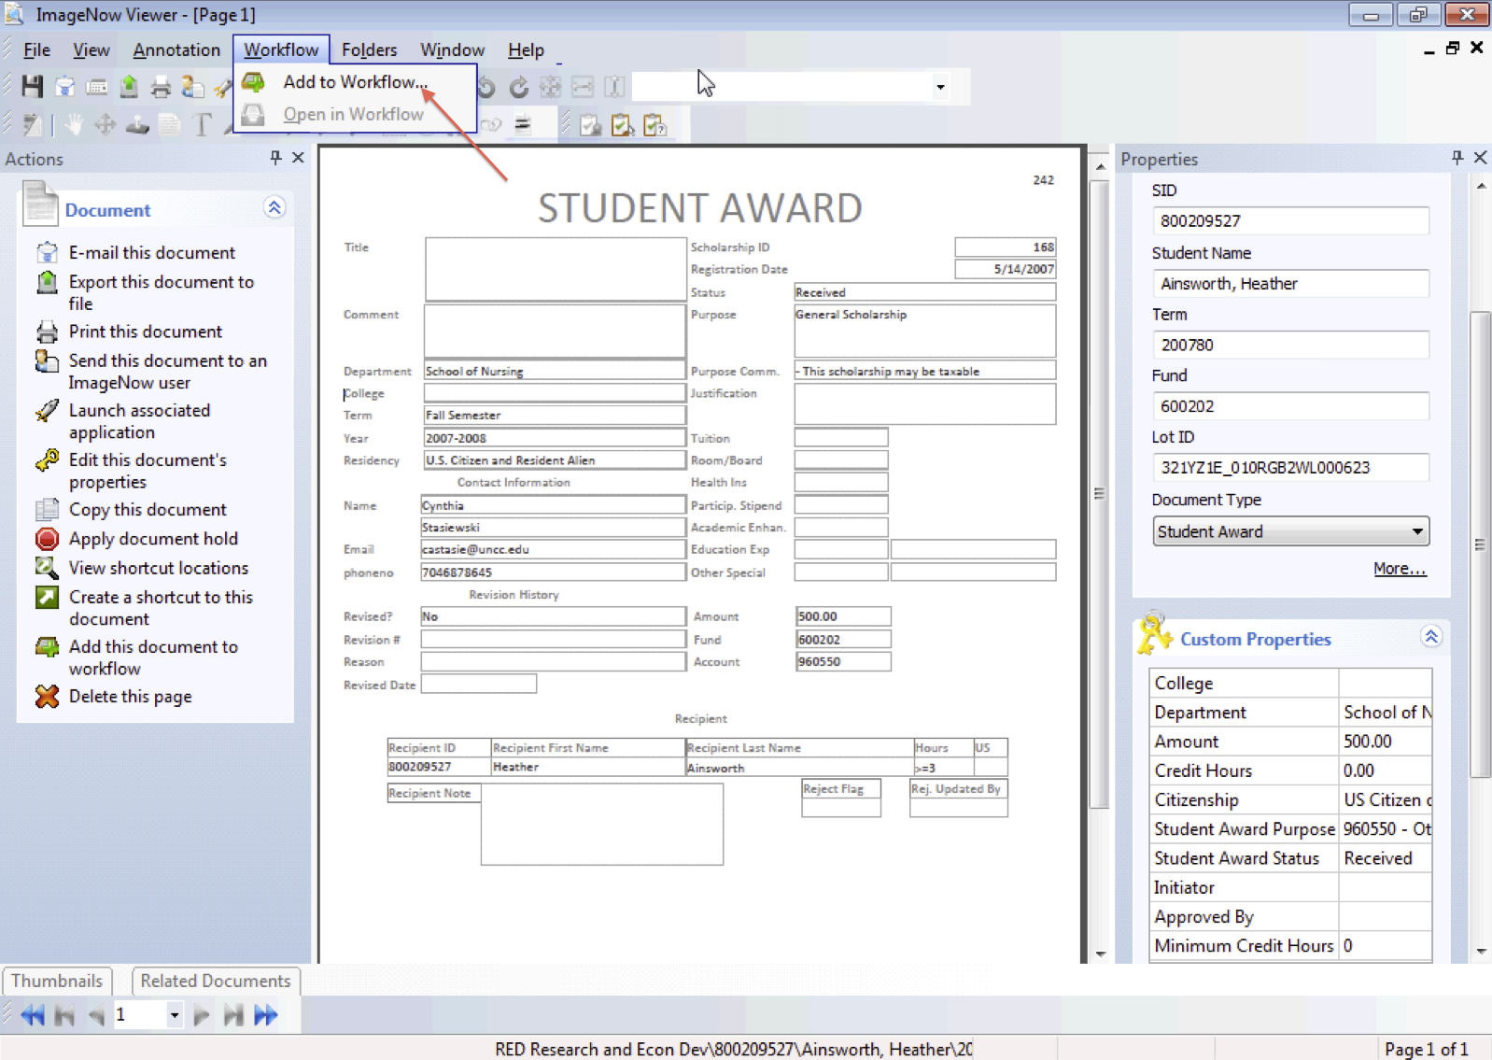

- An ADD TO WORKFLOW window will be displayed. Select the desired workflow to add the historical document. Click the ADD button to process, as shown below:

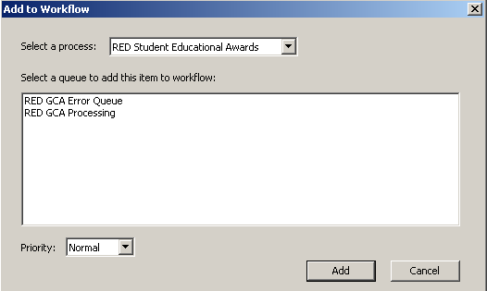

- Click the link labeled WORKFLOW in the header of the document. Then select the OPEN IN WORKFLOW option. The document is now in workflow and ready to be processed.
- All historical documents are PDF type documents. To annotate these documents, especially if the award document will become a DPR, route the document to the INMAC FEED CONVERT QUEUE. The document will be converted to TIFF and can be annotated once converted.

- Press the ROUTE FORWARD link or icon to route the document to INMAC FEED CONVERT QUEUE.
- A ROUTE FORWARD window will be displayed. Click the ROUTE button, as shown below:

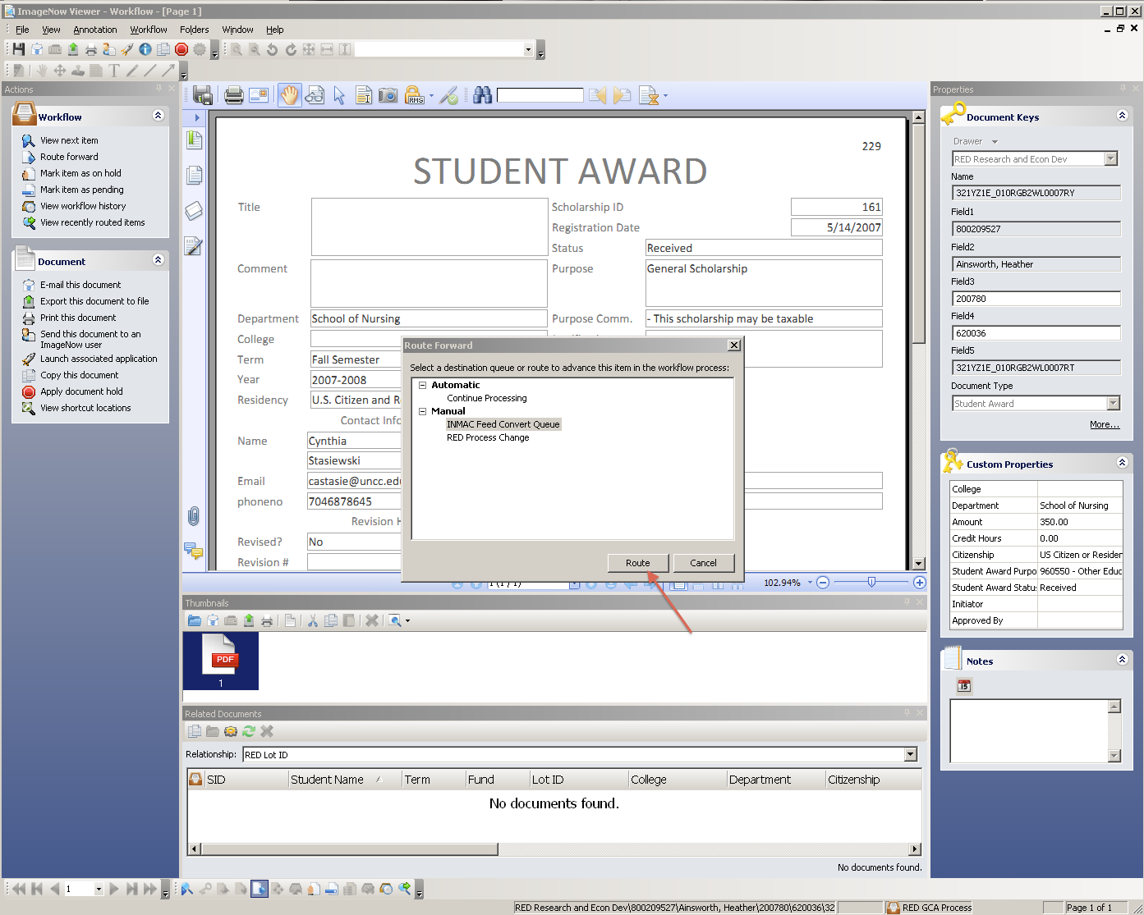
- The converted document will be routed back to the appropriate PROCESSING workflow queue for further processing.
- Refer to the Processing Documents in the Processing Workflow Queue section of this document for assistance in further processing of the historical award document.

Processing Documents in the Error workflow queue:

- A Budget, Grants & Contracts, or Financial Aid Specialist will receive an email notification stating a new document is in the respective error workflow queue, as shown below:
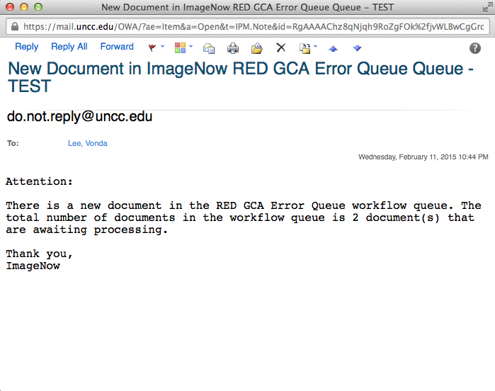

- Login to ImageNow or WebNow using your NinerNet credentials and click the CONNECT button as shown below:

- Proceed to the workflow queue mentioned in the email notification, as shown below:

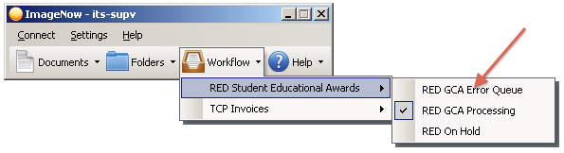

- An ImageNow Explorer window will launch displaying a list of award documents that contain errors, as shown below:
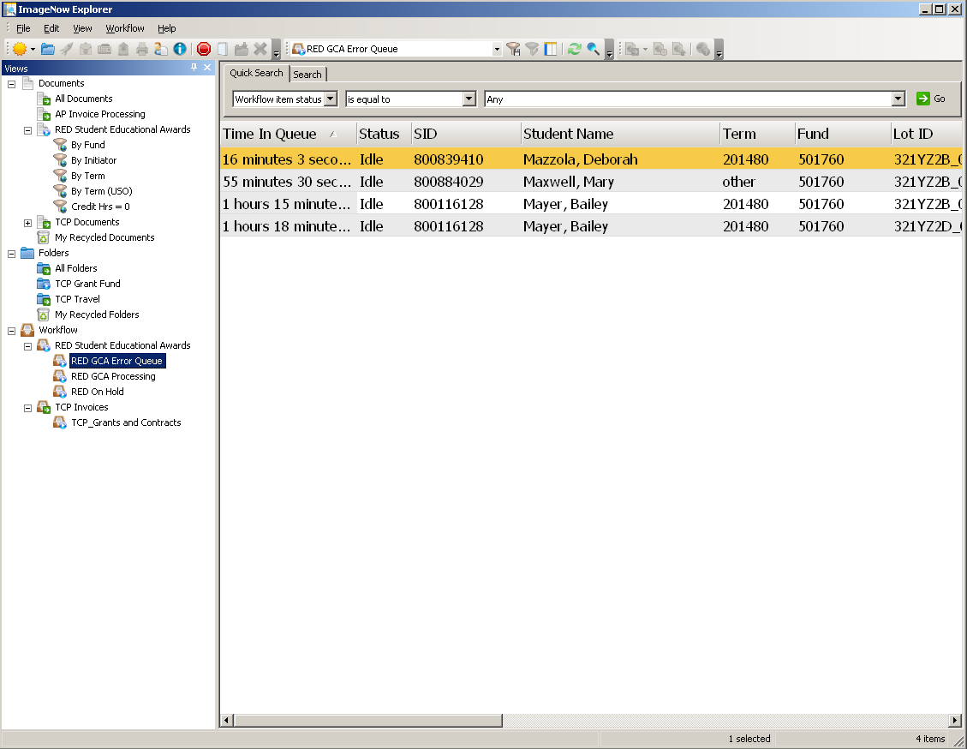

- There are there (3) reasons a document will enter the Error Queues:
  - An invalid Term in the document keys.
  - The custom property Approved By was not populated.
  - The custom property Credit Hours contains a value of -1.
- Correct the error listed above for documents in the queue.
- Save the changes to the document by clicking the SAVE icon.
- Click the ROUTE BACK icon or link to route the document back to RED Route Queue workflow queue to continue processing.
- Documents left in an error queue will be deleted after 30 days.

Searching for Documents:

- Search for documents in the document view called RED Student Educational Awards. There are six (6) document view filters to assist in the search:
  - By Fund
  - By Initiator
  - By SID (Student ID)
  - By Term
  - By Term (USO)
  - On Hold Awards
- Click a document view filter.
- Enter in the appropriate criteria for the document view filter selected, if applicable, and click the OK button.
- The ImageNow Explorer view will display a list of award documents that meet the selection criteria.

- For example, the document view filter On Hold Awards is selected. The ImageNow Explorer window will display a list of documents that reside in the RED On Hold workflow queue, as shown below:

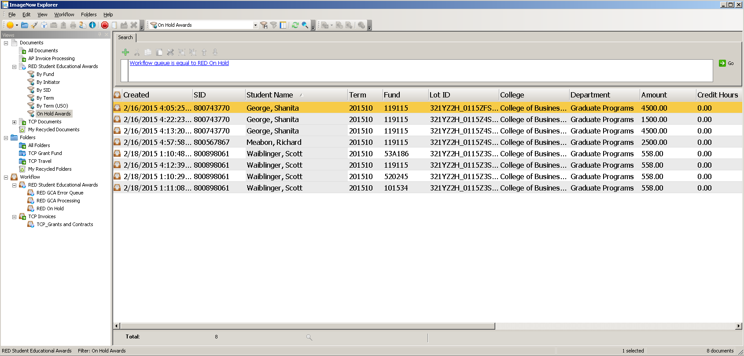
*Note: The documents in this workflow queue have credit hours = 0 or does not meet the minimum credit hours for the grant, state, or other source fund.

- You can search for documents using the Quick Search feature, as shown below:

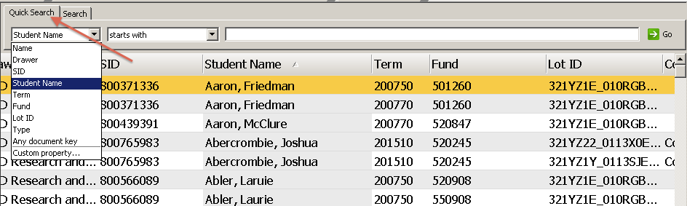
- Select and enter in the search criteria. Click the GO button to run the query. An ImageNow Explorer view will display a list of documents that meet the criterion.

