SA Credit Card Book Receipt (CCBR)
User Manual

Written By: Vonda Lee
June 3, 2015

Form Instructions:

This form is used by departments that process Credit Cards on site or accept Credit Cards via the Internet. All Book Receipts Must Be Submitted By 12pm (Noon) to ensure that we meet the State Treasurer’s Office daily deposit/certification deadlines. Failure to comply could jeopardize the status of your merchant account. Separate submissions must be made for each credit card type. The back-up documentation specific to each card type must be included with this deposit submission. After submitting the form, a notification will be sent to the Initiator and any associated "Designated Contacts" related to the merchant account. If there are errors, these will be notated in the confirmation email. Details of all transactions are maintained in TouchNet and can be accessed and exported at any time for your convenience.

To submit a subsequent Book Receipt form, click on the "Reset and Submit Another Receipt" button.

- Submitted By - This must be your UNCC ID Number (800#). You will see your name displayed next to the box when entered correctly.
- Merchant Name - You must select the correct merchant name from the dropdown list. The business officers / designated contacts for the selected merchant name will be copied on the confirmation email.
- Journal Voucher Type - Your only option is "Book Receipt".
- NEW! Report Date - This is prepopulated with yesterday's date. You can, and should, change this date to reflect the date shown on the ClientLine or OMS Report. The date format should be mm/dd/yyyy. You can choose the date by clicking on the calendar icon to the right of the text field.
- Credit Card Type - You must select the appropriate credit card type for the deposit being submitted. Specific documentation is required, depending on the Credit Card Type selected. Please review that list below, to ensure timely processing of your submission:
  - Visa/MasterCard
    - Online Sales - TouchNet Payment Gateway Batch Settlement Report (Totals Only) and ClientLine HL0605 Sales Report
    - POS Terminal Sales - ClientLine HL0605 Sales Report
(*Note: Settlement Tape/Report from POS Terminal is no longer required.)
  - American Express
    - Online Sales - OMS Merchant Financial Activity Settlement
    - POS Terminal Sales - OMS Merchant Financial Activity Settlement
(*Note: Settlement Tape/Report from POS Terminal is no longer required.)
- Index/Fund - You must enter the appropriate (valid) 6-digit Index/Fund code for the transaction line.
(*Note: AN INVALID INDEX/FUND WILL INVALIDATE THE ENTIRE SUBMISSION.)
- Account - You must select the appropriate account code from the dropdown list. If the desired account code doesn't appear in the list, please notify the Cashiers Office for assistance.
- Description - Each Credit Card Book Receipt line must contain a useful description. This description can be up to thirty-five (35) characters long. This description will be entered into Banner when then journal voucher (JV) is posted.
- Debits/Credits - This is a self-balancing entry, therefore only a debit or credit amount is required per line (but not both). The normal balance for a book receipt is a credit. Totals will automatically calculate as you enter line details.

When completing the CCBR, only one entry should be submitted for each Index/Fund and Account. Effective July 1, 2015, if you submit a CCBR with a list of individual payments going into the same Index/Fund and Account, then the information will be summarized into a single entry within Banner.

- Click the link Book Receipt for Credit Cards on the Financial Services form webpage, http://finance.uncc.edu/resources/forms. The entry form below will be displayed:

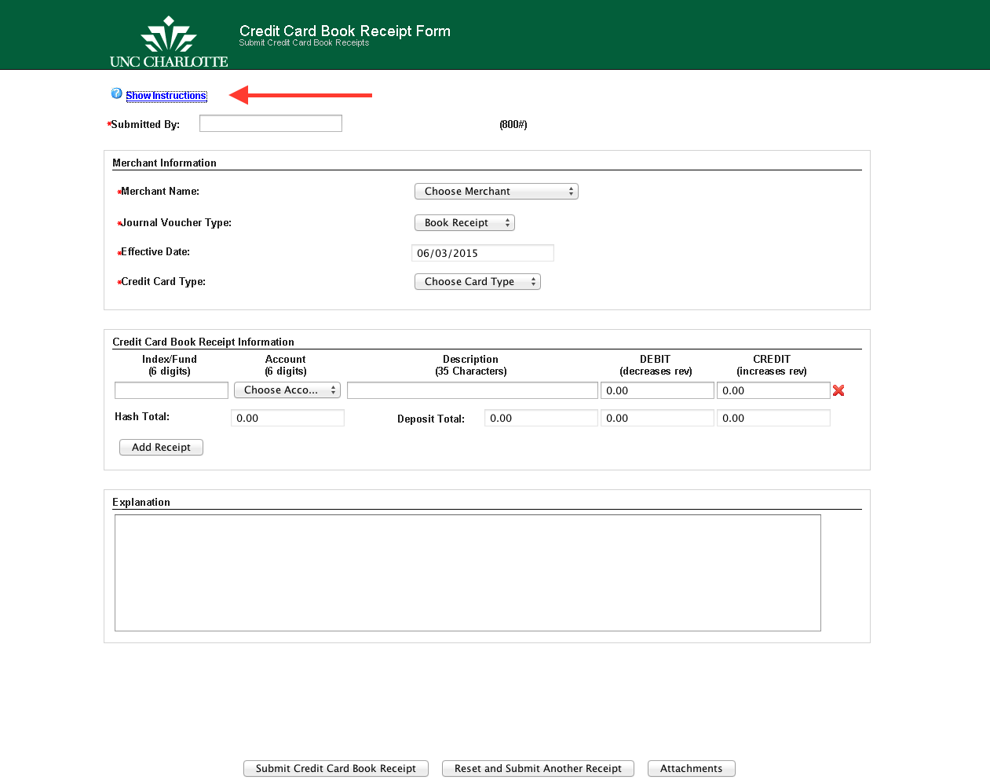

- Click on the link, Show Instructions, to display the form instructions.

- Click on the link, Hide Instructions, to hide the form instructions, as shown below:

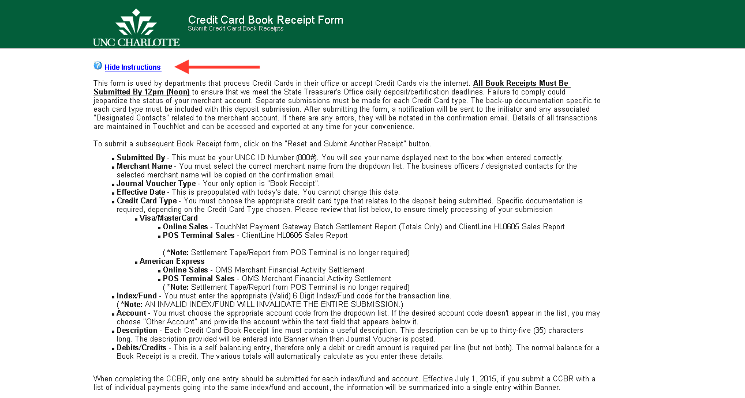

- Enter the Submitted By (800#) (UNCC ID Number) of the person submitting the form. (*Note: Once you press the TAB key the Initiator’s name will appear.)
- Select a Merchant for the credit card book receipt by clicking the drop-down list, as shown below:
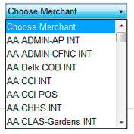
(*Note: See new list of Merchant Names located at the end of this document.)

- Select the Journal Voucher Type. Currently there is only one voucher type called Book Receipt; additional types may be used in the future.

- NEW! Select the Report Date for the date shown on the ClientLine or OMS report. This field defaults yesterday’s date.
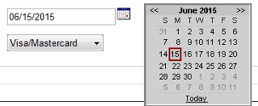

- Select a Credit Card Type for the book receipt by clicking the drop-down list, as shown below:

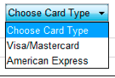

- Enter at least one Index/Fund/Account/Description/Debit or Credit combination. To add another line, click the Add Receipt button. You can enter an unlimited number of credit card book receipts (Index/Fund/Account/Description/Debit or Credit). You can also remove the last Receipt line by clicking the Remove Receipt button. See example below:

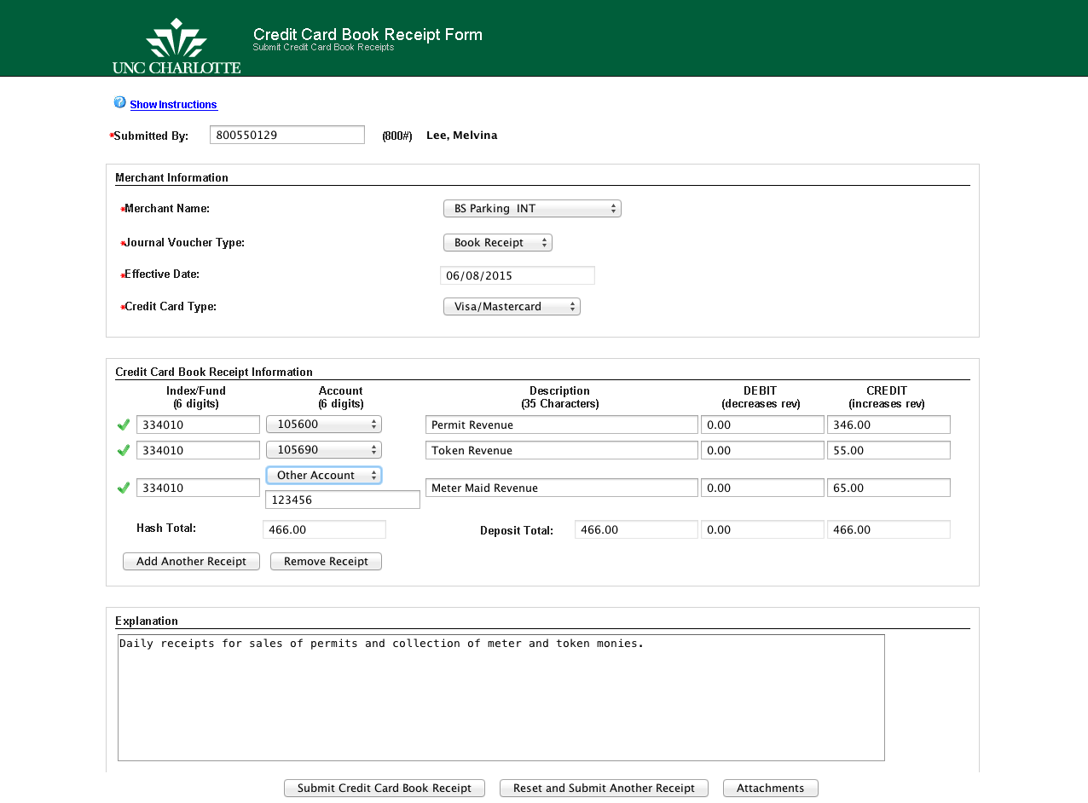
  - Enter a valid Index/Fund number.
*Note: If a valid Index/Fund number has been entered, a will be displayed. If the Index/Fund number is invalid (or if there are entries in the Debit and Credit fields, an will be displayed.

  - Select an Account by clicking the drop-down list, as shown below:

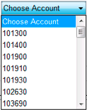
*Note: If an Account number does not appear in the drop-down list, select OTHER ACCOUNT and manually enter in the account number as shown below:

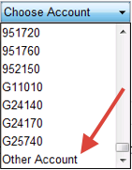
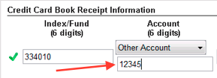
  - Enter a Description; this description can be up to thirty-five (35) characters and will be use in Banner when the journal voucher (JV) is posted.
  - Enter either a Debit or Credit amount, but not both.
- Enter any additional information in the Explanation section. Entry is required.
- You can attach any supporting documentation such as reports or emails to the form by clicking the Attachments button.

*Note: NEW! Only attach PDF formatted files. Use Adobe Acrobat X Pro to open/save the Bank Reports, see Printing Bank Reports section of this document. Contact the IT Service Desk for installation and details.

- Click the Submit Credit Card Book Receipt button to submit the ImageNow CCBR Form; a confirmation screen will be displayed as shown below:

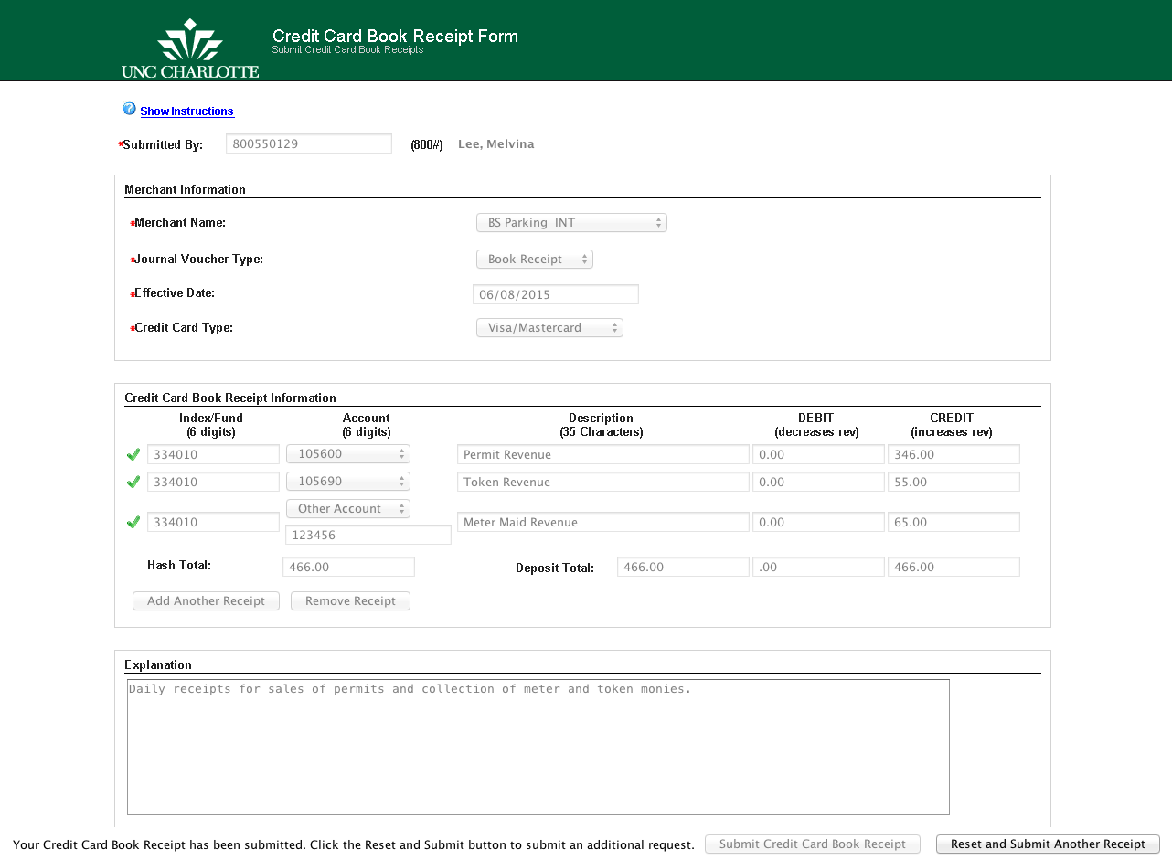

- Click the Reset and Submit Another Receipt button to create another credit card book receipt form.
- To exit the form, close the browser or tab.

- The following Email notifications will be sent to the Submitted By user.

  - Confirmation Email informing the Initiator and Designated Merchant Contacts the form submission has been received. This email will detail all book receipt and department contact information, as shown below.

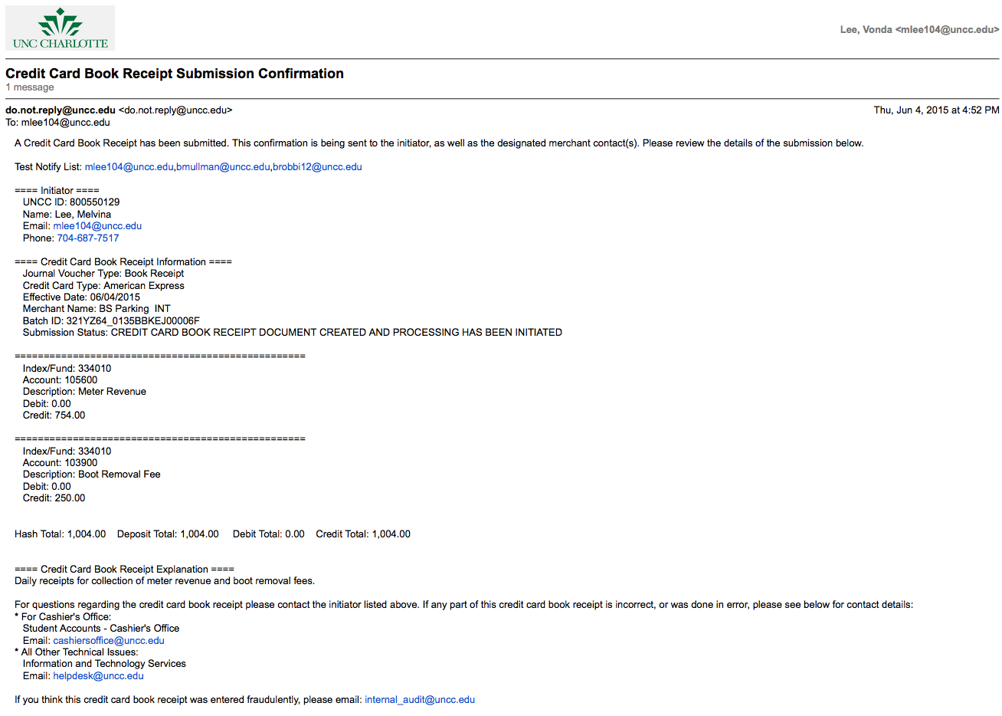
*Note: Make sure to review this email for errors and submission status.

  - Confirmation Email informing the Initiator the submitted book receipt has been APPROVED and processed, as shown below:

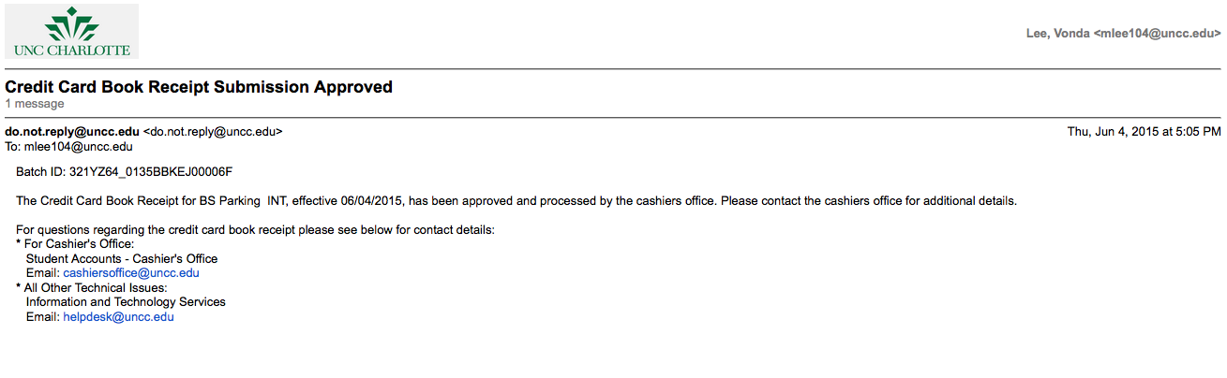

  - Confirmation Email informing the Initiator the submitted book receipt has been CANCELED, as shown below:

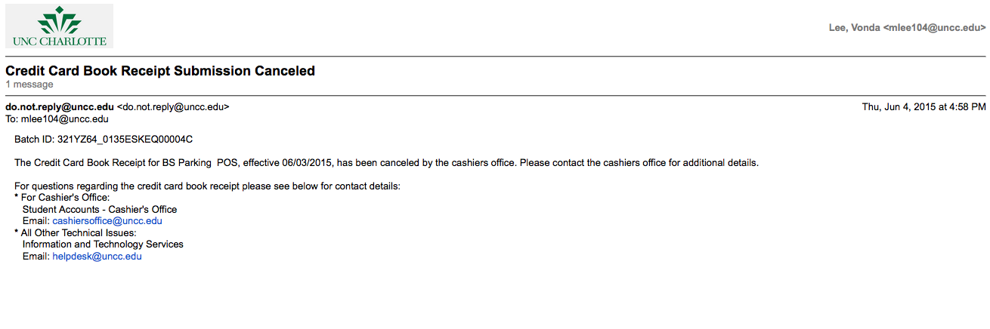

NEW! Printing Bank Reports– save reports to your desktop or selected folder to be used as an attachment for the CCBR submission.
- After querying the desired bank information to print, select the PRINT icon within the browser and the following Print windows will display:
  - For Windows:
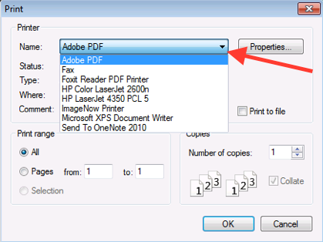
- Select the ADOBE PDF printer.
- Select the OK button.
- A Save PDF File As window will display; enter an appropriate name for your bank report.
- The bank report will open in Adobe Acrobat X Pro.

  - For MAC:
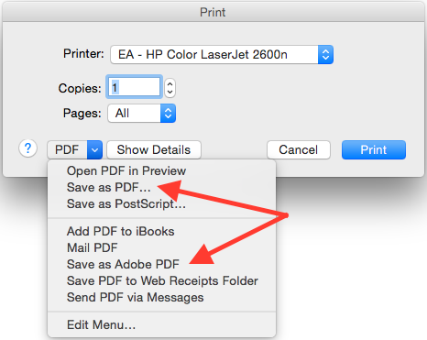
- Select the Save as PDF in the PDF drop-down list.
  - A Print window will display; enter an appropriate name for your bank report and select where to save.
  - Select the SAVE button.
  - Double-click the saved bank report in the Explorer window to open.
- Or select the Save as Adobe PDF in the PDF drop-down list.
  - A Save as Adobe PDF window will display; for the After PDF Creation parameter, select Adobe Acrobat Pro.
  - Select the Continue button.
  - A Save window will display; enter an appropriate name for your bank report and select where to save.
  - The bank report will open up in Adobe Acrobat X Pro.

Cancelations– canceling a Credit Card Book Receipt Form in process

For a CCBR form submission that is NOT fully processed (the Initiator has not received an email notification stating that the book receipt has been approved and processed), please forward the original email submission confirmation to the Cashiers Office below requesting the book receipt be canceled.

For a CCBR form submission that IS fully processed (the Initiator has received an email notification stating that the book receipt has been approved and processed), please forward the original email submission confirmation to the Cashiers Office below requesting the journal voucher (JV) be reversed.

- For Cashiers Office:
Cashiers Office SAO
Email: cashiersoffice@uncc.edu

Please attach any supplemental documentation to ensure cancellation of the correct book receipt.

Revisions– revising a Credit Card Book Receipt Form in process

If you need to revise a CCBR form submission that is NOT fully processed (the Initiator has not received an email notification stating the book receipt has been approved and processed), contact the Cashiers Office.

*Note: Only the information depicted below can be revised. Additional receipts cannot be added nor can entire lines be deleted.

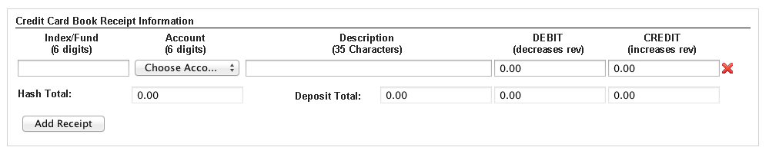

Please forward the original email submission confirmation to the Cashiers Office below requesting the book receipt be revised.

For a CCBR form submission that IS fully processed (the Initiator has received an email notification stating that the book receipt has been approved and processed), please forward the original email submission confirmation to the Cashiers Office below requesting the journal voucher (JV) be reversed. Another CCBR should be submitted with the correct information and supporting documentation.

- For Cashiers Office:
Cashiers Office SAO
Email: cashiersoffice@uncc.edu

Please attach any supplemental documentation to ensure revision of the correct book receipt.

List of ImageNow Merchant Names:

Assigned Merchant Name | ImageNow Merchant Name - Drop Down List
49er Card INT | BS 49erCard INT
49er Card Pos | BS 49erCard POS
AA ASCareer INT | AA Career Center INT
AA CHHS INT | AA CHHS INT
AA Cntr City INT | AA Center City INT
AA CoAA INT | AA CoAA INT
AA IUG INT | AA GRAD CGL-TFA
AA MAS INT | AA MAS INT
AA OIP INT | AA OIP INT
AARegistrar INT | AA Registrar INT
Alumni Off Pos | ADV Alumni POS
Athletic 49 INT | ATH Ticket Sales INT
Athletic 49 POS | ATH Ticket Sales POS
Belk COB INT | AA Belk COB INT
Box Office INT | AA COAA-Box Office
BS Mail SU POS | BS Mail POS
Cashiers INT | FS Cashiers INT
Cashiers POS | FS Cashiers POS
CLAS Gardns INT | AA CLAS-Gardens INT
CLAS Gardns POS | AA CLAS-Gardens POS
Clg of CI INT | AA CCI INT
Clg of CI POS | AA CCI POS
CoEd OEO INT | AA CoED-OEO INT
CoED STEM INT | AA CoEd-STEM INT
CoER ENGR INT | AA CoER-INT
CoER EPIC INT | AA CoER-EPIC INT
Cont Ed Off INT | AA ExAP INT
CRI INT | AA RED INT
Dean of Stu INT | SA DSO INT
Dev Ath Fd INT | ADV Ath Fd INT
Dev Fd INT | ADV Fd INT
Dining Serv Pos | BS Dining POS
ELTI INT | AA OIP ELTI INT
Foundation POS | ADV Fd POS
GenMark1 INT | FS GenMark 1 INT
GenMark2 INT | FS GenMark 2 INT
Grad Admin INT | AA GRAD INT
Housing INT | SA HRL INT
HousingConf INT | SA HRL Conference INT
Library POS | AA Library POS
MSWomensSum INT | AA WGRA INT
OEA INT | AA OIP-OEA

Parking INT | BS Parking INT
Parking POS | BS Parking POS
ParkingDec POS | BS Parking Decks POS
Registrar POS | AA Registrar POS
SA AppleSto POS | SA Niner Tech POS
SA CnslCntr INT | SA Counseling Center INT
SA RecSvcs INT | SA Rec Services INT
SA StuHlth INT | SA Student Health INT
SA SUAR INT | SA SUAR INT
SA Venture INT | SA Venture INT
Stu Accts INT | FS StuAccts INT
Stu Health POS | SA Student Health POS
Und Grad Ad INT | AA ADMIN-CFNC INT
UnderGrad AP INT | AA ADMIN-AP INT
UnivTimes INT | SA Student Media INT

Appendix

- Browser Bookmark URL – http://imagenow.uncc.edu/imagenowforms/fs?form=CCBR_Form
- Contact IT Service Desk for any technical issues with the online form, Java, or browser:
  - Call 704-687-5500 (7-5500)
  - HelpDesk Online
  - Email help@uncc.edu

