SA Credit Card Book Receipt (CCBR)

Workflow Process Manual

Written By: Vonda Lee
June 4, 2015

Table of Contents
Notification of New CCBR in the Folder Processing workflow queue: 3
Processing in the Merchant Folder Processing workflow queue: 7
Canceling CCBRs in the CCBR Processing workflow queue: 11
Drag and Drop Feature 13
Drop as a New Page 13
Drop as a New Document within a Folder 14
Searching for Documents: 16

Notification of New CCBR in the Folder Processing workflow queue:

- Cashiers will receive an email notification stating a new CCBR is in the workflow queue for processing, as shown below:

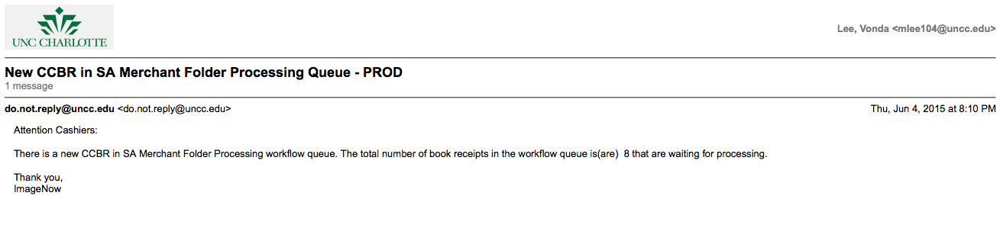

- Login to ImageNow or WebNow using your NinerNet credentials and click the CONNECT button as shown below:
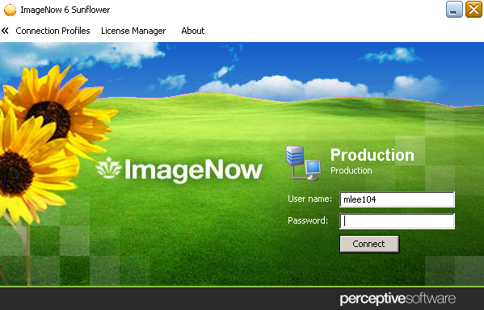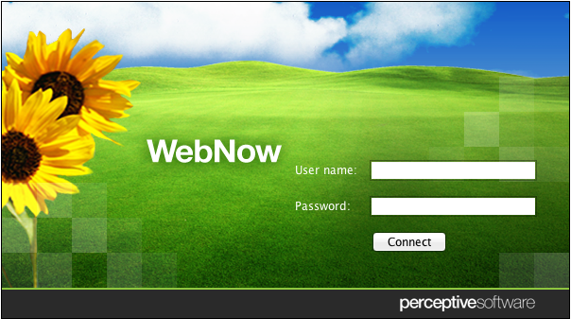

- Proceed to the workflow queue identified in the email notification, as shown below:
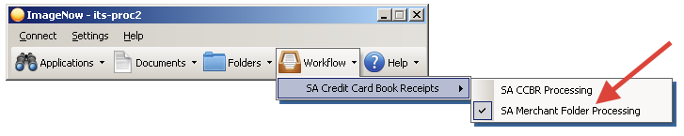
- An ImageNow Explorer window will display a list of book receipt folders to be processed by the Cashiers, as shown below:
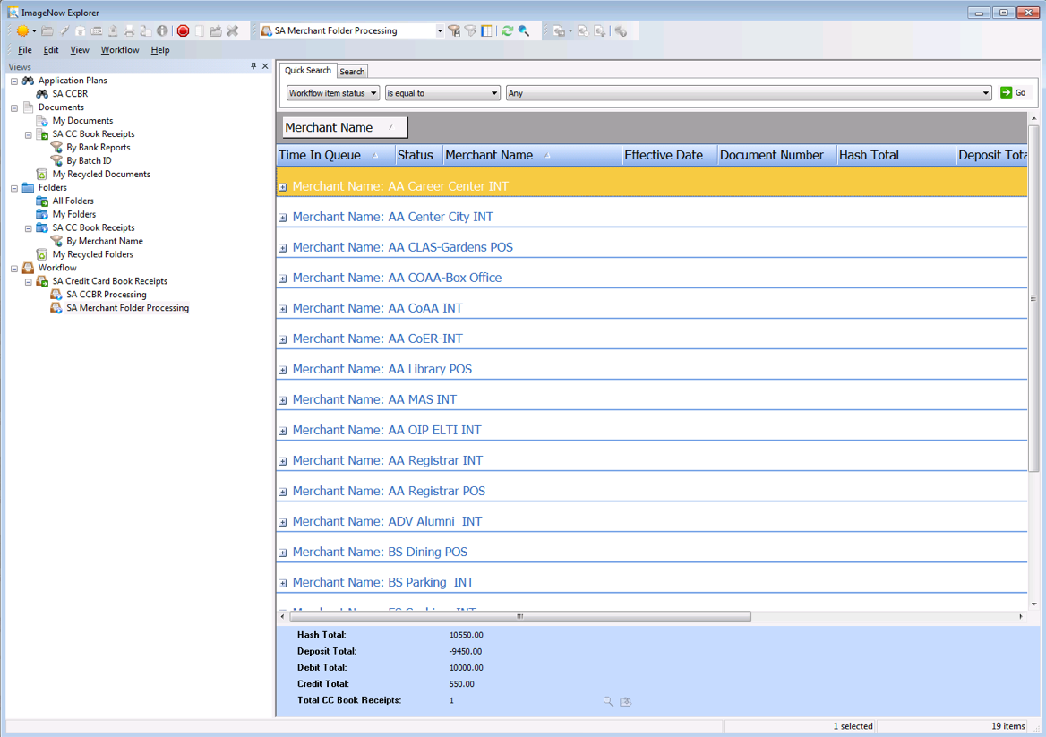
*Note: The folder list is grouped and sorted by Merchant Name and Time In Queue.

- The book receipt folders in the list are ready for approval and processing.

- There will also be email notifications in the departmental email inbox regarding book receipt form revisions and cancelations. It is very important to check that email account on an hourly basis, or even more frequently. The email account is:
For Cashiers Office:
Cashiers Office SAO
Email: cashiersoffice@uncc.edu

Processing in the Merchant Folder Processing workflow queue:
- A cashier will select and expand a folder grouping as shown below:
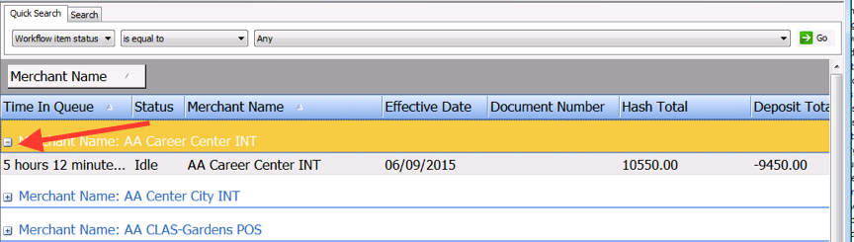
- Next, double-click on a folder to open and a list of CCBRs will display for that Merchant and report date, as shown below:
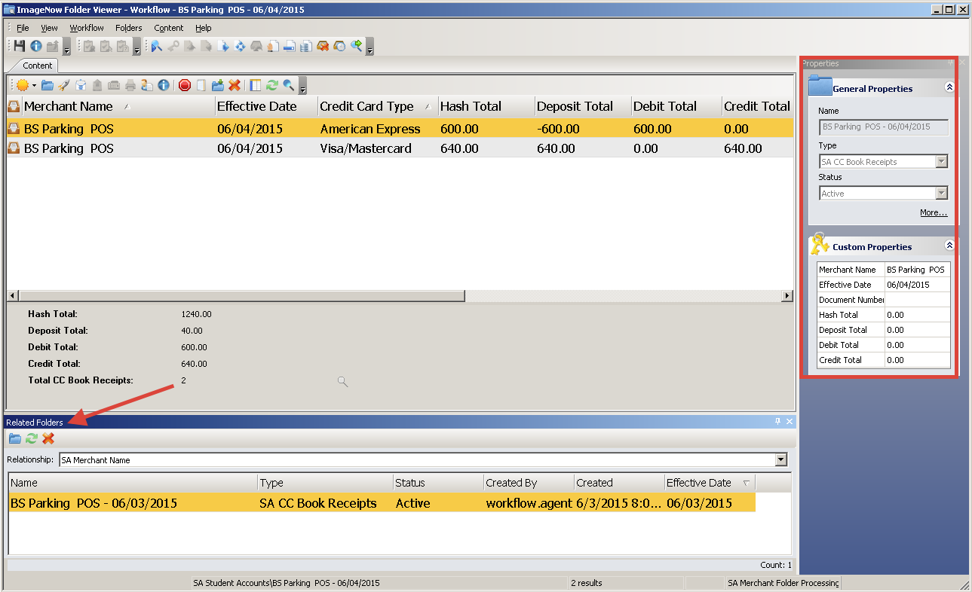
- Ensure that the PROPERTIES and RELATED FOLDERS views are evoked, as shown above.

*Note: Related Folders will display a list of all CCBRs previously submitted for that Merchant.

- Select a CCBR and double-click to open. The CCBR form will display as shown below:
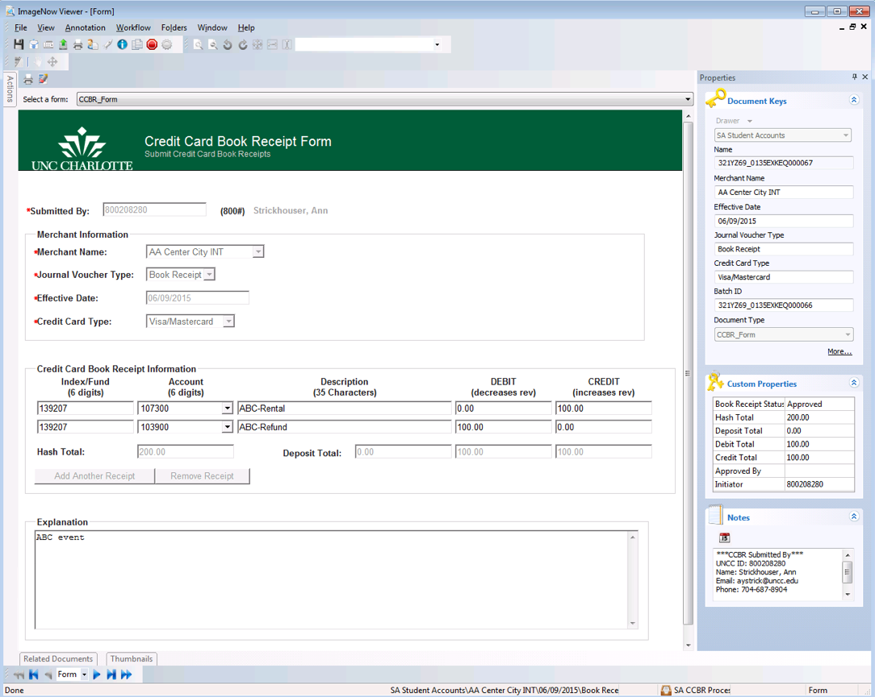
- Review the following to reconcile:
  - Document keys
  - Custom properties
  - Any attachments, etc. OSM/ClientLine/TouchNet reports
  - Any information in the Explanation field
- If any changes are required in the Credit Card Book Receipt Information section of the form, make the changes within the form; the custom properties fields will automatically update when the document is saved.

*Note: You will manually have to change the folder custom properties TOTALS to reflect the document change.)

- Attach any additional supplemental documentation you received regarding this CCBR, if applicable, by using the drag-drop feature.
- Go to the Banner form, FGAJVCQ, to create a journal voucher (JV) for all the CCBR(s) for this Merchant. Refer to your JV posting instructions.

*Note: Use the copy/paste function for the Index/Fund, Account, and Descriptions to transfer the information from ImageNow to Banner. Remain on this Banner form until all CCBR(s) have been processed.
- Once all departmental due diligence is completed, the Cashier will change the following custom property:
- Approved By – enter your NinerNet credentials.
- Click the save icon and exit the document by clicking the button.
- Repeat steps 4 thru 10 for the remaining CCBR(s) for that Merchant and report date.
- Once all CCBR(s) are processed for that Merchant, enter the JV Document Number in the folder custom properties field.
- If changes occurred within the CCBR form, you will manually have to change the folder custom property TOTALS (ex. Hash, Deposit, Debit, and Credit) to reflect the document changes, if applicable.
- Next, click the save icon to save all folder changes.
- Route the folder to Archive by selecting the Route Forward icon.
- The Merchant folder will be routed to archive and the Initiator will receive an email notification.
- If the Merchant folder re-appears in the workflow queue, an error has occurred and the folder will be highlighted blue as show below:
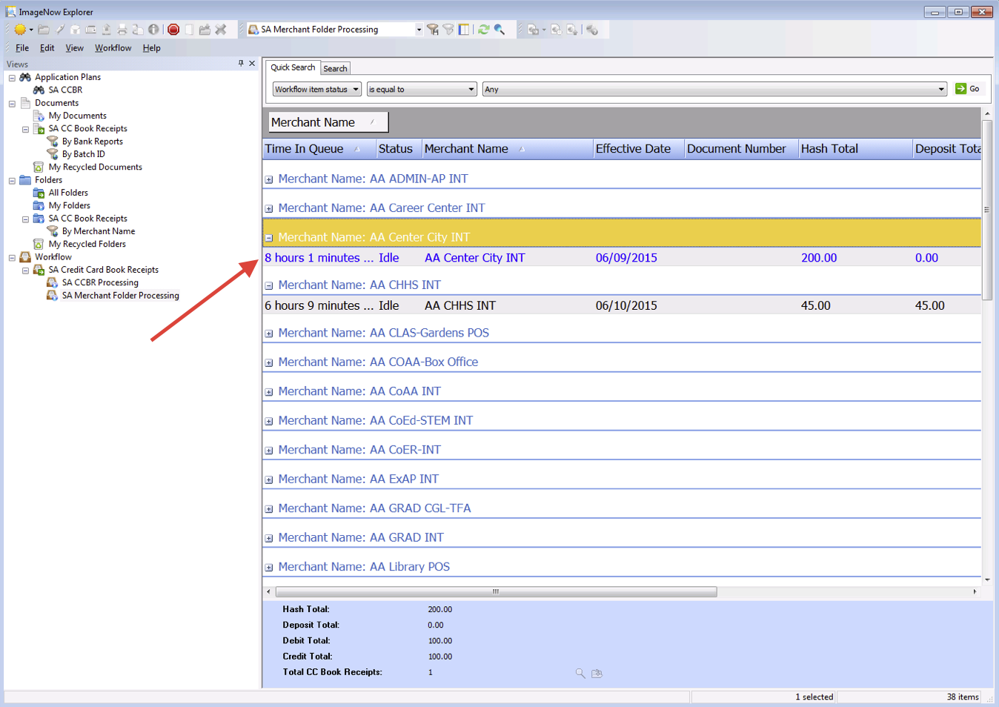
- Select that folder in the list and select the Properties icon to view the error as show below:
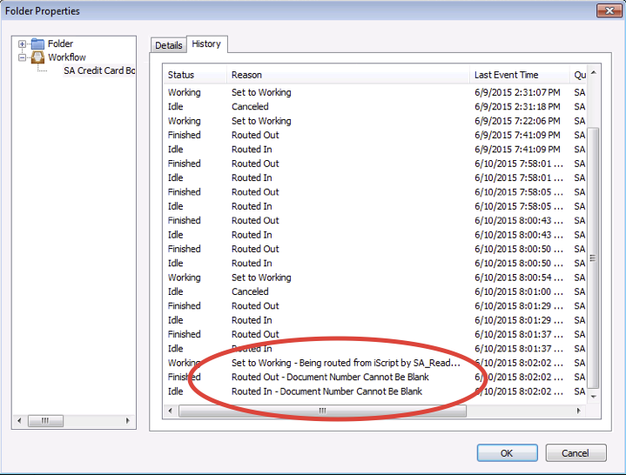
- Select the OK button to exit the Folder Properties window.

Canceling CCBRs in the CCBR Processing workflow queue:

- A Cashier has the ability to cancel any CCBR in the SA CCBR PROCESSING workflow queue. In the ImageNow Explorer view, the documents are grouped by Credit Card Type and Merchant Name as shown below:

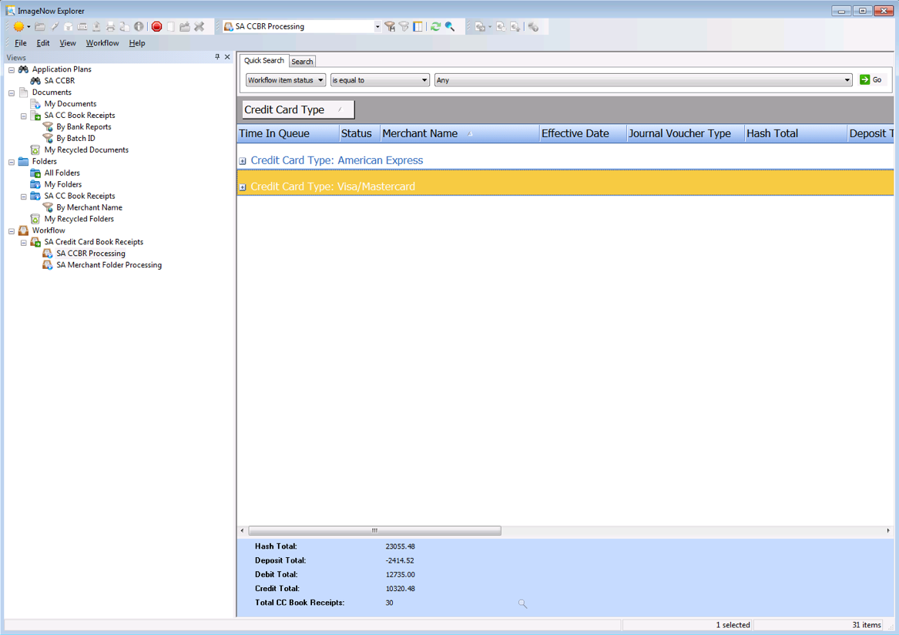
- Expand the desired Credit Card Type by clicking the “+” sign to display all documents within that particular credit card type.
- Open the selected document and attach any supplemental documentation to support the canceling of the document. The drag-drop feature can be used to attach documents.
- Once all departmental due diligence is completed, the Cashier will change the following custom properties:
  - Book Receipt Status to Canceled due to the CCBR was submitted in error.
  - Approved By - enter your NinerNet credentials.
- Route the document forward by clicking the ROUTE FORWARD link or icon.
- The document will be routed to Archive. The Initiator will receive an email notification that the document has been canceled.
- All remaining CCBR documents that are not canceled will be archived in 72 hours and will be removed from this workflow queue.

*Note: If the canceled CCBR is the only document in the Merchant folder, then the Merchant folder can be deleted. Go the workflow queue, SA Merchant Folder Processing, and locate/select the Merchant folder. Then, delete the folder by selecting the Delete icon. The following Delete Items window will be displayed, as shown below:

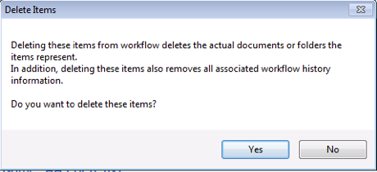
Select the YES button to delete the folder, else the NO button to cancel the action.

Drag and Drop Feature

Using the Drag and Drop feature, a user can select a document from the desktop and drop the document into a particular ImageNow workflow queue or document.

Drop as a New Page

- Open a document by double-clicking the document item in the ImageNow Explorer window grid.
- Ensure the THUMBNAILS view is evoked.
- Drag and drop a document from your desktop or selected drive into the whitespace in the THUMBNAILS view as show below:
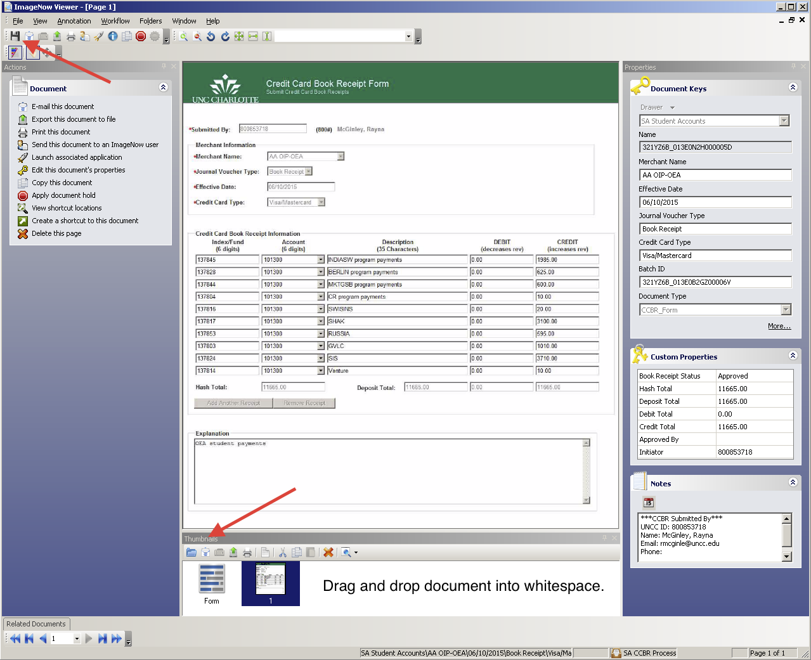
- Click the Save icon to save the added document as a new page.

Drop as a New Document within a Folder

- In the ImageNow Folder Viewer window, drag and drop a document from your desktop, or selected drive, into the whitespace in the grid as show below:
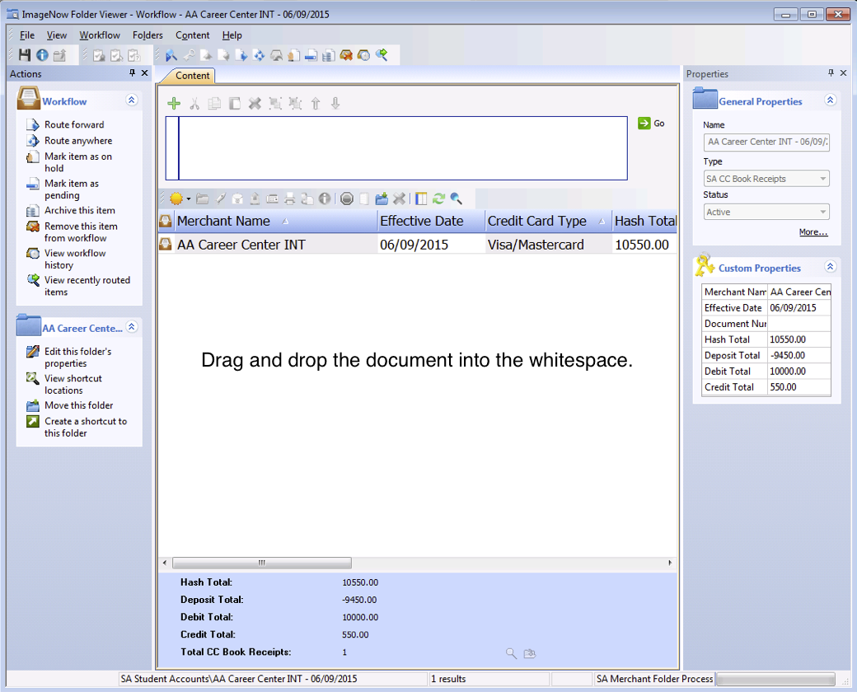

- A New Document window will display, as shown below:
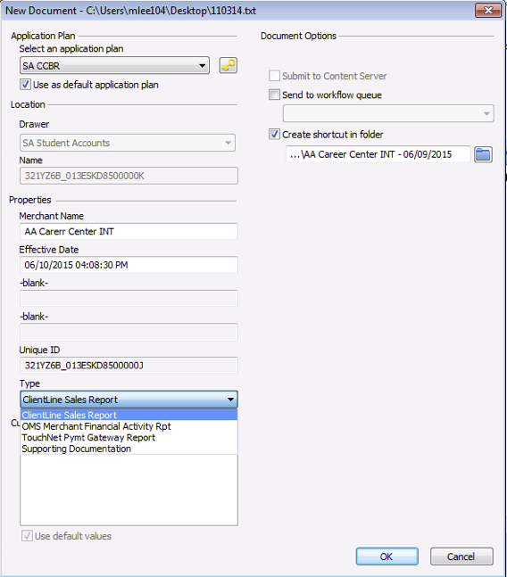
- Select the application plan, SA CCBR.
- Enter the Merchant Name.
- Select the document Type.
- Select the OK button to add the document to the Merchant folder. The document will open automatically.
- Exit the document by selecting the button.
- Refresh the folder viewer by selecting the Refresh icon and the document will display in the list.

Searching for Documents:

- Search for documents in the document view called SA CC Book Receipts. There are three (3) document view filters to assist in the search:
  - By Bank Reports
  - By Batch ID
  - By Report Date
- Click a document view filter.
- Enter in the appropriate criteria for the document view filter selected, and click the OK button.
- The ImageNow Explorer view will display a list of CCBR documents that meet the selection criteria.
- For example, the document view filter By Batch ID is selected. The ImageNow Explorer window will display the CCBR document for that Batch ID, as shown below:

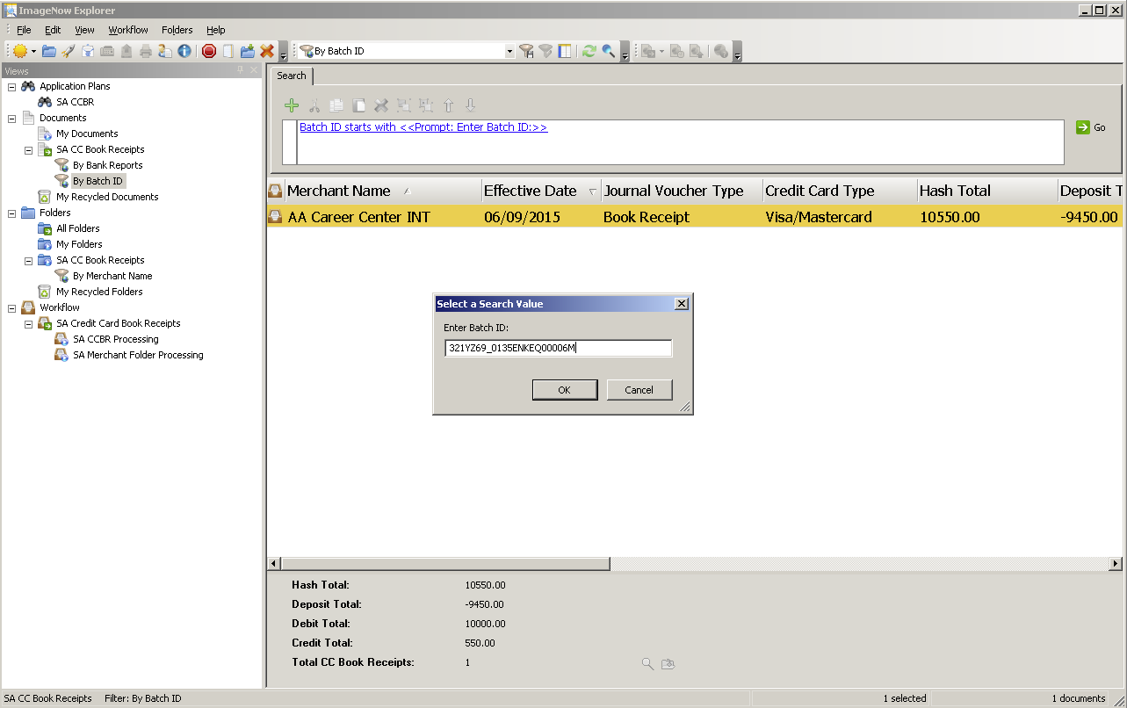

- You can search for documents using the Quick Search feature, as shown below:

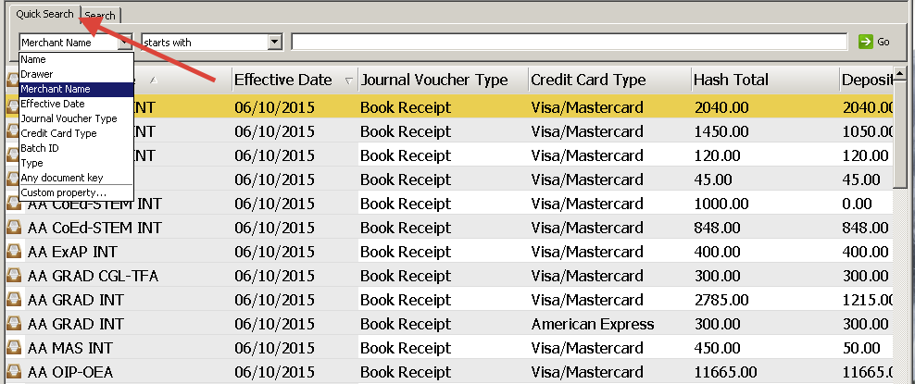
- Select and enter in the search criteria. Click the GO button to run the query. An ImageNow Explorer view will display a list of documents that meet the criterion.

