- SEA Org Level Approval for a Student Educational Awards:

Student Educational Awards (SEA) are now being processed via ImageNow with departmental approval. There are two (2) ways a SEA form can be processed:

- Approved
- Denied

- The Org Approver will receive an email that a new Student Educational Award is the workflow queue, as shown below:

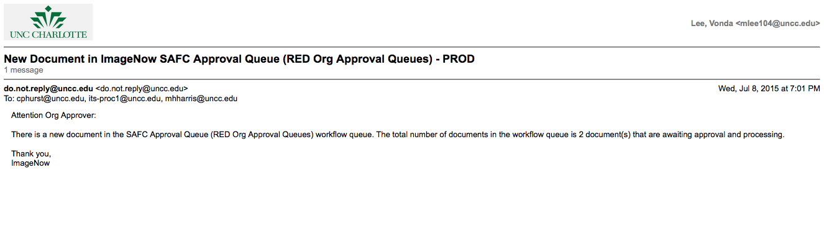
- Open a browser and type the WebNow URL below in the address bar:
https://imagenow.uncc.edu.

- A WebNow login screen will display, as shown below:
- Login to WebNow using your NinerNet credentials.
- Proceed to the workflow queue named in the email you received, as shown below:
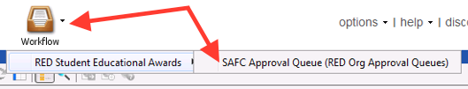

- The following WebNow viewer will display the SEA documents:
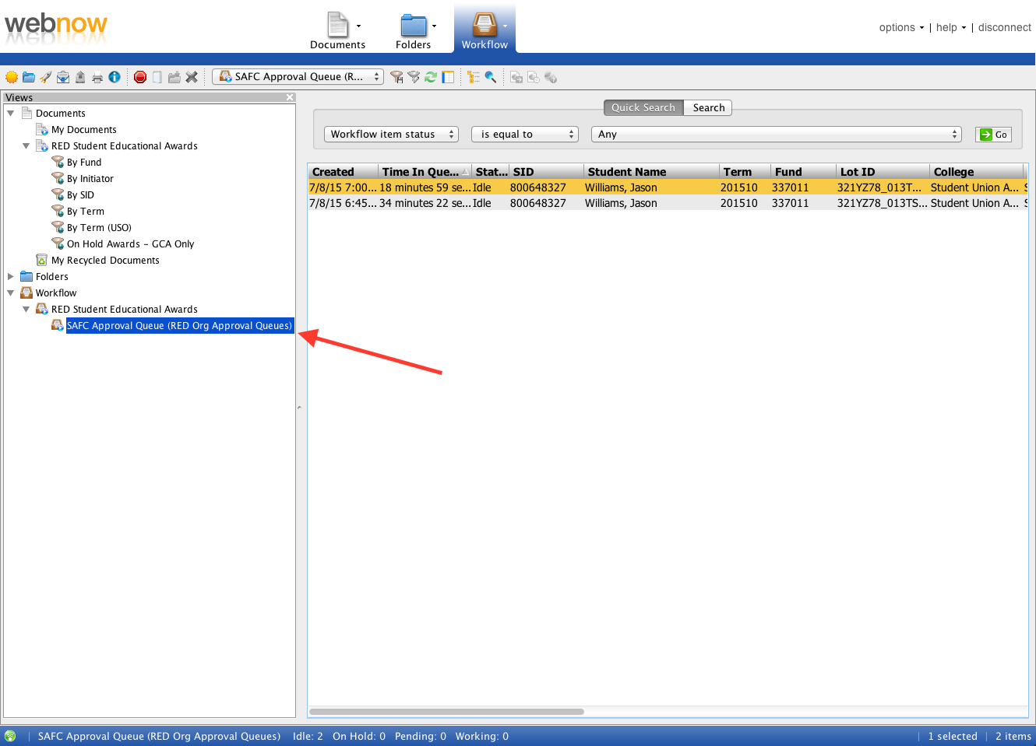
  - Open the desired document in the list by double-clicking the item.
  - The Org Approver will perform the departmental due diligence.
- In the Custom Properties section, select the appropriate Student Award Status – valid values:
  - Approved
  - Denied
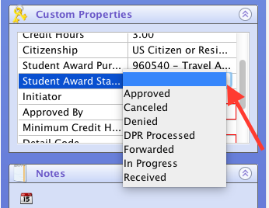

- In the Custom Properties section, enter your NinerNet credentials in the Approved by field.
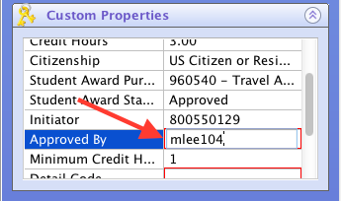
  - In the NOTES field, the Initiator contact information is displayed if any correspondence is needed and additional notes can be entered.
  - Route the document forward using the ROUTE FORWARD icon or the ROUTE FORWARD link, as shown below:
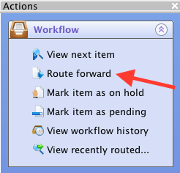
  - An email notification will be sent to the Initiator stating if the SEA was denied, else the SEA document will be forwarded for further processing.

