- TCP DPR for a Student Educational Award:

Student Educational Awards (SEA) are now being processed via ImageNow. There are three (3) ways a SEA form can be processed as a DPR:

- If an award is entered for a student who has less than 3 credit hours for a particular term.
- If an award is entered for a Non US Citizen or Resident Alien.
- Or, if a Travel Award is entered for a registered student.

*Note: The grant or state funded student awards will be approved first by either the Budget or Grants & Contracts Offices before being converted to a DPR and routed to TCP. All other source-funded awards will be converted to a DPR and routed directly to TCP without any approvals.

- Below is a copy of the NEW Student Award and Student Educational Award DPR:

Document Type – Student Award:
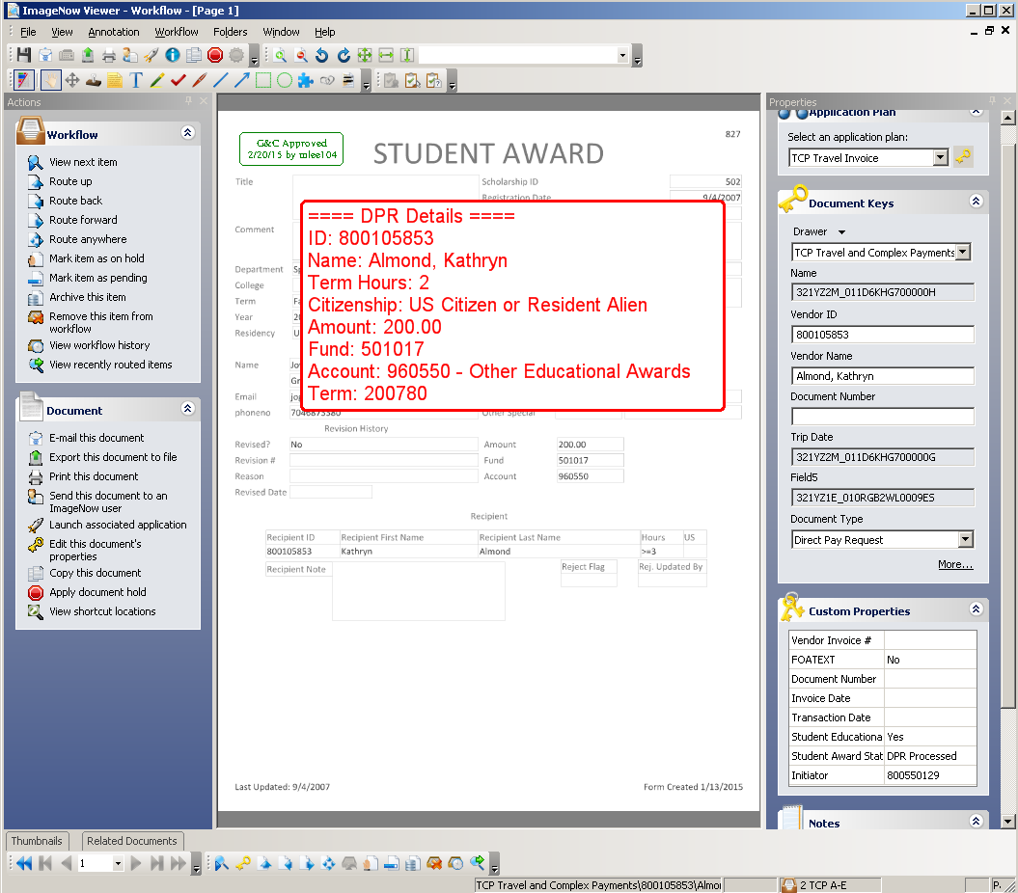
*Note: There is a DPR Details stamp with all the student award information needed for the Data Entry Processor to key in Banner. The approval stamps from the Budget and Grants & Contracts Offices will also be displayed.

Document Type - Student_Educational_Award_Form:
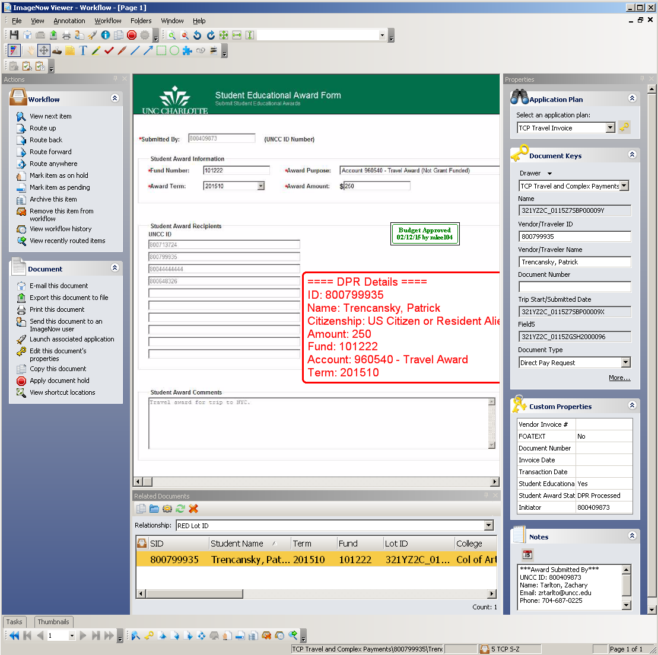
*Note: There is a DPR Details stamp with all the student award information needed for the Data Entry Processor to key in Banner. The approval stamps from the Budget and Grants & Contracts Offices will also be displayed.

  - There are three (3) new custom properties added to the DPR:
- Student Educational Ward - value is:
  - YES for SEA DPRs
  - NO for non-SEA DPRs
- Student Award Status – valid values:
  - DPR Processed
  - Denied
  - Canceled
- Initiator – valid values are 800#s

  - In the NOTES field, the Initiator contact information is displayed if any correspondence is needed.
  - The TCP Invoice Processor or TCP Tax Approver will perform the departmental due diligence.
  - Otherwise, if the TCP Invoice Processor or TCP Tax Approver needs to deny the award, change the Student Award Status to DENIED. Attach any supplemental documentation to the DPR supporting the denied decision.
  - Then, route the document to archive, as shown below:

For TCP Processors:
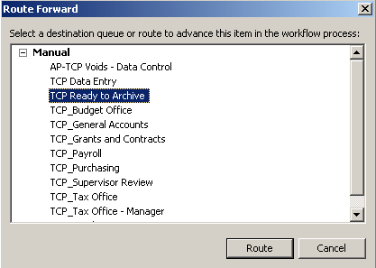

For TCP Tax Approvers:
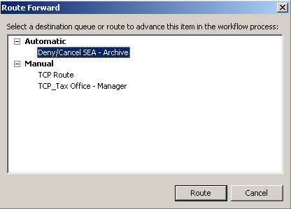
(*Note: If denying the student ward, route to DENY/CANCEL SEA – ARCHIVE workflow queue, else route to TCP ROUTE workflow queue for additional processing.)

  - An email notification will be sent to the Initiator stating that the DPR was approved and processed or denied.
  - If the TCP Invoice Processor needs to route the DPR back to the approving department for additional processing, then route to TCP_Budget Office or TCP_Grants and Contracts workflow queues.

Processing Documents in the On Hold workflow queue:

If a student has 0 credit hours entered for an award term, the document will be displayed in the RED On Hold workflow queue. These documents will reside in the queue until the student registers for classes or meets the restricted credit hours for that grant, state, or other source fund requirements. Once a student has registered or met the requirements, then the document will be automatically routed to the respective processing workflow queues.

- A Budget, Grants & Contracts, Financial Aid, or Travel Specialist has the ability to cancel any awards in the RED On Hold workflow queue. In the ImageNow Explorer view, the documents are grouped by FUND as shown below:

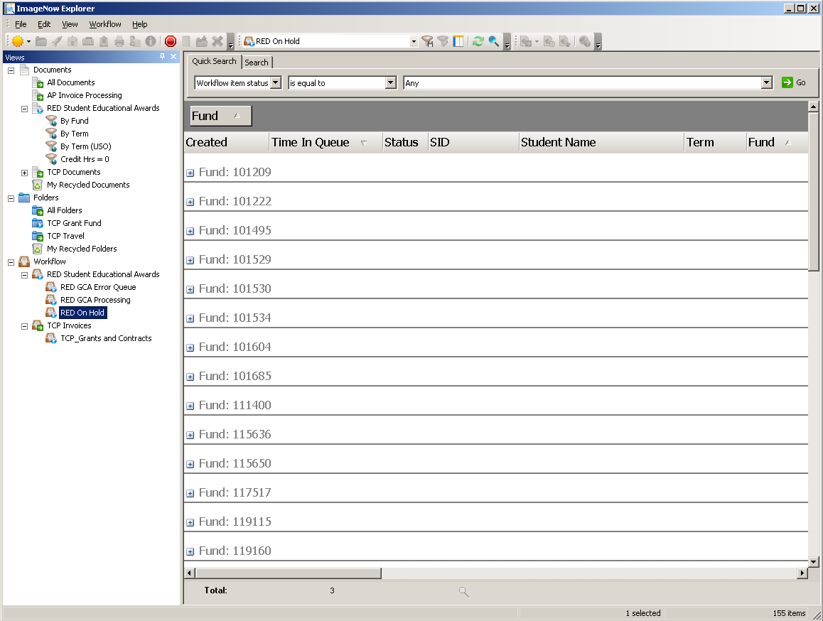

- Expand the desired FUND by clicking the “+” sign to display all the documents within that particular fund.
- Open the selected document and attach any supplemental documentation to support the cancelling of the document. The drag-drop feature can be used to accomplish this.
- Once all departmental due diligence is completed, the Specialist will change the following custom properties:
- Student Award Status to Canceled due to the award was submitted in error.
- Approved By – enter TCP Processor’s NinerNet credentials that approved the cancellation of award.
- Route the document forward by clicking the ROUTE FORWARD link or icon. The window below is displayed:

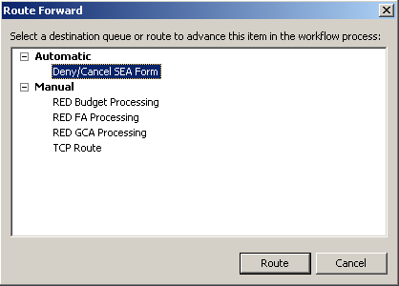
- Select Deny/Cancel SEA Form workflow queue. The document will be routed to archive. The SEA Initiator will receive an email notification that the document has been canceled.

- New! Cancelations – cancelling a Student Educational Award Form in process

For a SEA form submission that is NOT fully processed, thus the Initiator has not received an email notification stating that the award has been completed, the Initiator will forward the original email submission confirmation to the respective fund approvers below requesting the award to be canceled:

- For Travel Awards:
Travel and Complex Payments
Email: travel@uncc.edu
- For Grant Funded Awards:
Office of Grants and Contracts Administration
Email: grants-contracts@uncc.edu
- For State Funded Awards:
Budget Office
Email: budget-genfund@uncc.edu
- All Other Funding Sources:
Please wait for the award to process and then submit a revised award for the student.
The Initiator may attach any supplemental documentation containing details of the award to ensure cancellation of the correct award.

- New! Revisions – Submitting a revised Student Educational Award Form that is fully processed

For a SEA form submission that has been processed, thus the Initiator has received an email notification stating that the award has been approved and processed, the Initiator will submit a revised award that reduces the award value for a particular student.

To reduce an award, the Initiator will submit a new award with a negative dollar value reflecting the value to reduce the initial award. If the Initiator is reducing an award, they will include detailed information in the Comments section of the form to reflect the Lot ID of the original award and reason for change. Also the Initiator may attach any supplemental documentation, if necessary.

For example:
 | Award Amount | Form Comments
Original Student Educational Award | 2500.00
Revised Student Educational Award | -1000.00 | Enter the Lot ID of initial award and reason for change.
Corrected Student Educational Award after initiating the revised award. | 1500.00

To increase the value of a Student Educational Award, the Initiator will submit another award with the increased value and purpose.

