File Upload via Citrix:

Instead of dragging and dropping a document, you can add a document to an existing folder using a file upload capture profile called, UHP Upload File To Folder.

- Open the desired Student folder.
- Evoke the CAPTURE command by clicking VIEW>TOOLBARS>CUSTOMIZE.
- A CUSTOMIZE window will display as shown below:
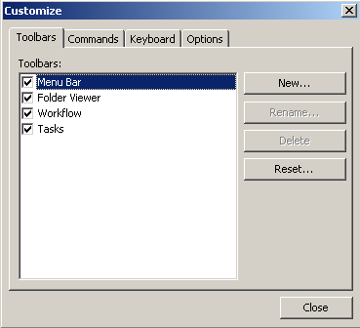

- Select the COMMANDS tab.
- Under the FOLDER VIEWER category, drag the CAPTURE command out of the dialog box to the Folder Viewer toolbar, as shown below:
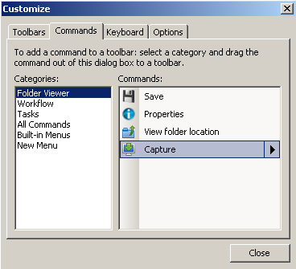

- Once you drag the command to the Folder Viewer toolbar, click the CLOSE button.
- Your FOLDER VIEWER will display as shown below:
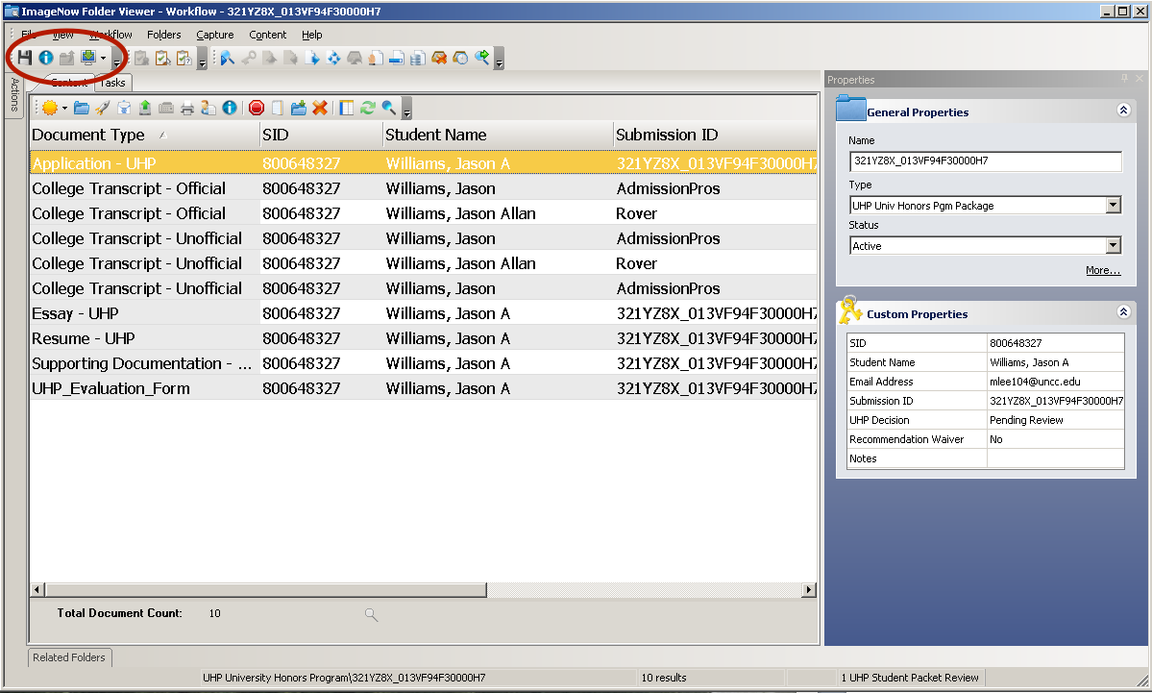
- Click the Capture icon drop-down menu and select, UHP Upload File To Folder, the capture profile, as shown below:
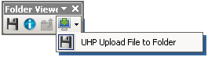

- A PROPOSED KEYS window will appear; enter in the Submission ID and select the appropriate Document Type, as shown below:
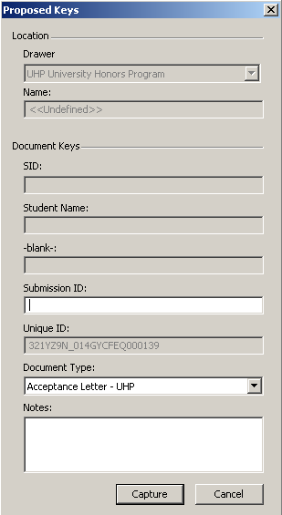
- Click the CAPTURE button to upload the document.
- Click the REFRESH button to see the added document in the list of student folder documents.
- Proceed to the UHP_Evaluation_Form and open the document.
- Click the REFRESH button to index the newly added document and exit the document.
- Click the REFRESH button to see the newly indexed document in the list of student folder documents.

