FA Scanners Manual
(ImageNow Full-Client Only)

Written By: Vonda Lee
April 23, 2015

Table of Contents
Introduction 3
Scanning and Printing Documents 4
Capture Profiles 4
Accepting Certain Documents 4
FA Scan to WF – Single 5
FA Scan to WF - Batch 8
FA Print to WF 11
Processing Documents in the FAX and EMAIL Processing Workflow Queues 14
Drag and Drop Feature 17
Drop as a New Page 17
Drop as a New Document 18

Introduction

This document will assist you with scanning, linking, and processing a document in the main processing section of the FA Financial Aid workflow process. There are three (3) workflow queues:
- FA Email Processing
This workflow queue will include all documents that have been imported into ImageNow via email using the email address ImageNowFA@uncc.edu. A user will have to monitor this workflow for new documents to link and process.
- FA Fax Processing
This workflow queue will include all documents that have been imported into ImageNow via fax. A user will have to monitor this workflow for new documents to link and process.
- FA Processing Queue
This workflow queue will include all documents that have been imported into ImageNow via scanning.

In addition to processing and routing documents, you can import documents into ImageNow via printing using the DRAG and DROP feature. (*Note: There is a virtual printer called ImageNow Printer that can be selected when printing a document.)

Scanning and Printing Documents

Capture Profiles

There are two (2) capture profiles for scanning and one (1) printing profile:
- FA Scan to WF – Single
This capture scanning profile is used when scanning a single document without a PATCHCODE and requires the user to be logged into BANNER for a particular 800#.
- FA Scan to WF – Batch
This capture scanning profile is used when scanning documents with PATCHCODES and does not require the user to be logged into BANNER.
- FA Print to WF
This capture printing profile is used when printing a document and requires the user to be logged into BANNER for a particular 800#.

Accepting Certain Documents

- When receiving any of the following document types for students, go to BANNER's RRAAREQ form and mark the student’s record with the specific codes listed below, relative to the document received:

- Amended Taxes AMTAX
- Birth Certificate BCERT
- Consortium Agreement CONSAG
- Driver’s License DRIVE
- Marriage Certificate MCERT
- Medical Records – Parent MEDICP
- Medical Records – Student MEDICS
- NC Reach Application NREACH
- OSFA Scholarship Application OSFA
- Parent Statement STATMP
- Receipts RECEIP
- Student Statement STATMT
- Verification of Utilization of UCAE Services UCAE

- When receiving any of the following document types for students, DO NOT SCAN the document; hand the document directly to the Loan Processing Team for processing:

- Master Promissory Note
- Perkins Loan
- Jamieson Loan

FA Scan to WF – Single
This capture scanning profile is used when scanning a single document without a PATCHCODE. The user must be logged into one of the following BANNER forms using a particular student 800# and Aid Year, if applicable:

- RBAPBUD
- RHACOMM
- RNANA*
- ROARMAN
- ROASTAT
- RPAAWRD
- RRAAREQ
- SFAWDRL

- Login to one of the BANNER forms listed above for a particular student 800# and Aid Year, if applicable.
- Place document into the scanner.
- Click the CAPTURE drop-down menu and select FA SCAN TO WF – SINGLE option to scan the document, as shown below:
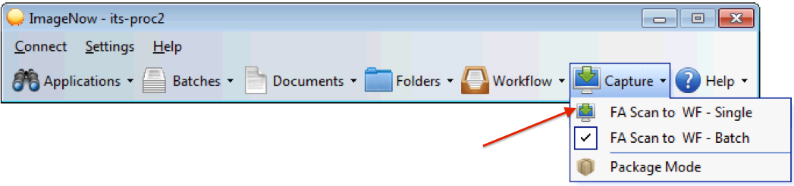

- A PROPOSED KEYS window will display, as shown below:
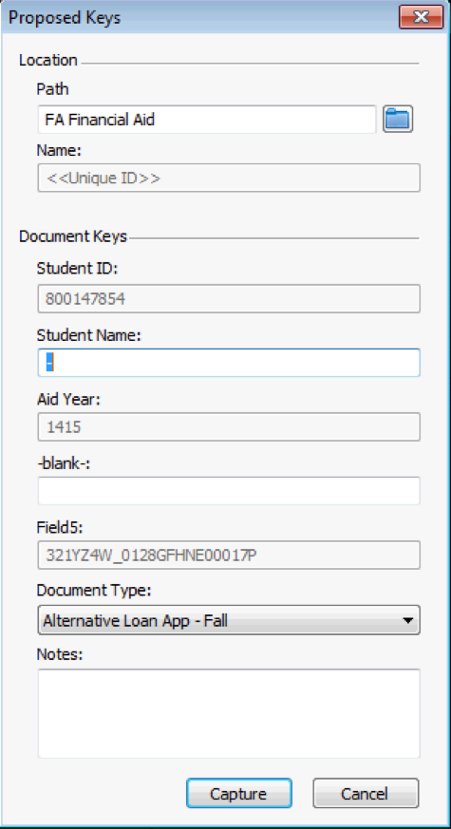
*Note: The Student Name will not be populated from Banner automatically; it will contain a “-“ in the STUDENT NAME box as shown above. The student’s name will be automatically populated before the document is routed to the departmental area workflow queues.
- Select the appropriate DOCUMENT TYPE in the drop-down list.
- Select the CAPTURE button.

- A CREATE SHORTCUT window will display, as shown below. The student’s folder is created from this screen. (*Note: If a student’s folder already exists this window will not be displayed.)
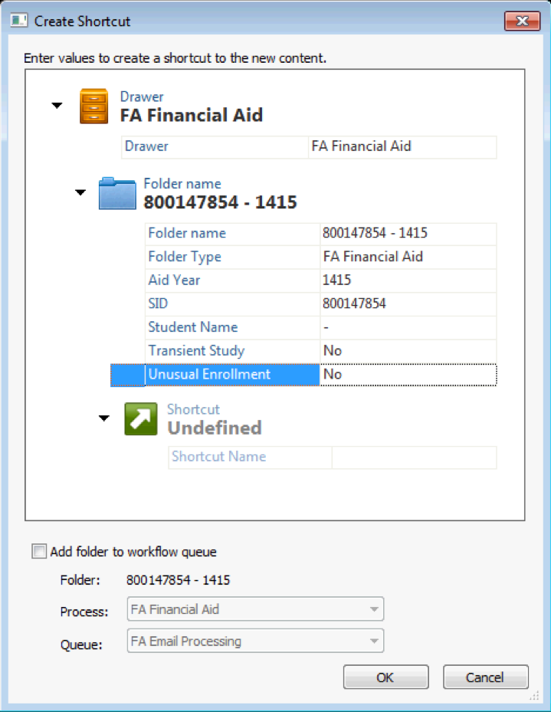
*Note: The Student Name will not be populated from Banner automatically; it will contain a “-“ in the STUDENT NAME box as shown above. The student’s name will be automatically populated before the document is routed to the departmental area workflow queues.

- Select the appropriate Transient Study (required) and Unusual Enrollment (required) values.
- Select the OK button and the document will be routed to the appropriate workflow queue for the document type you selected.

FA Scan to WF - Batch
This capture scanning profile is used when scanning documents with PATCHCODES and does not require the user to be logged into BANNER.

- Place document into Scanner.
- Click the CAPTURE drop-down menu and select FA SCAN TO WF – BATCH option to scan the document, as shown below:
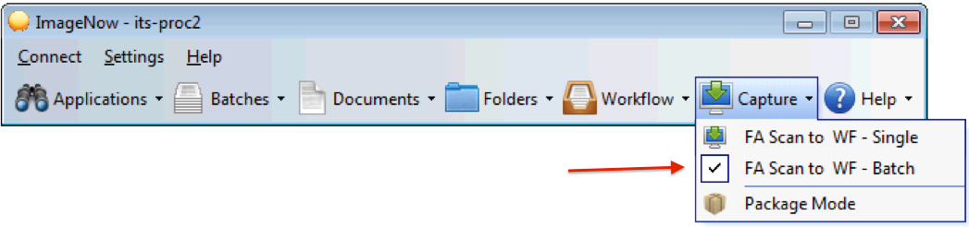
- Go to the FA Processing Queue workflow queue to view the document(s) just scanned.
- Open the first scanned document by double-clicking the desire document item in the ImageNow Explorer window grid.
- Login to BANNER and go to one of the following BANNER forms using a particular student 800# and Aid Year, if applicable:

- RBAPBUD
- RHACOMM
- RNANA*
- ROARMAN
- ROASTAT
- RPAAWRD
- RRAAREQ
- SFAWDRL

- Link the document to Banner by clicking the link icon; the document key fields will be populated with the Banner information.
- Select the appropriate DOCUMENT TYPE in the drop-down list.
- Click the ROUTE FORWARD link or icon.

- A CREATE SHORTCUT window will display as shown below. This window will create the student’s folder. (*Note: If the student’s folder already exists, this window will not be displayed.)
*Note: The Student Name will not be populated from Banner automatically; it will contain a “-“ in the STUDENT NAME box as shown above. The student’s name will be automatically populated before the document is routed to the departmental area workflow queues.

- Select the appropriate Transient Study (required) and Unusual Enrollment (required) values.
- Select the OK button.

- A ROUTE FORWARD window will display, as show below:
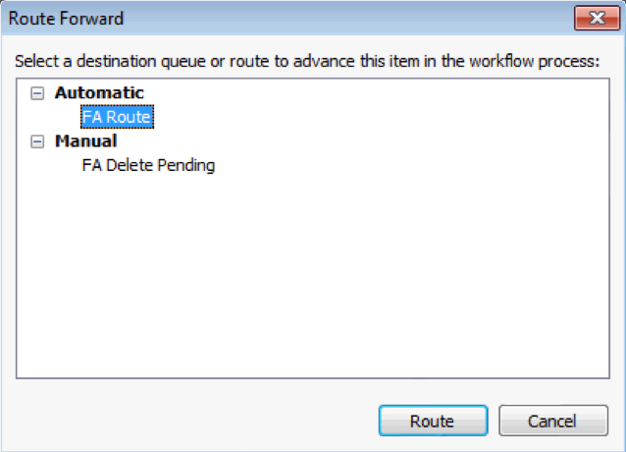
- Select the FA ROUTE workflow queue.
- Select the ROUTE button and the document will be routed to the appropriate workflow queue for the document type you selected.
- The next document in the grid will open in an ImageNow Viewer.
- Repeat steps 4 thru 14 for the remaining scanned documents.

FA Print to WF
This capture printing profile is used when printing a document. The user must be logged into BANNER and have a particular student 800# on screen.

- Open the document to be imported into ImageNow in an application like MS Word, Adobe PDF, etc.
- Select the PRINT button to print the document.
- Select the IMAGENOW PRINTER option.
- Select the PRINT button.
- An IMAGENOW PRINT window is displayed, as shown below:
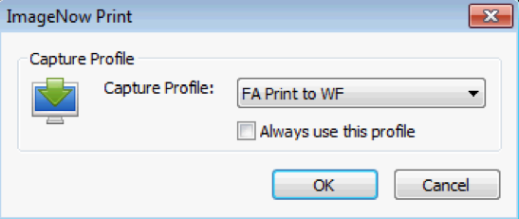
- Ensure the ALWAYS USE THIS PROFILE box is checked.
- Select the OK button.

- A PROPOSED KEYS window will display, as shown below:
*Note: The Student Name will not be populated from Banner automatically; it will contain a “-“ in the STUDENT NAME box as shown above. The student’s name will be automatically populated before the document is routed to the departmental area workflow queues.
- Select the appropriate DOCUMENT TYPE in the drop-down list.
- Select the CAPTURE button.

- A CREATE SHORTCUT window will display, as shown below. The student’s folder is created from this screen. (*Note: If a student’s folder already exists this window will not be displayed.)
*Note: The Student Name will not be populated from Banner automatically; it will contain a “-“ in the STUDENT NAME box as shown above. The student’s name will be automatically populated before the document is routed to the departmental area workflow queues.
- Select the appropriate Transient Study (required) and Unusual Enrollment (required) values.
- Select the OK button and the document will be routed to the appropriate workflow queue for the document type you selected.

Processing Documents in the FAX and EMAIL Processing Workflow Queues

- Go to either the FA Fax Processing or FA Email Processing workflow queue to view the document(s).
- Open the first document by double-clicking the document item in the ImageNow Explorer window grid.
- Identify the student ID and name and login to BANNER and go to one of the following BANNER forms using the student’s 800# and Aid Year, if applicable:

- RBAPBUD
- RHACOMM
- RNANA*
- ROARMAN
- ROASTAT
- RPAAWRD
- RRAAREQ
- SFAWDRL

- Link the document to Banner by clicking the link icon; the document key fields will be populated with the Banner information.
- Select the appropriate DOCUMENT TYPE in the drop-down list.
- Click the ROUTE FORWARD link or icon.

- A CREATE SHORTCUT window will display, as shown below. The student’s folder is created from this screen. (*Note: If a student’s folder already exists this window will not be displayed.)
*Note: The Student Name will not be populated from Banner automatically; it will contain a “-“ in the STUDENT NAME box as shown above. The student’s name will be automatically populated before the document is routed to the departmental area workflow queues.
- Select the appropriate Transient Study (required) and Unusual Enrollment (required) values.
- Select the OK button and the document will be routed to the appropriate workflow queue for the document type you selected.

- A ROUTE FORWARD window will display, as show below:
- Select the FA ROUTE workflow queue.
- Select the ROUTE button and the document will be routed to the appropriate workflow queue for the document type you selected.
- The next document in the grid will open in an ImageNow Viewer.
- Repeat steps 2 thru 12 for the remaining documents.

Drag and Drop Feature

Using the Drag and Drop feature, a user can select a document from the desktop and drop the document into a particular ImageNow workflow queue or document.

Drop as a New Page

- Open a document by double-clicking the document item in the ImageNow Explorer window grid.
- Ensure the THUMBNAILS view is evoked.
- Drag and drop a document from your desktop or selected drive into the whitespace in the THUMBNAILS view as show below:
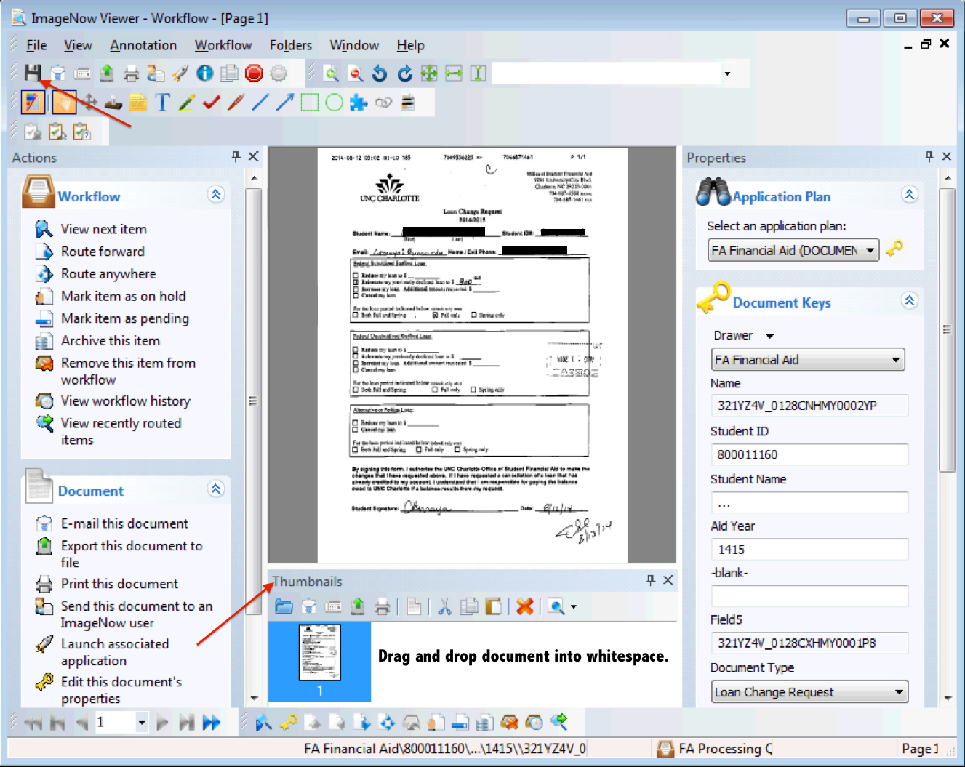
- Click the Save icon to save the added document as a new page.

Drop as a New Document

- In the ImageNow Explorer window, drag and drop a document from your desktop, or selected drive, into the whitespace in the grid as show below:
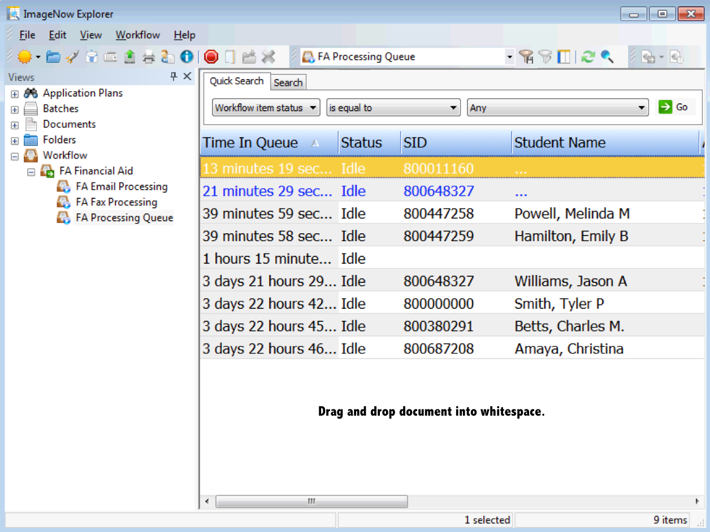

- A New Document window will display, as shown below:
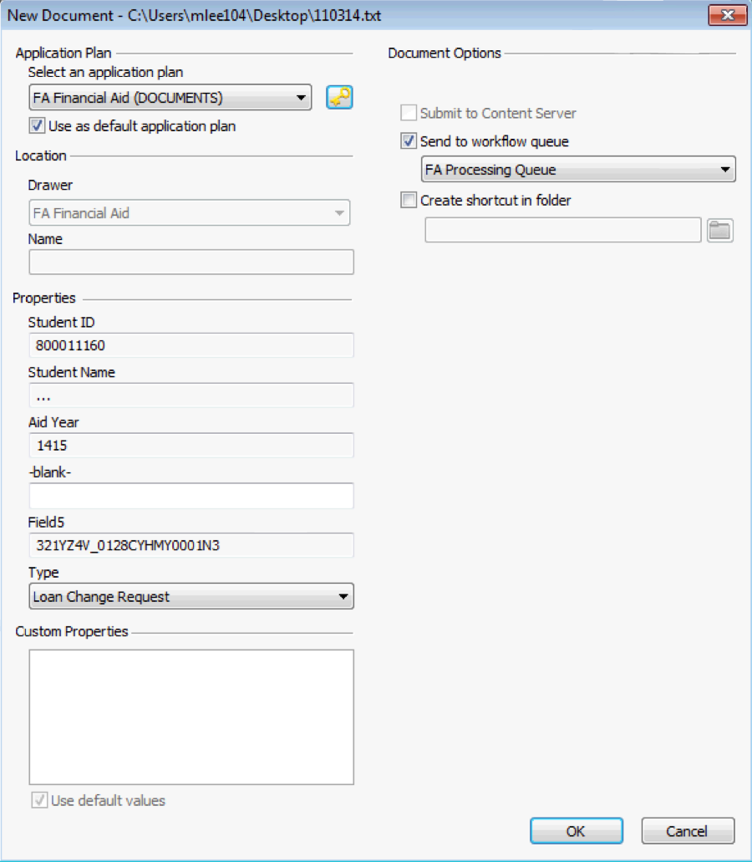
- Login to BANNER and go to one of the following BANNER forms using the student’s 800# and Aid Year, if applicable:

- RBAPBUD
- RHACOMM
- RNANA*
- ROARMAN
- ROASTAT
- RPAAWRD
- RRAAREQ
- SFAWDRL

- Link the document to Banner by clicking the link icon; the document key fields will be populated with the Banner information.
- Select the appropriate DOCUMENT TYPE in the drop-down list.
- Select the OK button.
- A CREATE SHORTCUT window will display, as shown below. This window will create the student’s folder. (*Note: If a student’s folder already exists, this window will not be displayed.)
*Note: The Student Name will not be populated from Banner automatically; it will contain a “-“ in the STUDENT NAME box as shown above. The student’s name will be automatically populated before the document is routed to the departmental area workflow queues.
- Select the appropriate Transient Study (required) and Unusual Enrollment (required) values.
- Select the OK button.
- Next, select the ROUTE FORWARD link or icon and the ROUTE FORWARD window will display, as show below:
- Select the FA ROUTE workflow queue.
- Select the ROUTE button and the document will be routed to the appropriate workflow queue for the document type you selected.

