FA Training Manual
(ImageNow Full-Client Only)

Written By: Vonda Lee
February 20, 2015

Table of Contents
Introduction 3
About ImageNow Support 4
Your ImageNow Team: 4
About ImageNow 5
WebNow vs ImageNow: 6
About Logging into WebNow: 7
About Logging into ImageNow: 8
About Searching: 11
About Workflows: 15
Drag and Drop Process - Document: 17
Linking Documents and Folders: 18
About ImageNow Terminology: 20
Types of Views: 23

Introduction

This document will assist you with navigating your way around ImageNow, linking, searching, and processing a document, and understanding the ImageNow terminology.

About ImageNow Support

Your ImageNow Team:
- Vonda Lee – Functional Support Lead
Email: mlee104@uncc.edu
Ext. 77517
- Jason Williams – Technical Support Lead
Email: jwill417@uncc.edu
Ext. 77547
- Ian Tyndall – Technical Support
Email: ityndal1@uncc.edu
Ext. 78287
- Robin Weaver – Manager
Email: sweave20@uncc.edu
Ext. 78237

To report an ImageNow issue, call the ITS Service Desk at ext. 75500 or email onlinehelpdesk@uncc.edu. All Helpdesk incidents or work orders regarding ImageNow will be assigned to the Imaging and Workflow group. You can also contact the ImageNow Team at Imaging-Workflow@uncc.edu. Our group has a Drupal website with important information regarding departmental forms and such; you can access it using the URL http://workflowforms.uncc.edu/.

About ImageNow

ImageNow is an enterprise electronic filing cabinet and a process and content management solution that provides structure, promotes organized collaboration, and secures content all by intelligently incorporating:

- Capturing documents
- Via scanners, import agents, drag and drop, email, e-forms, and printing
- Managing documents
- From capture and retention to archiving and destruction
- Processing documents
- Using workflows, folders, tasks, and email alerts
- Using LearnMode to link documents to Banner, 49er Mart, VA Once, etc.
- Locating documents
- Searches using the document keys and custom properties
- Reporting of documents using ImageNow Business Insight tools
- Uses IBM Cognos 8

Perceptive Software (PS) developed ImageNow. Currently, UNC Charlotte has a service and maintenance contract with PS.

ImageNow can be accessed by:

- Full Client
- WebNow
- Citrix

WebNow vs ImageNow:
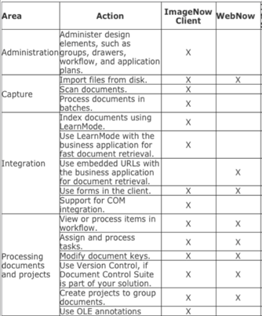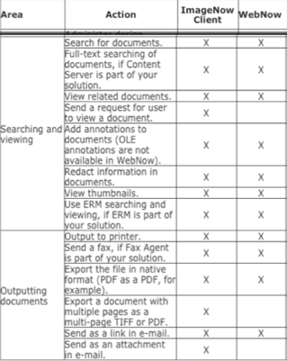
Major Differences:

- No Scanning
- No Linking
- No Single Click Access
- No Admin Access
- Limited Customization

About Logging into WebNow:

- Production: https://imagenow.uncc.edu
- Test: https://imagenow-test.uncc.edu

Open a browser and go to one of the above URLs to access WebNow interactive login screen, as seen below:
(*Note: There will be rolling clouds within the login screen)

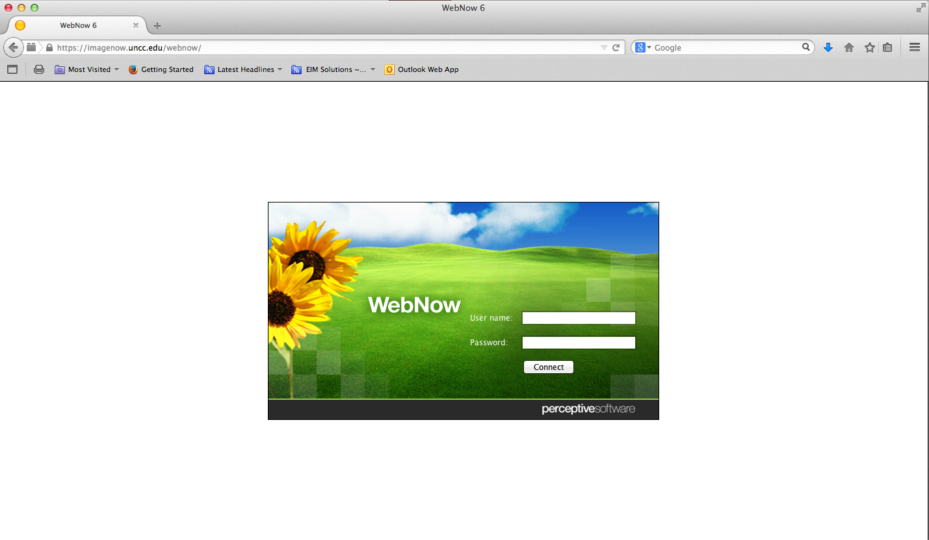

About Logging into ImageNow:

- Click on the ImageNow desktop icon as seen below:

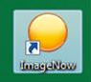

- When the ImageNow login window appears, login using your NinerNet credentials.

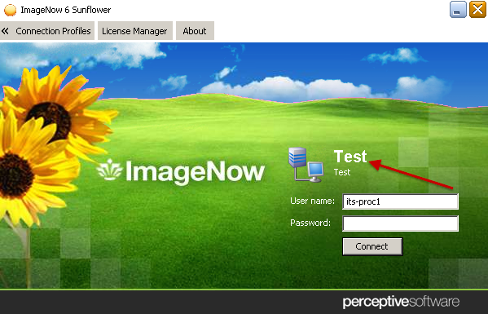
*Note: To toggle between the Production and Test systems, right click on the word Production or TEST to select the environment.

- You should have 2 connection profiles, production and test.
  - Production (created during installation of ImageNow)

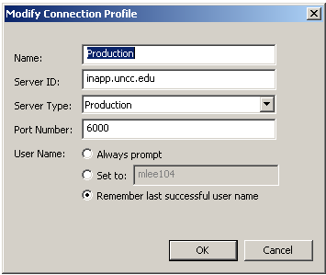

  - Test

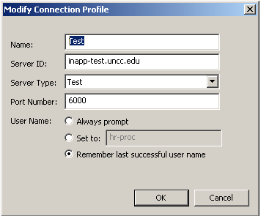

- Once you login to ImageNow, the ImageNow Toolbar will display as shown below:

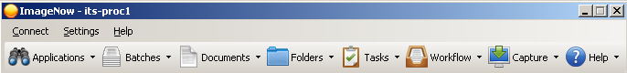

- Once you login to WebNow, the Documents View will display as shown below:

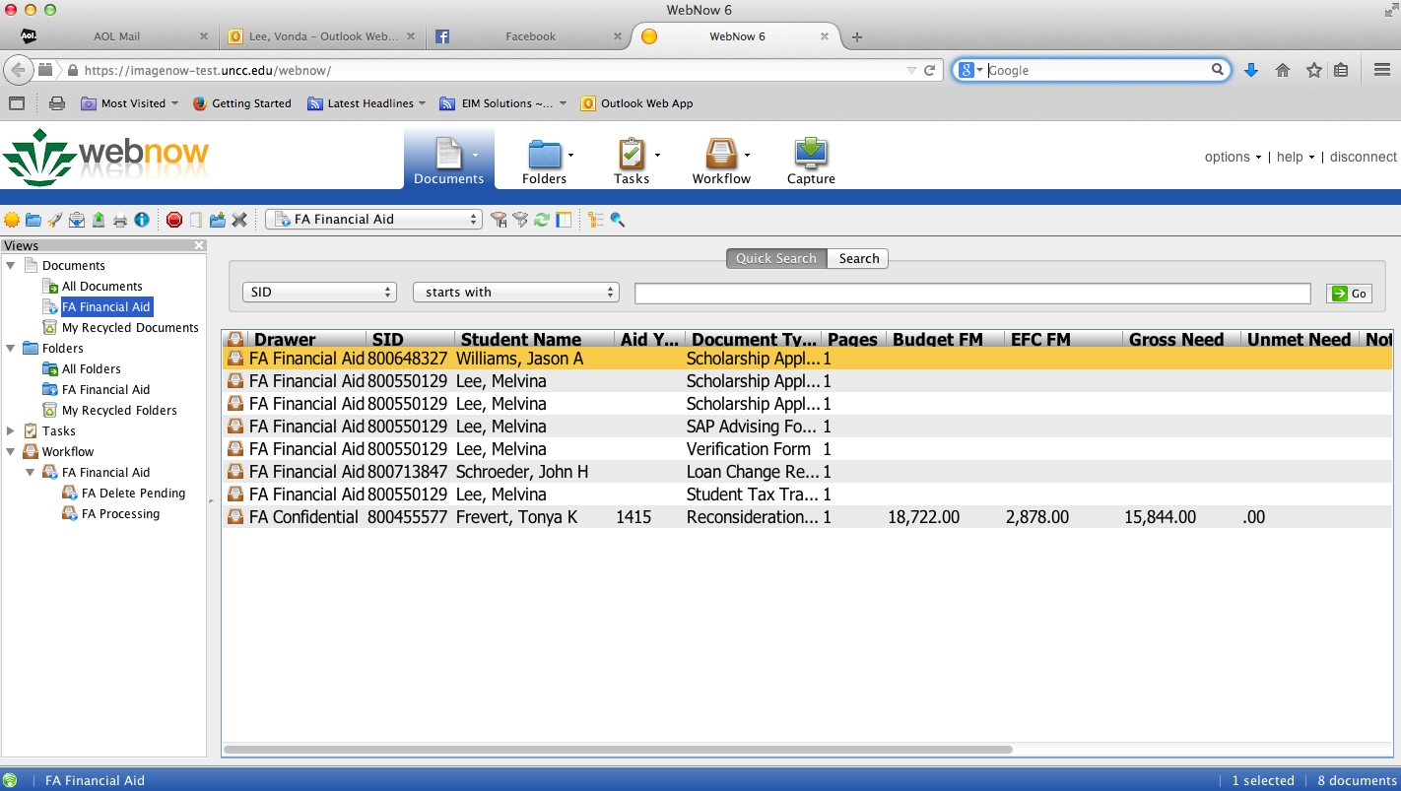

About Searching:
Search for documents in the document view called FA Financial Aid. The following steps explain how to search for a document or folder using a quick selection or using multiple conditions. You must have the Search privilege for the associated drawer.

- Click the SEARCH tab in the ImageNow viewer.
- Click the sign to enter search criteria and an ADD CONDITION window will appear, as seen below:

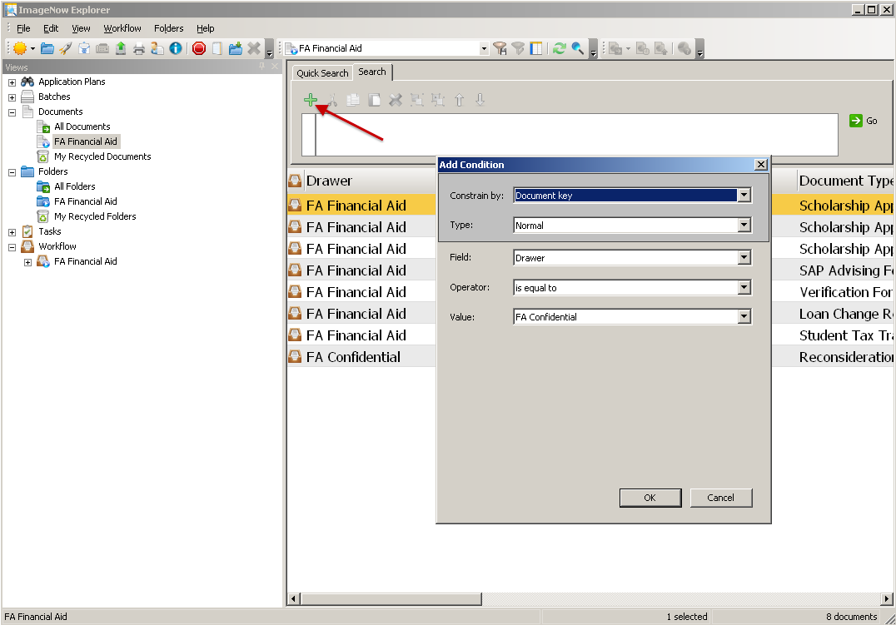
- Enter the desired search conditions, and then press the OK button to add to the search criteria.
- Press the GO button to execute the search and a list of documents will appear matching your search criteria.

- To search for criteria in the current document list (defaults to the first 500 documents), then click the button to open the find toolbar at the bottom of the screen. You can search for an employee’s 800# in the list as seen below:

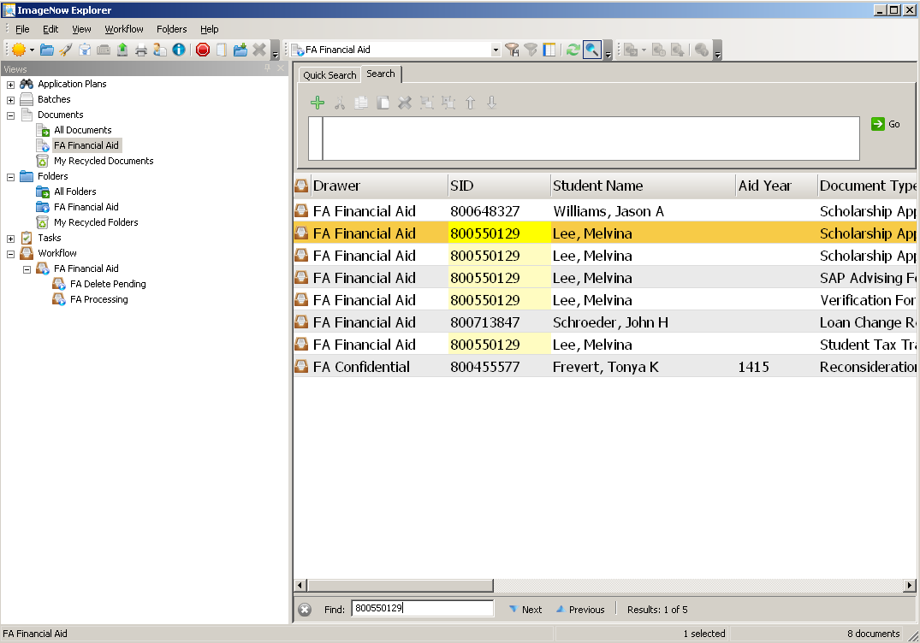

- All documents matching the FIND search criteria will be highlighted in YELLOW as seen above.
- To view the desired document, double click the line item to open the document. Once the document is open, you can email, print, or save the document file locally. Press F7 to view the document properties displayed on the right-hand side panel of the following screen. Here you can see all Banner properties and notes, in addition to any annotations.

- You can search for documents using the Quick Search feature, as shown below:
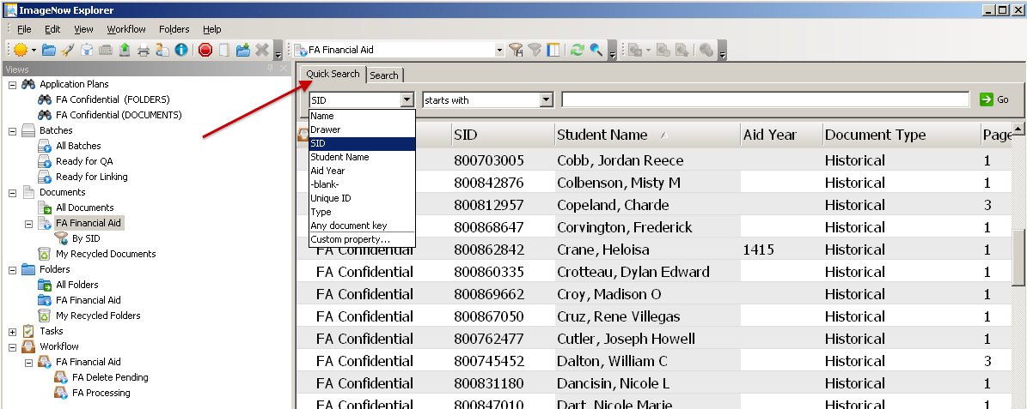
- Select and enter in the search criteria. Click the GO button to run the query. An ImageNow Explorer view will display a list of documents that meet the criterion.

- Filters - A filter lets you select a predefined subset of documents or folders from its parent view and simplifies the task of processing a large number of rows in a view. As soon as you click a filter, ImageNow applies the filter to the view and displays the results in the grid.

  - To create a private filter (*Note: you must have the Filter privilege for any view for which you save a filter.)
- On the ImageNow toolbar, click Documents, Folders, or Workflow, depending on the kind of view you want to filter.
- In ImageNow Explorer, in the left pane under Documents, Folders, or Workflow, select the view to which you will apply the new filter.
- Perform a search for a document. A prompted search for Student ID is saved as a filter as shown below.
- Optional. If your search returned the documents, folders, or items you wanted, click the Save private filter button.
- Optional. In the Save Filter dialog box, give the filter a name and an optional description and then click OK.

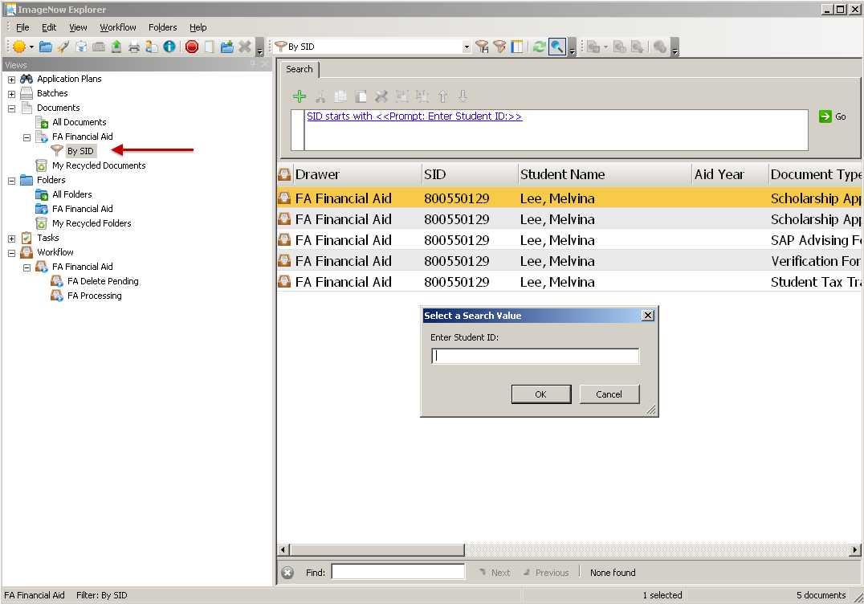

About Workflows:

ImageNow workflows let you automate business processes and create review checkpoints. After you have saved a document in ImageNow, the document can be routed through any number of queues, which might represent different departments or different desks within a department. The documents and folders can also be linked using Banner and other 3rd party applications. A document or folder must be added to the workflow to do any processing such as linking, routing, etc.

- Search for a document in the document view called FA Financial Aid using the quick search feature.
- Open the desired document and click the link labeled WORKFLOW in the header of the document. Then select the ADD TO WORKFLOW option, as shown below:

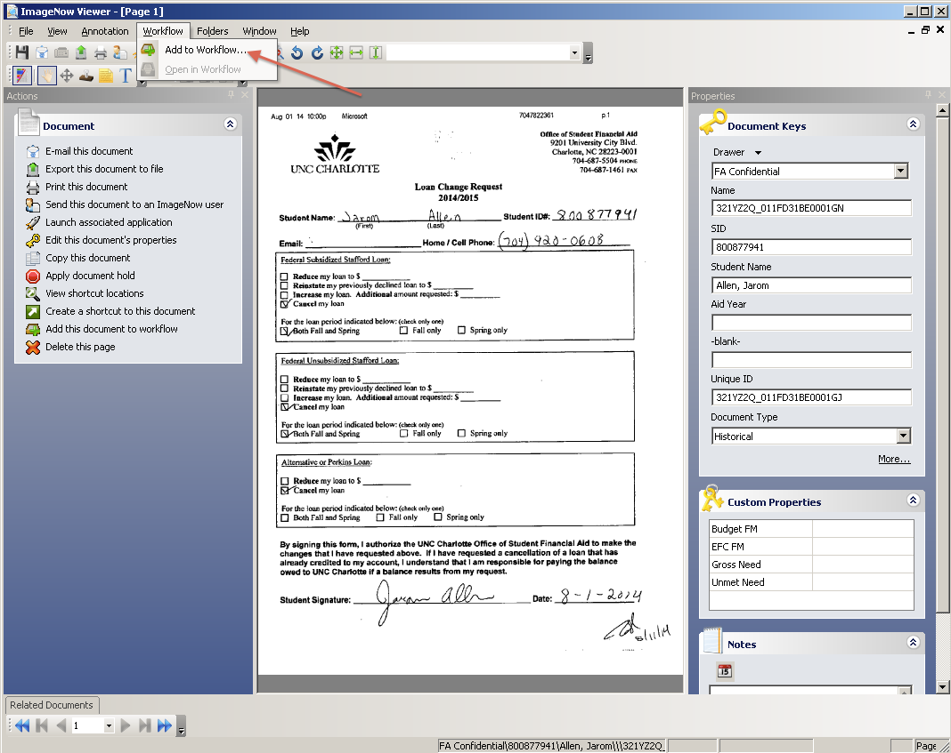

- An ADD TO WORKFLOW window will be displayed. Select the desired workflow to add the historical document. Click the ADD button to process, as shown below:
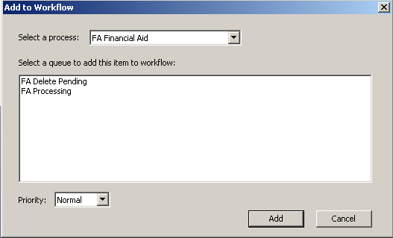
- Click the link labeled WORKFLOW in the header of the document. Then select the OPEN IN WORKFLOW option. The document is now in workflow and ready to be processed.

- Ensure that the THUMBNAIL view is evoked. See below:
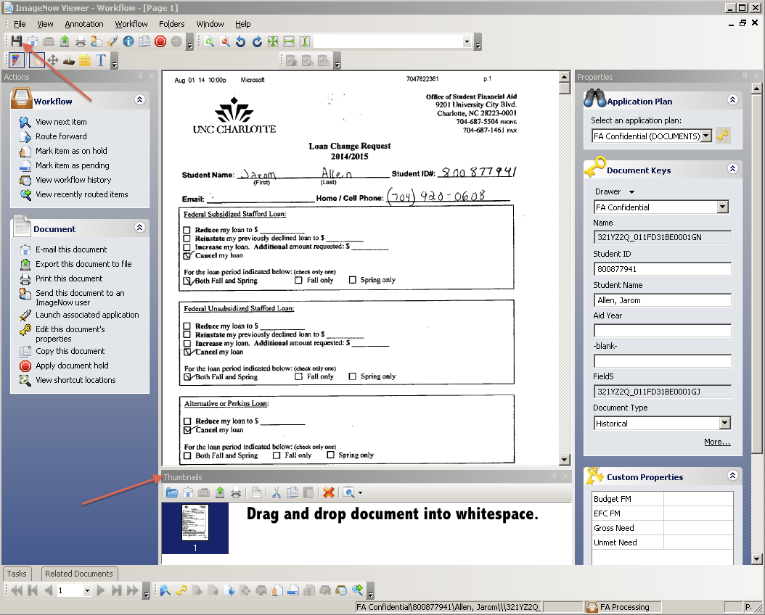

Drag and Drop Process - Document:
- Drag and drop a document from your desktop or selected drive into the whitespace in the Thumbnails view, as seen above.
- Click the SAVE icon to save the added document as a new page.

Linking Documents and Folders:

You can link a document to a record in any business application such as Banner, 49er Mart, etc. to associate the document with the record and to automatically assign the property values to the document stored in ImageNow. When documents are linked to a record in Banner, you can easily retrieve the documents by opening the record and clicking the ImageNow icon in the system tray to display a list of the linked documents (called Single Click Access). For linking, ImageNow uses the settings your administrator defined in an application plan map to gather values and assign them to the document.

There are two (2) FA application plans that are available, which utilizes the Banner Form ROASTAT:
- FA Confidential (Documents) – links documents with the option of creating a Folder and adding that document to the Folder.
- FA Confidential (Folders) – links a newly created folder when in the FOLDER view.

To Link a document, perform the following steps:
- Login to ImageNow and click on the WORKFLOW drop-down button at the top of the ImageNow toolbar and select the appropriate workflow queue, as seen below:

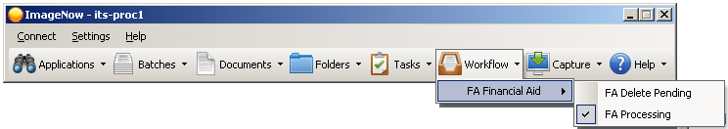

- An ImageNow Explorer window will appear displaying all the workflow documents in a list.
- Login to Banner and proceed to ROASTAT Banner form; enter in a valid Student ID and Aid Year.
- Double-click to open a document in the list and determine the proper document type.
- Click the LINK icon and verify that all the information populated is correct.
- Next, route the document to Archive by pressing the ROUTE FORWARD icon.

- A ROUTE FORWARD window will appear displaying the available workflow queues to route to, as seen below:
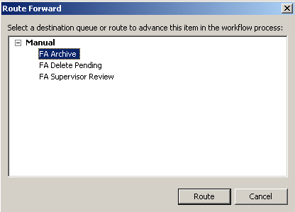
- The available workflow queues to route to are:
  - FA Archive – this is where all processed documents reside that are not in workflow.
  - FA Delete Pending – this workflow queue is where documents that need to be deleted are routed. Only the Supervisors can delete document as necessary, but the Processors have access to route to this workflow queue.
  - FA Supervisor Review – this workflow queue is where documents can be routed if a Supervisor needs to review before processing. The Supervisor can correct any issue or route the document back to the processing workflow queue with a resolution noted in the NOTES field or a TEXT annotation for the Processor.
- Further document processing such as email, view, merge, copy, print, export, and view document history can be performed, as shown below:

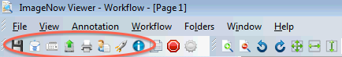

About ImageNow Terminology:

- ImageNow Toolbar - The ImageNow toolbar lets you configure the appearance such as toolbar size, button size, and button text. All of the functions and documents you need are only one mouse click away. The options below change depending on your security privileges. The ImageNow toolbar provides access to all ImageNow functions.

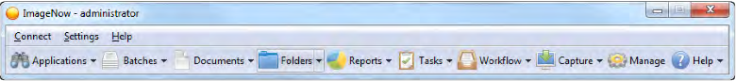

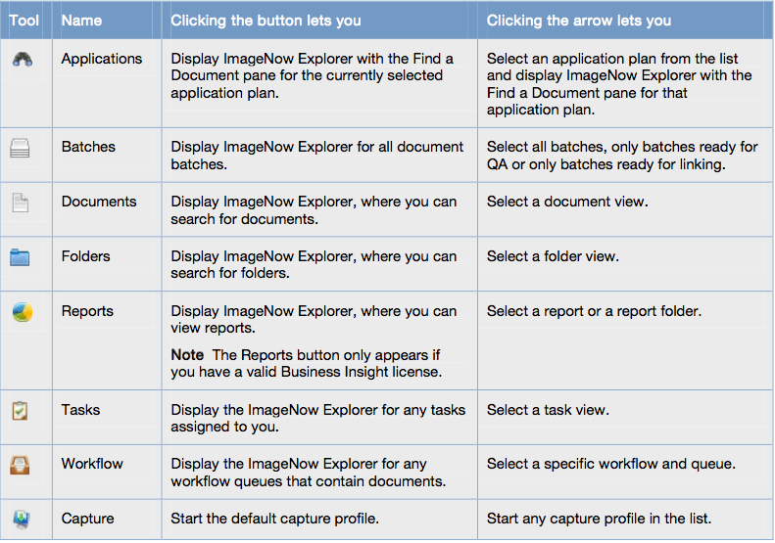

- ImageNow Explorer Window (see below) - The Explorer windows display document and folder information in grids. In the Views pane, you can switch between following types of grids:
  - Application Plans view displays the documents that are linked to records in an external business application, such Banner and 49er Mart.
  - Batches view displays one or more groups of pages that are ready for QA or Linking.
  - Documents view displays the documents that satisfy the document views and filters defined for your user account.
  - Folders view displays the folders that satisfy the folder views and filters defined for your user account. Double-clicking a folder row displays the documents in the folder.
  - Reports view displays the folders and reports accessible to you. Clicking a report folder displays the reports and subfolders associated with it.
  - Tasks view displays the documents associated with the various task types that a manager assigns to you, for example, To Review, Returned to Me, or Complete.
  - Workflow view displays any documents that reside in the workflow and queue you select in the tree.

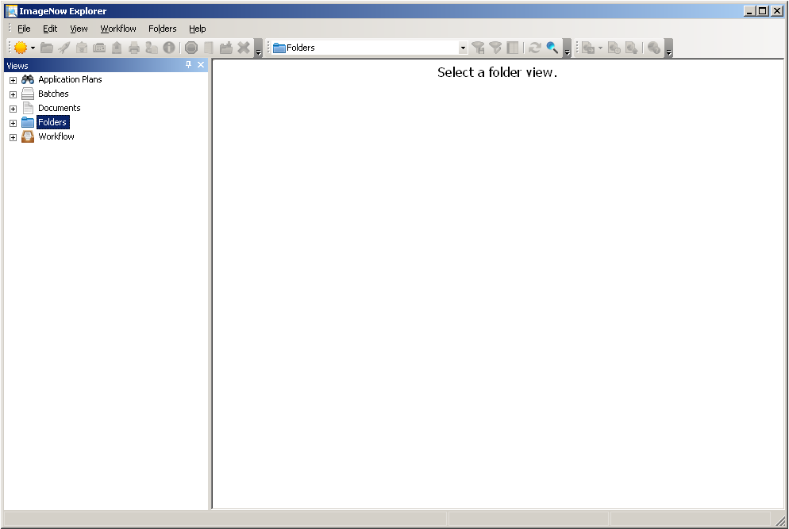

- ImageNow Viewer – Workflow (see below) - The Viewer enables you to see the content of your documents. The viewer appears when you double-click a document in the ImageNow Explorer window.

In addition to displaying the document, ImageNow Viewer can also display information about the document in the following panes that appear when you select them in the View menu:
- In the Actions pane, you can perform actions on the document such as emailing the document, exporting the document to a file, faxing or printing the document, editing the documents properties, digitally signing the document, adding the document to a folder or workflow, or launching the application that is associated to the document.
- In the Properties pane, you can display and update the document keys and custom properties that describe and define the document. You can also add a note to the document or update an existing note.
- In the Related Documents pane, you can select a view in the Relationship list. The relationship view then runs automatically and shows all of the documents in ImageNow that satisfy the conditions defined in the related view.
- In the Tasks pane, you can view the document-related tasks assigned to you as well as complete, return, or temporarily skip a task.
- In the Thumbnails pane, you can double-click a different page of a multiple-page document to display it in the Page pane.

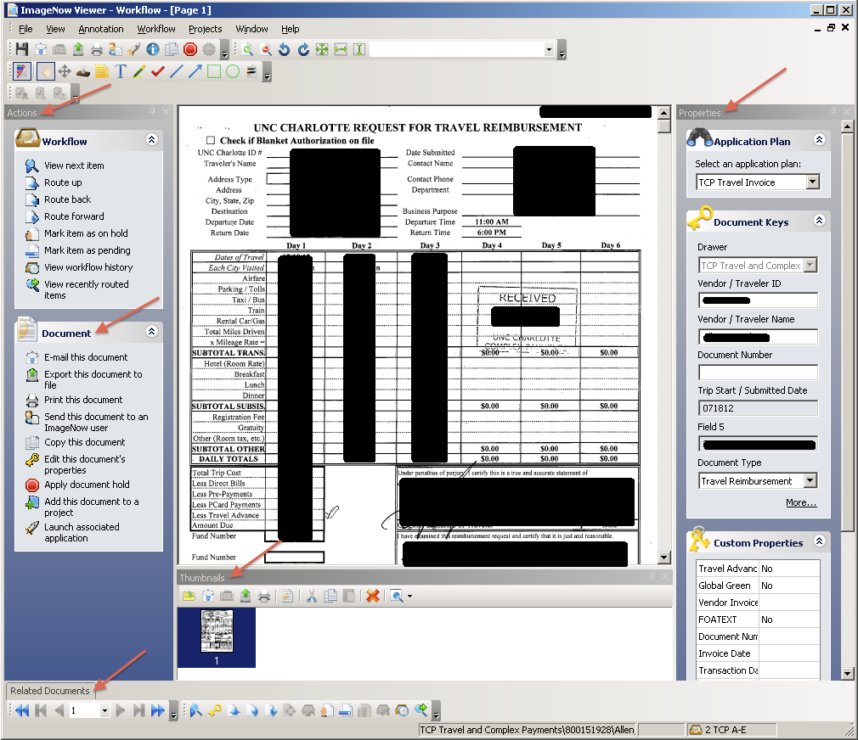

- Documents – A document is a set of scanned images or imported files or both, along with the metadata (such as index keys) that make it easy to search for the document. A document can contain many different file formats. TIFF, DOCX, and PNG are just a few of the accepted file types. A document appears in ImageNow Viewer.
- Folders – Folders group related documents independently of the index keys assigned to them.
- Tasks - A task is work that you assign to one or more users for documents and folders. There are three (3) task types: document deficiency, pointer, and signature required.
- Views - a view is a subset of all ImageNow items tailored for you. The view can hide dozens, hundreds, or even thousands of documents that might otherwise clutter your ImageNow Explorer window. Views display only the columns you need to see or work with, including custom property columns. Your view is customized so that the appearance, name, and width of columns in ImageNow Explorer fit your needs.

Types of Views:

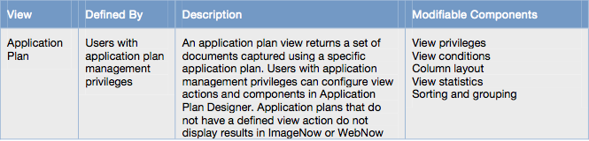

Types of Views cont’d:
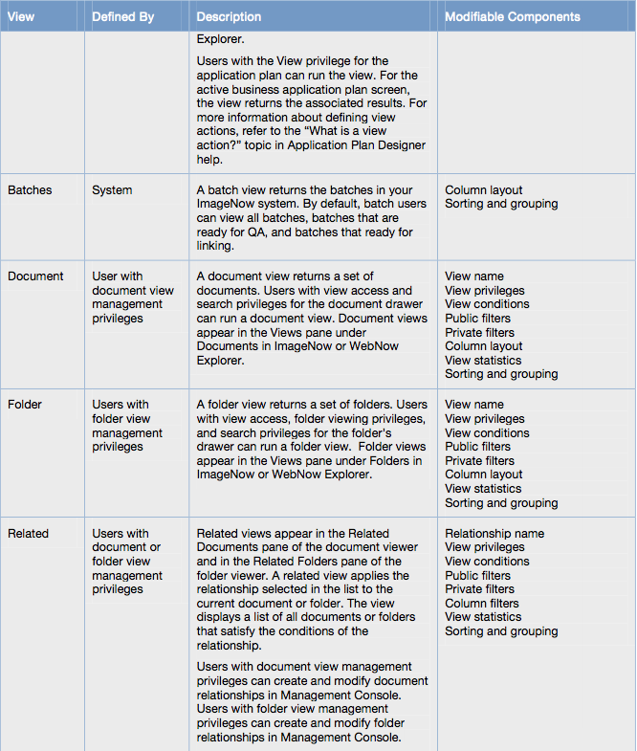

Types of Views cont’d:

