Drag and Drop Documents:

You can add a document to an existing folder several ways:
- Drag and Drop a new document and create a shortcut.
- Drag and Drop a document into the desired folder.

Drag and Drop a new document and create a shortcut:
  - Drag and drop a new document into one of the DOCUMENT filter views, ex. FM Archives By Building Name/0008-Denny.
  - A New Document window will display as shown below:
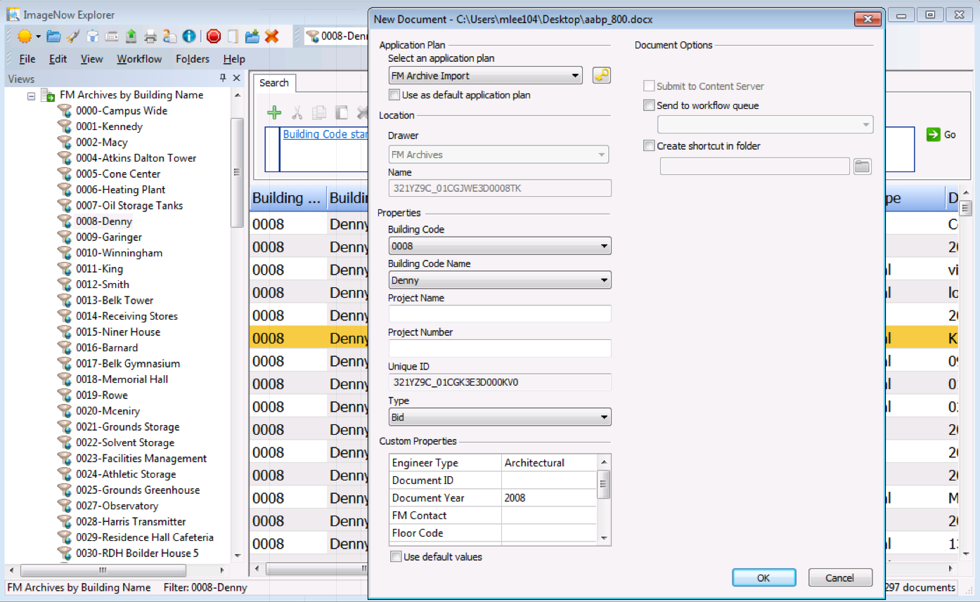

  - Select the application plan FM Archive Import.
  - Select the appropriate Building Code, Building Code Name, and Document Type.
  - Enter in the appropriate Project Name, Project Number, and Custom Properties.
  - Check the Create Shortcut in Folder box and click the Create Location icon .

  - A SELECT LOCATION window will appear; enter in the Building Code and press the SEARCH button. A list of folders will appear as seen below:
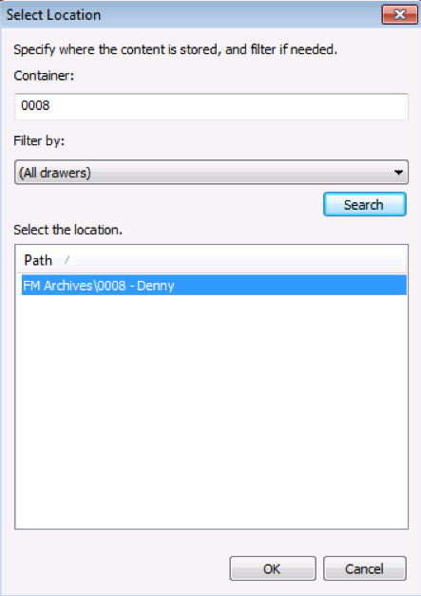
  - Press the OK button again to add the document to the folder and archive it.
  - The document will open in an ImageNow Viewer. You can make any changes to the document. Save and exit the document.
Drag and Drop a document into the desired folder:
- Go to the FOLDER view, as seen below:

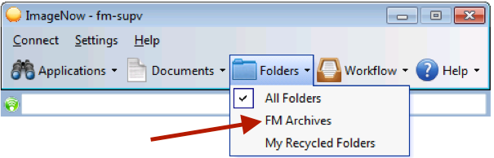

- Open the desired folder in the folder list.
- Drag and drop a document from your desktop or selected drive into the whitespace in the folder viewer, as seen below:

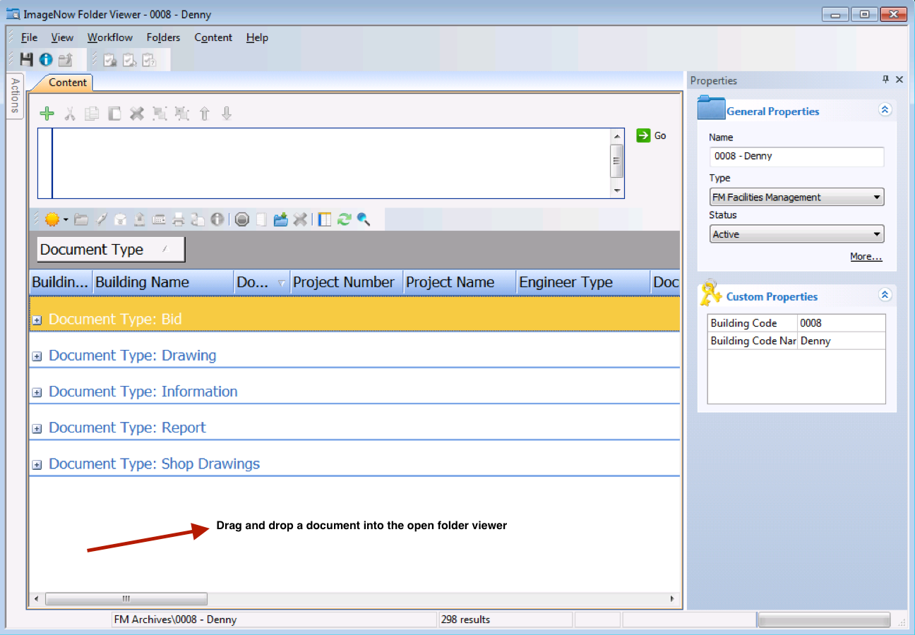

- A NEW DOCUMENT window will appear, as seen below. Select the application plan, FM Archive Import and click the LINK button to link the document.
  - Select the appropriate Building Code, Building Code Name, and Document Type.
- Enter in the appropriate Project Name, Project Number, and Custom Properties.
- Ensure the checkbox for CREATE SHORTCUT IN FOLDER is checked; this will add the document to current folder.

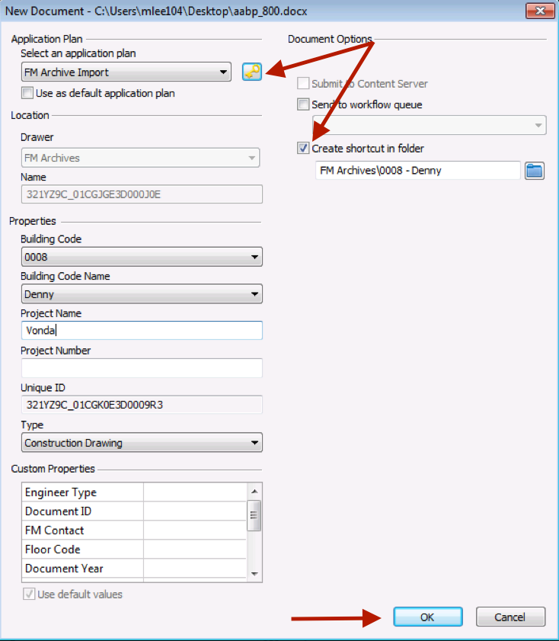
- Press the OK button to add the document to the folder.

