User Navigation Manual
(ImageNow Full-Client Only)

Written By: Vonda Lee
December 2, 16

This document will assist with navigating your way around ImageNow, customizing ImageNow, and understanding the ImageNow terminology. Login to ImageNow using your NinerNet credentials to perform the following customization steps.

Customizing ImageNow:

- Select Settings, then Options as seen below to customize ImageNow:

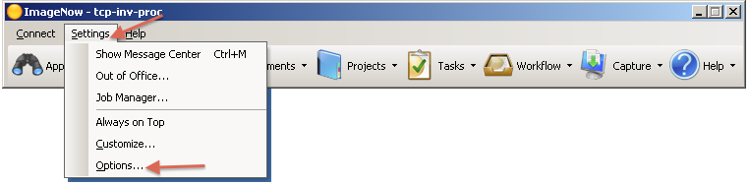
- The ImageNow Options window will appear (see below) on the General option, ensure that the Show System Tray Icon and Allow Notifications To Display In The System Tray boxes are checked. *Note: must be selected for Single Click Access to work properly.
- You can customize the Date and Time format.
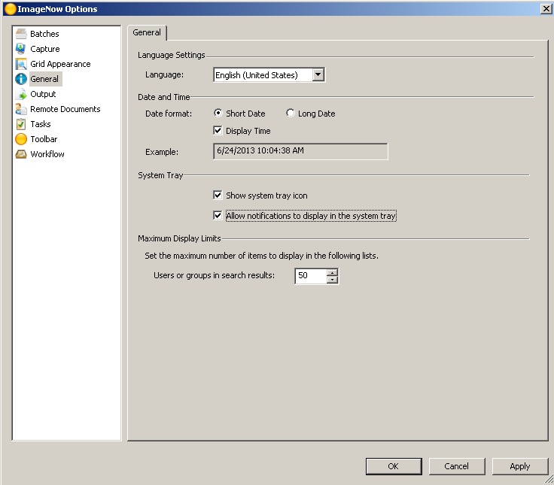

- Click the Batches option; you can customize how you would like to QA. *Note: These values should in accordance with your department’s QA process.
- Click the Grid Appearance option (see below); this is where you can change the colors of your text, background, and alternative row.

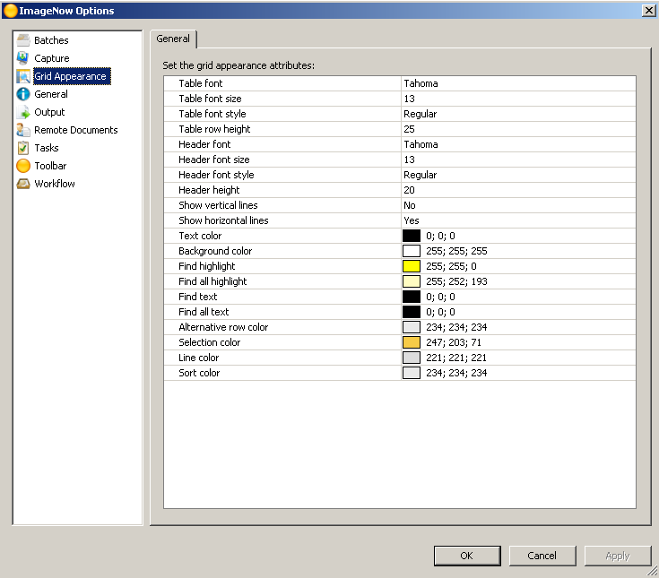

- Click the Tasks option (see below); here you can customize how tasks should startup and how you will process each task. *Note: Only certain processors will have this option.

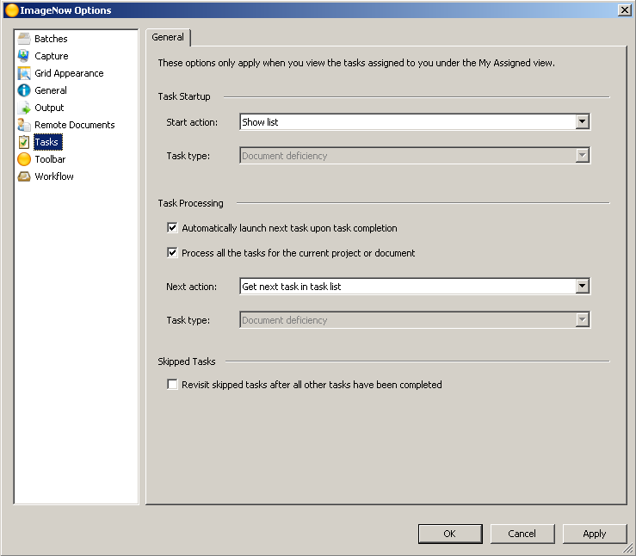

- Click the Toolbar option (see below); you can customize theme, icon size, menu bar, button text, and split buttons.

For example, if you would like to change the icon size of the icons on the toolbar, select the desired size:

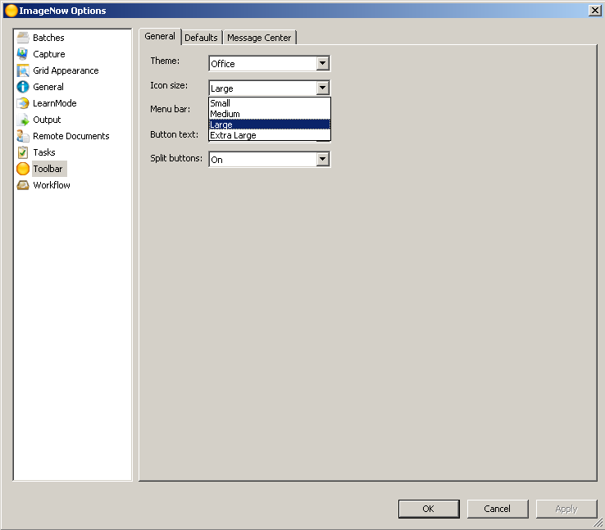

- Click the Toolbar option and then Defaults tab (see below); you can customize what Application Plan, Batches, Documents, Projects, Tasks, Workflow, and Capture default values.

For example, if you process Vendor names A – C, you can default your Workflow to 2 AP A-C workflow queue as seen below. Also, if you would like for the Workflow Explorer Window to launch when you logon, set the Initial State Action to Workflow Default as seen below, other significant actions include Application Default, Batches Default, Documents Default, Projects Default, Tasks Default, and Capture Default:

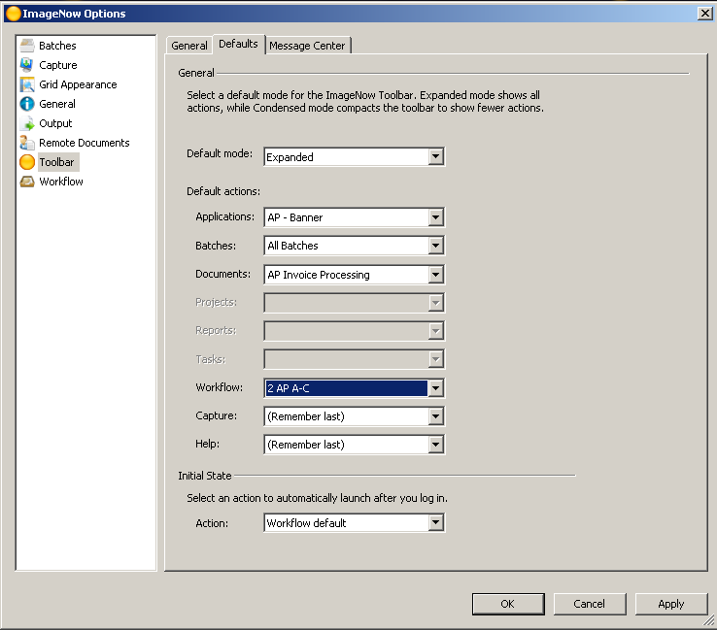

- Click the Workflow option (see below); you can customize how workflow startup, workflow processing, and set workflow grid color for document items that have been in the queue more than once (route-back documents that may have had an issue):

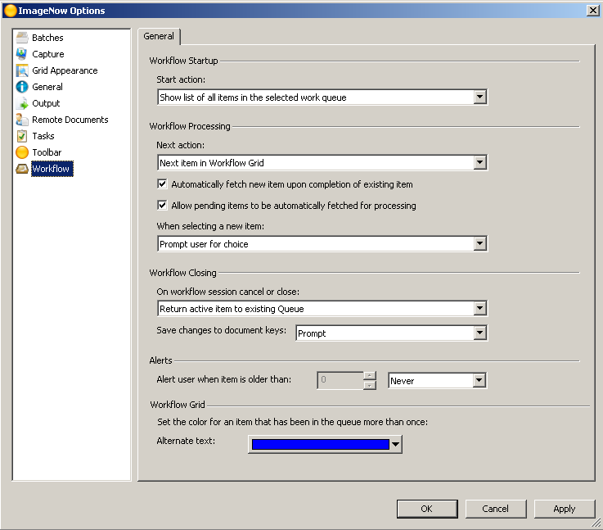

- Press the Apply button to save all ImageNow Options.

- Open an ImageNow Viewer for a desired document, to customize the viewer so that you can route, email, edit document properties or link, apply document hold, delete page, view document thumbnails (pages), related documents, document keys, custom properties, and notes; Click View Option at the top of the viewer and select items as seen below:

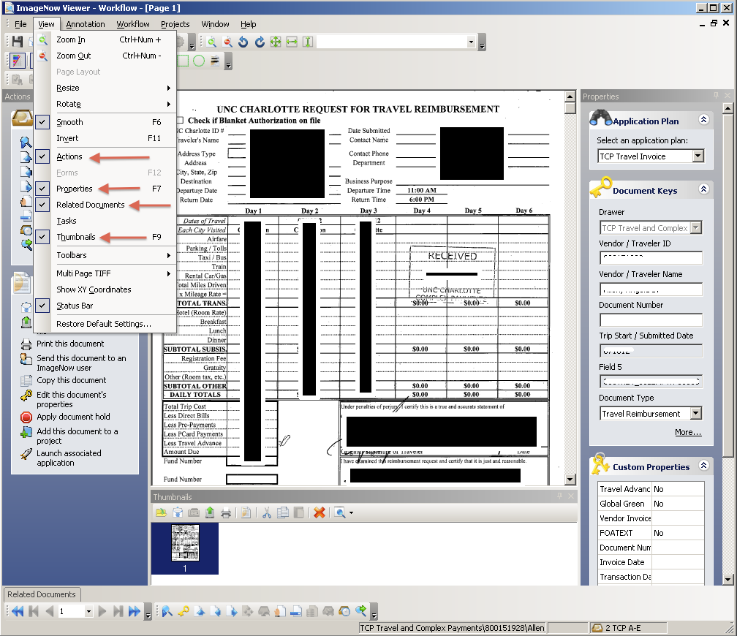

To ensure the above view when opening/viewing/linking another document, press the save button. These settings should be set for future viewing.

- Follow the above steps for opening an ImageNow Project Viewer and ImageNow Task Viewer.

ImageNow Terminology:

- ImageNow Toolbar - The ImageNow toolbar lets you configure the appearance such as toolbar size, button size, and button text. All of the functions and documents you need are only one mouse click away. The options below change depending on your security privileges. The ImageNow toolbar provides access to all ImageNow functions.

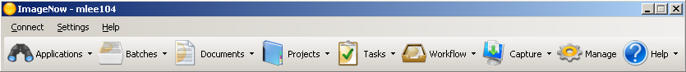

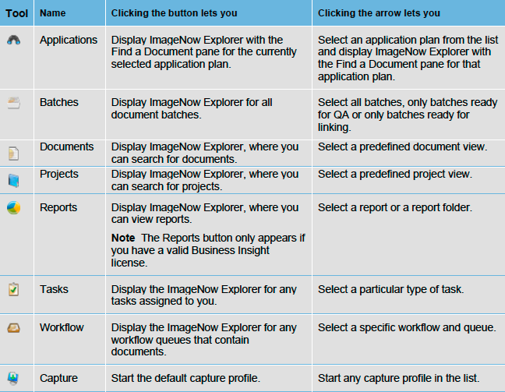
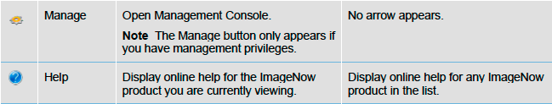

- ImageNow Explorer Window (see below) - The Explorer windows display document and project information in grids. In the Views pane, you can switch between following types of grids:
  - Application Plans view displays the documents that are linked to records in an external business application, such as AP, HR, or student records management.
  - Batches view displays one or more groups of pages that are ready for QA or Linking.
  - Documents view displays the documents that satisfy the document views and filters defined for your user account.
  - Projects view displays the projects that satisfy the project views and filters defined for your user account. Double-clicking a project row displays the documents in the project.
  - Reports view displays the folders and reports accessible to you. Clicking a report folder displays the reports and subfolders associated with it.
  - Tasks view displays the documents associated with the various task types that a manager assigns to you, for example, To Review, Returned to Me, or Complete.
  - Workflow view displays any documents that reside in the workflow and queue you select in the tree.

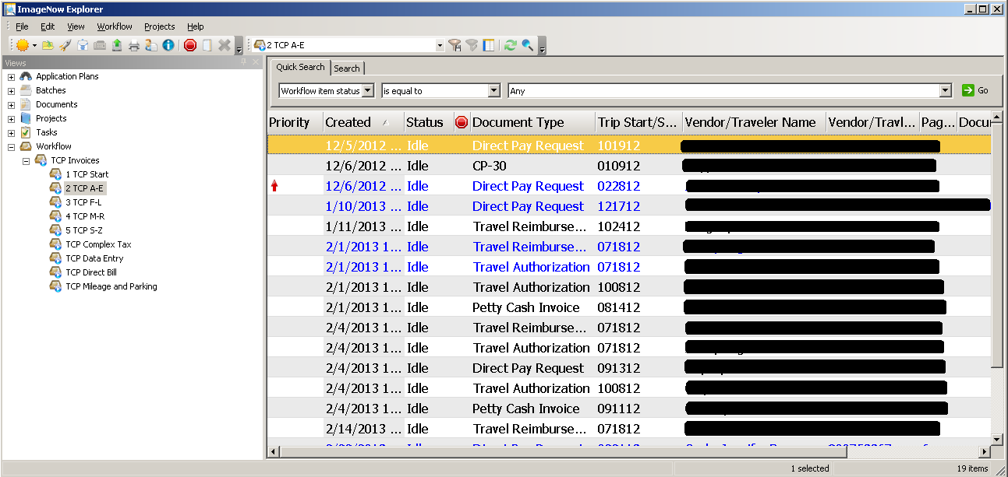

- ImageNow Viewer (see below) - The Viewer enables you to see the content of your documents. The viewer appears when you double-click a document in the ImageNow Explorer window.

In addition to displaying the document, ImageNow Viewer can also display information about the document in the following panes that appear when you select them in the View menu:
- In the Actions pane, you can perform actions on the document such as emailing the document, exporting the document to a file, faxing or printing the document, editing the documents properties, digitally signing the document, adding the document to a project or workflow, or launching the application that is associated to the document.
- In the Properties pane, you can display and update the document keys and custom properties that describe and define the document. You can also add a note to the document or update an existing note.
- In the Related Documents pane, you can select a view in the Relationship list. The relationship view then runs automatically and shows all of the documents in ImageNow that satisfy the conditions defined in the related view.
- In the Tasks pane, you can view the document-related tasks assigned to you as well as complete, return, or temporarily skip a task.
- In the Thumbnails pane, you can double-click a different page of a multiple-page document to display it in the Page pane.

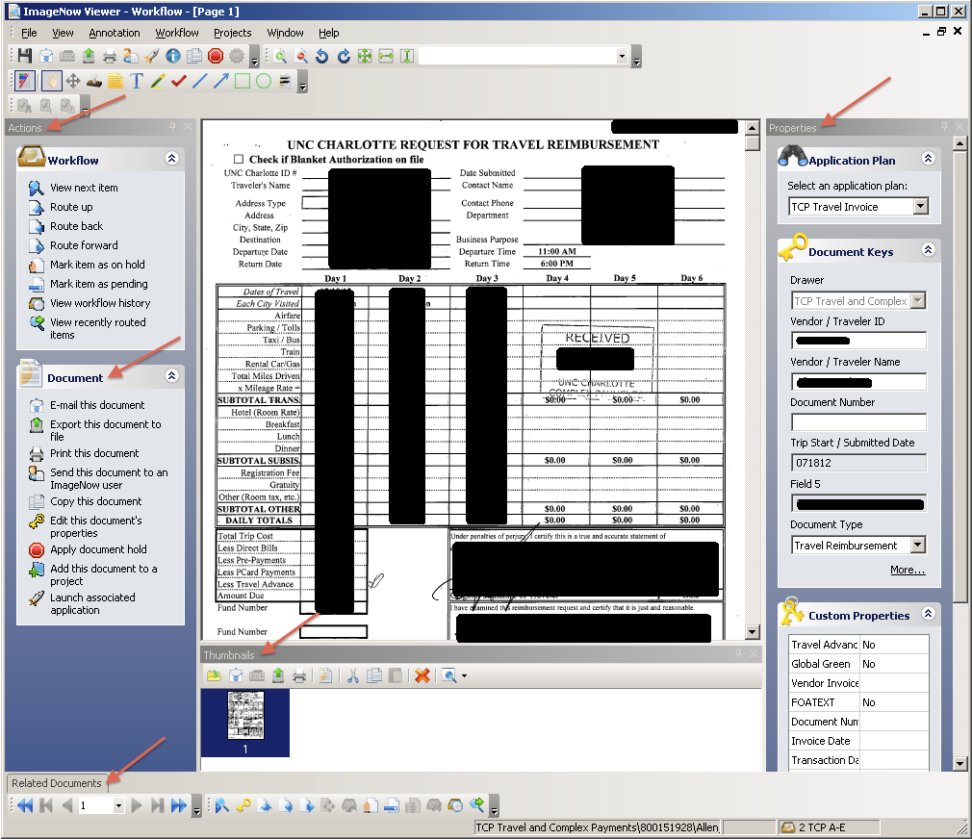

- Documents – A document is a set of scanned images or imported files or both, along with the metadata (such as index keys) that make it easy to search for the document. A document can contain many different file formats. TIFF, DOCX, and PNG are just a few of the accepted file types. A document appears in ImageNow Viewer.
- Projects – Projects group related documents independently of the index keys assigned to them.
- Tasks - A task is work that you assign to one or more users for documents and projects. There are three (3) task types: document deficiency, pointer, and signature required.
- Views - a view is a subset of all ImageNow items tailored for you. The view can hide dozens, hundreds, or even thousands of documents that might otherwise clutter your ImageNow Explorer window. Views display only the columns you need to see or work with, including custom property columns. Your view is customized so that the appearance, name, and width of columns in ImageNow Explorer fit your needs.

Types of Views:
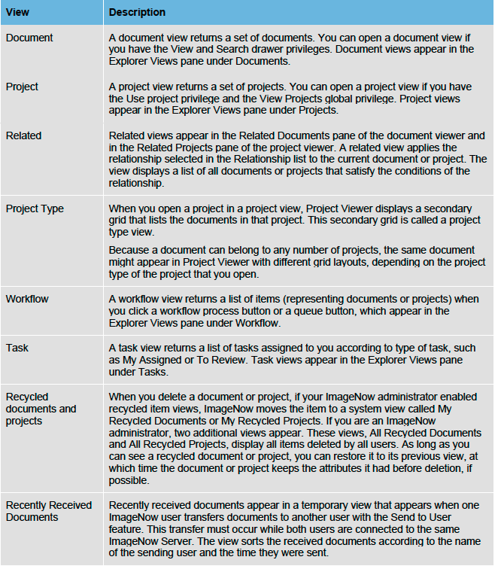

Below is an example of an AP Invoice Processors views:

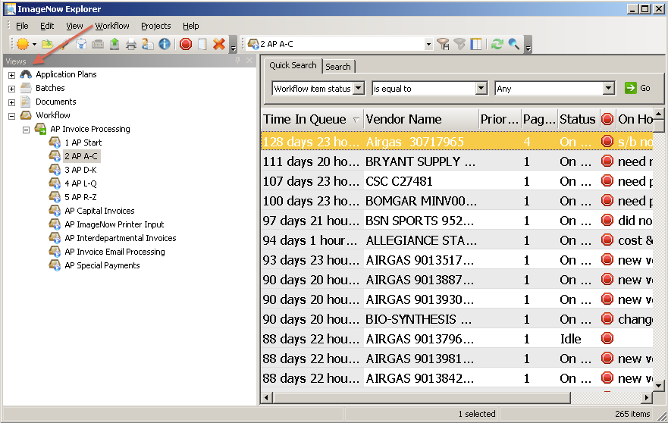

- Filters - A filter lets you select a predefined subset of documents or projects from its parent view and simplifies the task of processing a large number of rows in a view. As soon as you click a filter, ImageNow applies the filter to the view and displays the results in the grid.

Create a private filter
You must have the Filter privilege for any view for which you save a filter.
- On the ImageNow toolbar, click Documents, Projects, or Workflow, depending on the kind of view you want to filter.
- In ImageNow Explorer, in the left pane under Documents, Projects, or Workflow, select the view to which you will apply the new filter.
- Perform a search for a document
- Optional. If your search returned the documents, projects, or items you wanted, click the Save private filter button.
- Optional. In the Save Filter dialog box, give the filter a name and an optional description and then click OK.

