UHP Workflow Process Manual

Written By: Vonda Lee
August 7, 2015

Table of Contents
Notification of New Student Application Packet: 3
Processing in the UHP Student Packet Review Workflow Queue: 6
Processing in the UHP Evaluation Processing workflow queue: 13
Reassigning an Essay Task 15
Notification of A UHP Recommendation Exception: 20
Processing in the UHP Recommendation Exception Workflow Queue: 20
Notification of A UHP Decision Exception: 23
Processing in the UHP Decision Exception Workflow Queue: 23
Drag and Drop Feature 26
Drop as a New Page 26
Drop as a New Document within a Folder 27
Searching for Folders: 30
Searching for Documents: 31

Notification of New Student Application Packet:

- The UHP Processor will receive an email stating a new student application packet is in the UHP Student Packet Review workflow queue for processing, as shown below:

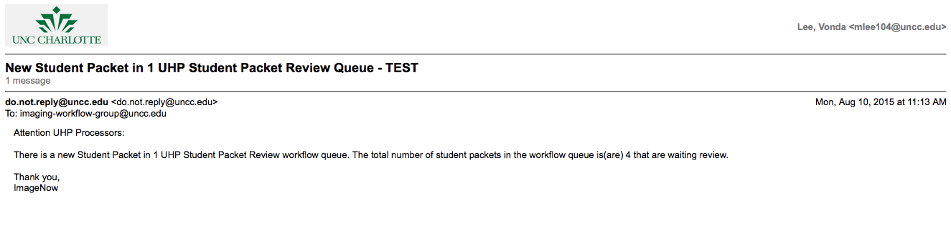

- Login to ImageNow or WebNow using your NinerNet credentials and click the CONNECT button as shown below:
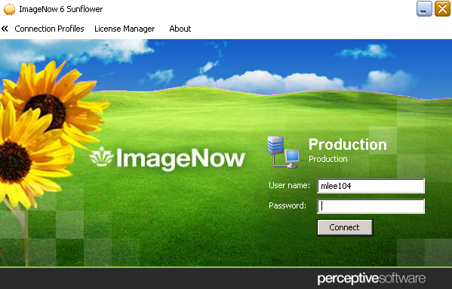

- Proceed to the workflow queue identified in the email, as shown below:
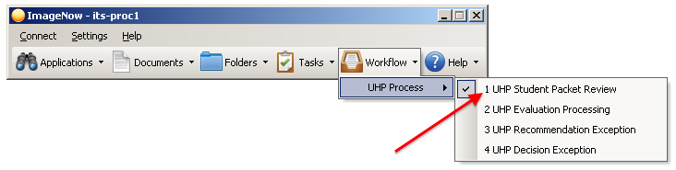
- An ImageNow Explorer window will display a list of UHP student application folders to be processed, as shown below:
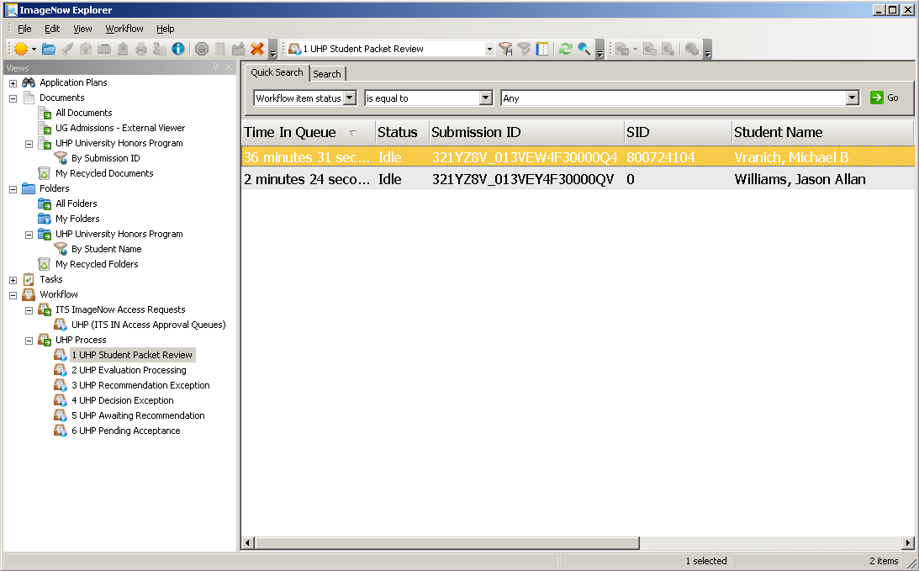
*Note: The folder list is sorted by Time In Queue.

- The student application folders in the list are ready for review and processing.

Processing in the UHP Student Packet Review Workflow Queue:
- To process student application folders that do not have a student ID number (ZERO in the SID column):
  - Double-click on the item to open the student application.
  - Verify the student exists in Banner.
  - Open the UHP_Evaluation_Form, by double-clicking the document within the folder.
  - Enter the student’s 800# in the form ID Number field, and then press TAB to populate the remaining form fields with Banner information.

*Note: Do not press the SAVE Button.

  - Click the EXIT icon to exit the document.
  - Press the REFRESH button, to view updates to the SID and Name for all the documents in the folder list.
- To process student application folders that have a SID number and Student Name, open a student application folder by double-clicking on the desired item in the grid display.

- Evoke the TASK view panel by selecting VIEW>TASKS, if necessary.
- Evoke the TASK Toolbar by selecting VIEW>TOOLBARS>TASKS, if necessary.
- Evoke the ANNOTATIONS Toolbar by selecting VIEW>TOOLBARS>ANNOTATIONS, if necessary.
- To redact a student’s ESSAY document, double-click on Essay – UHP in the folder.
- Click the rectangle annotation icon and select the text in the document to be redacted, as shown below:
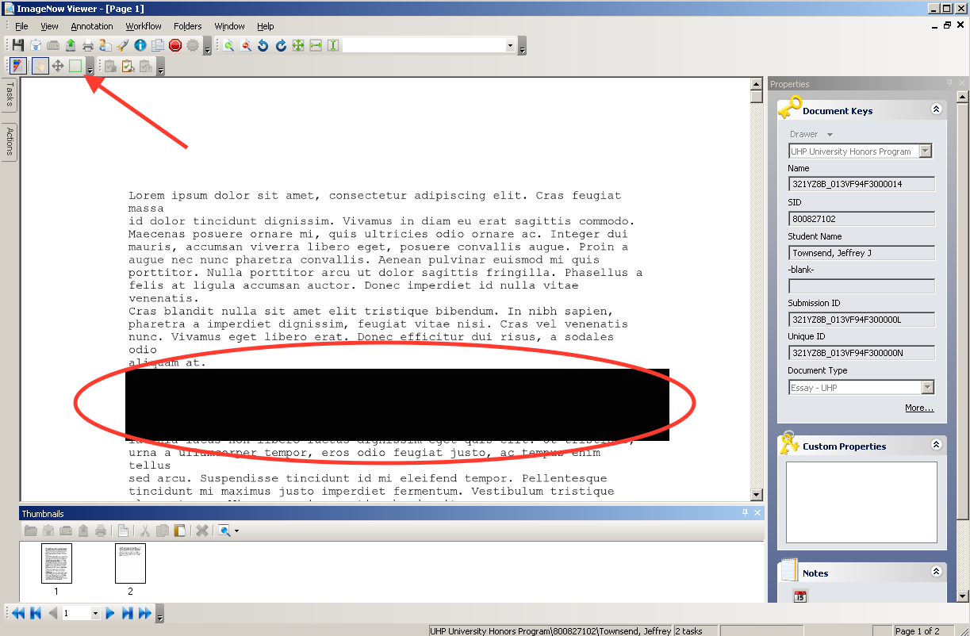

*NOTE: The rectangle can be adjusted to include only the text to be redacted. The rectangle can also be deleted if necessary.

- To assign a Student Ambassador to review the ESSAY document:
  - Click the NEW TASK button and a New Task – UHP Essay Review window will display as shown below:
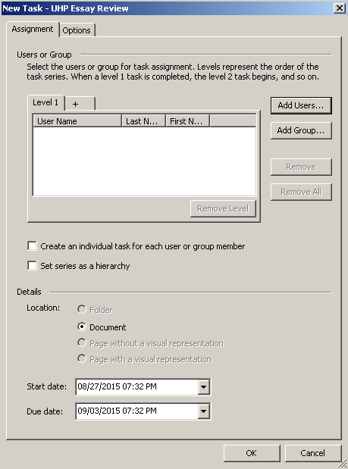
  - Click the ADD USERS button and a Select Users window will display as shown below:
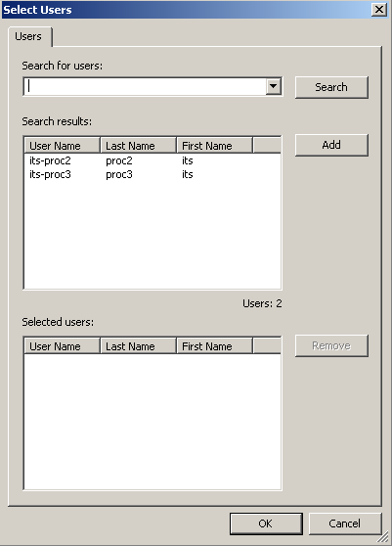
  - Select the desired Student Ambassador user(s) from the search results and click the ADD button, then click the OK button to return to the New Task window.
  - If you selected multiple Student Ambassador users, select the CREATE AN INDIVIDUAL TASK FOR EACH USER box, else ignore this field.
  - Select the OK button to add the task and exit the NEW TASK window.
  - Now you will see a new task in the TASKS panel for the student applicant. This Student Ambassador(s) will receive an email with a link referencing the ESSAY document where they can review it.
- Click the SAVE button to save changes to the document.
- Click the EXIT icon to exit the document.
- Verify all six (6) required documents have been received. The following documents are required:
  - Application
  - Essay
  - Resume
  - Evaluation Form
  - Transcripts
  - Recommendation Letter
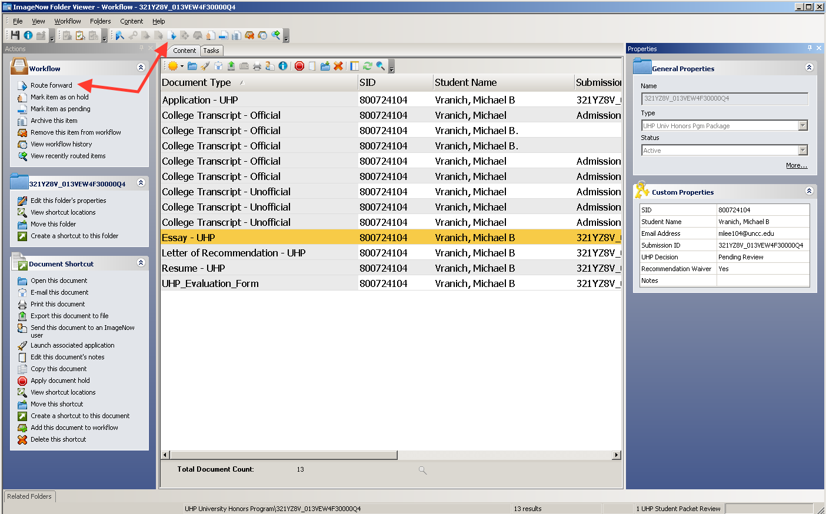
- Once the student application packet has been reviewed and completed, click the ROUTE FORWARD icon to the UHP Evaluation Processing workflow queue for evaluation.

*NOTE: After the folder is routed forward, an email will be sent to the Student Ambassadors stating the student essay is available for review.

- If no Letter of Recommendation has been received within 30 days for a student applying to the University Honors Program, then the student application packet folder will be routed automatically to UHP Awaiting Recommendation workflow queue, as shown below:
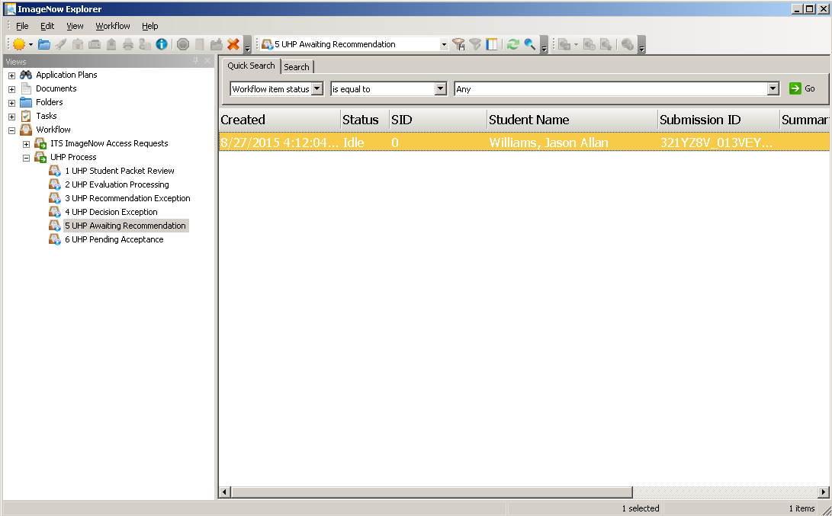
- The UHP Processor has 2 options:
  - The UHP Processor can wait for the student’s Letter of Recommendation to be submitted and when received the student application packet folder will automatically be routed to UHP Student Packet Review workflow queue.

  - Or, the UHP Processor can deny the student application packet folder by:
    - Changing the UHP Decision folder custom property to DENIED, as shown below:

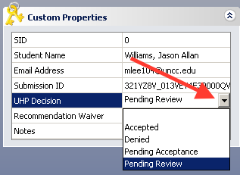
    - Click the SAVE icon to save all changes.
    - Select the Route Forward icon and the student application packet folder will be routed to Archive.

*NOTE: After the folder is routed forward, an email will be sent to the Student Applicant stating that he/she has been denied.

Processing in the UHP Evaluation Processing workflow queue:

- Proceed to the workflow queue called UHP Evaluation Processing, as shown below:
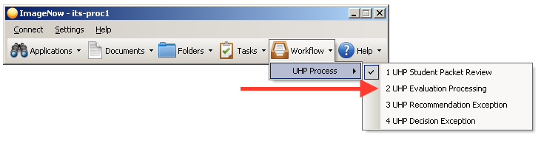
- A list of student application packet folders will be displayed, as shown below:
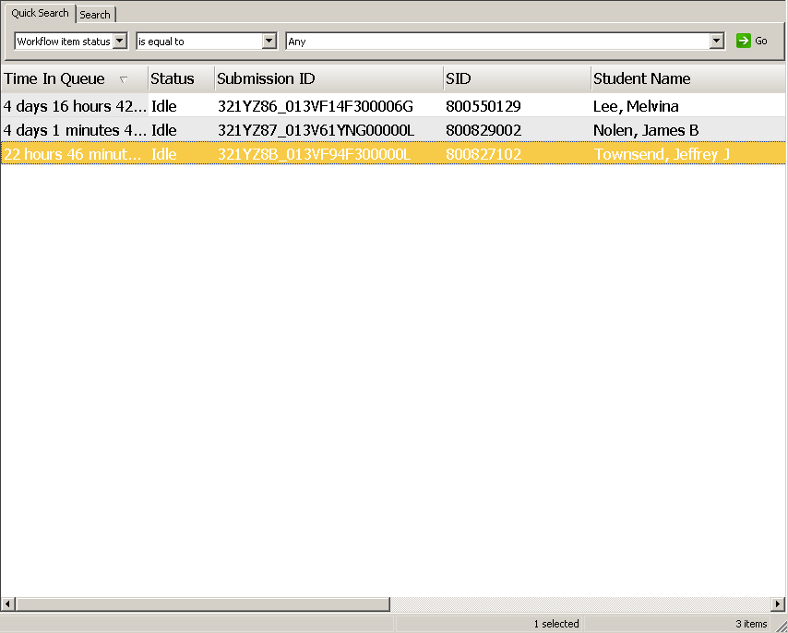
- Select a student folder and double-click to open. A list of documents for that student will be displayed, as shown below:
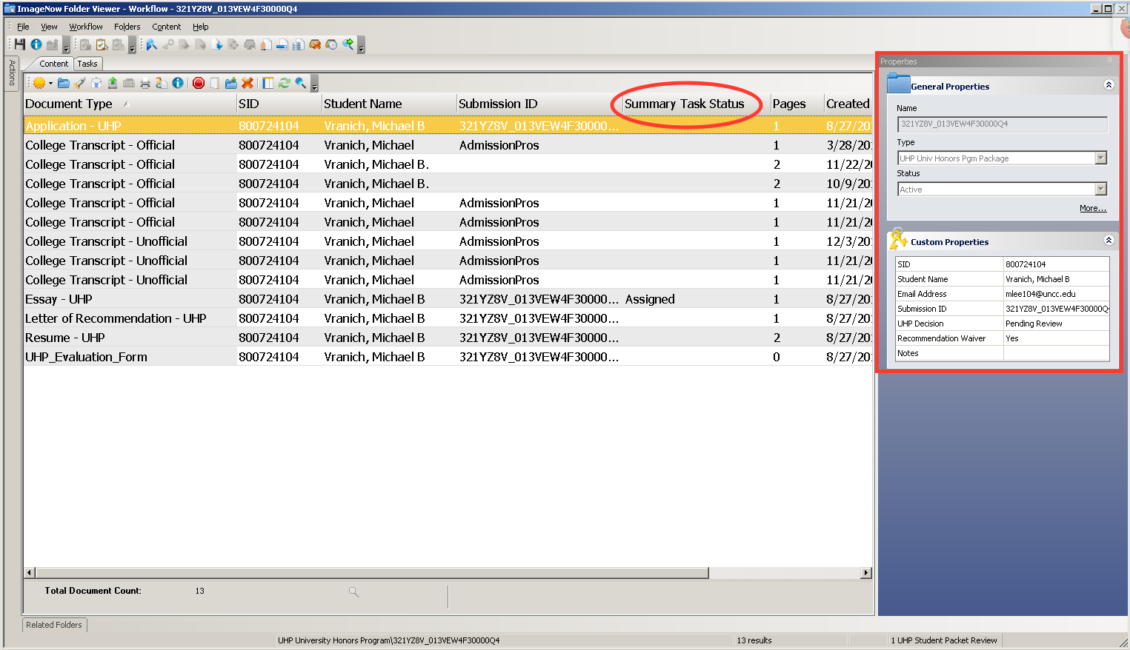
- Press the F7 key to ensure the PROPERTIES panel is displayed.
- Attach any additional supplemental documentation regarding this student, if applicable, by using the drag-drop feature. See the Drag and Drop section of this document for more details.
- To verify a final essay score is ready:
  - Find the Essay - UHP line in the document list and review the Summary Tasks Status column.
    - If the information in the Summary Tasks Status is COMPLETE – all Ambassadors have provided their feedback.
    - If the information in the Summary Tasks Status is ASSIGNED – the Ambassador evaluation is not completed.
  - Double-click to open and review the Essay – UHP document task comments and ratings.
  - Evoke the TASK view panel.
  - Select each task associated with the document to review the Ambassador’s comments and rating.

Reassigning an Essay Task

To reassign an Essay task to replace another Student Ambassador, first you must delete the current task and assign a new task. The reason for this is to ensure the new Student Ambassador receives an email with the document link embedded.

  - To reassign a TASK to another Student Ambassador:
    - First, select the desired TASK(s), then click the DELETE button as shown below:
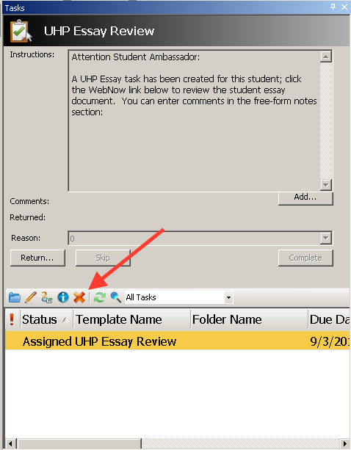

    - A DELETE TASK window will display as shown below:
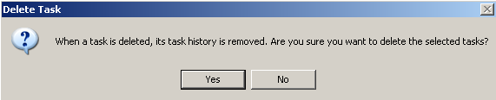
    - Select the YES button to delete the TASK.
    - To assign a new Student Ambassador to review the ESSAY document:
    - Click the NEW TASK button and a New Task – UHP Essay Review window will display as shown below:

    - Click the ADD USERS button and a Select Users window will display as shown below:
    - Select the desired Student Ambassador user(s) from the search results and click the ADD button, then click the OK button to return to the New Task window.
    - If you selected multiple Student Ambassador users, select the CREATE AN INDIVIDUAL TASK FOR EACH USER box, else ignore this field.
    - Select the OK button to add the task and exit the NEW TASK window.
    - Now you will see a new task in the TASKS panel for the student applicant. This Student Ambassador(s) will receive an email with a link referencing the ESSAY document where they can review it.
    - Click the SAVE button to save changes to the document.
    - Click the EXIT icon to exit the document.

- Double-click on the UHP_Evaluation_Form document. The form will be displayed as shown below:
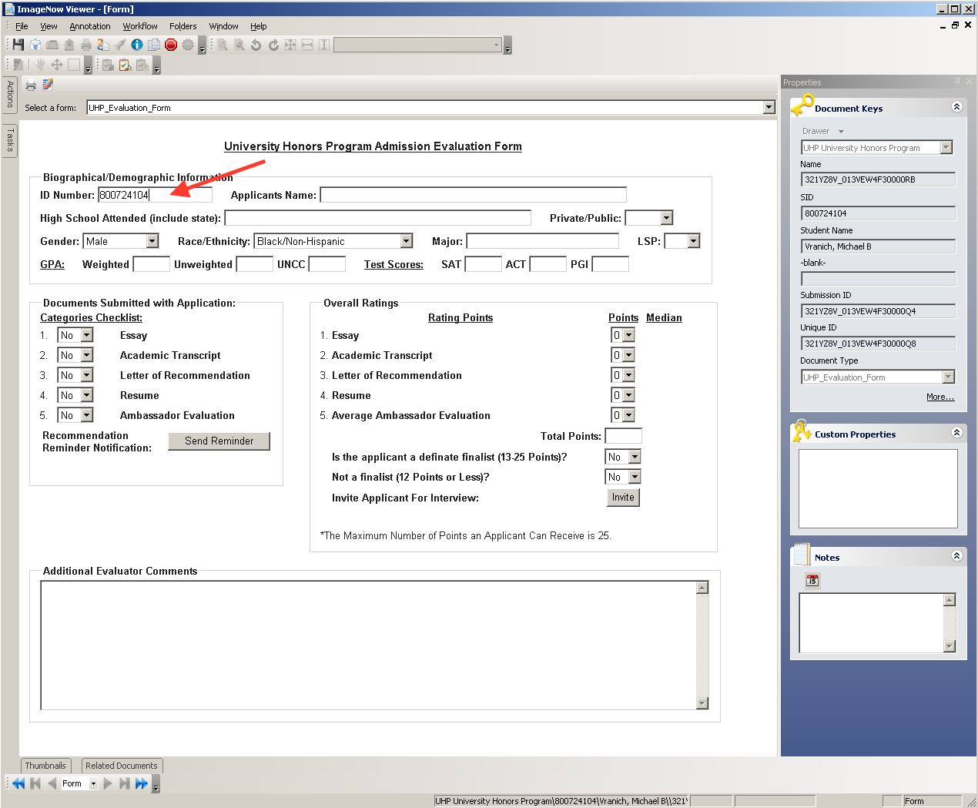
- Complete the following:
  - Enter the applicant’s 800# and click the TAB key or click the REFRESH button to update the form to associate the essay scores from the document. Note: Do not press the SAVE Button.
  - Adjust the Overall Ratings, if applicable.

Note: If you hover over the Average Ambassador Evaluation Median score, all Ambassador Evaluation review scores will display.

  - Add your evaluation comments in the Additional Evaluator Comments box.

  - To Invite the Student Applicant for an interview, click the INVITE button . If a student needs to reschedule an interview appointment, the button can be clicked more than once.

Note: A message in red text will be displayed, indicating the student has been authorized to schedule an appointment.
- To exit the document, click the EXIT icon.
- Once all due diligence is completed and an applicant has been either accepted or denied, the UHP Processor will change the UHP Decision custom property to either ACCEPTED or DENIED, as shown below:

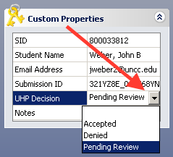
- Click the SAVE icon to save all changes.
- Select the Route Forward icon to route the student folder to Archive.
- After the student folder is routed to archive, the Student Applicant will receive an email of the final decision.

Notification of A UHP Recommendation Exception:

Documents are added to the UHP Recommendation Exception workflow queue when:
- The Letter of Recommendation was emailed into ImageNow and flagged as an invalid document type.
- The Letter of Recommendation document submission ID does not match any submissions in the ImageNow UHP application.

- The UHP Processor will receive an email stating a new student Letter of Recommendation document has been added to the UHP Recommendation Exception workflow queue for processing, as shown below:
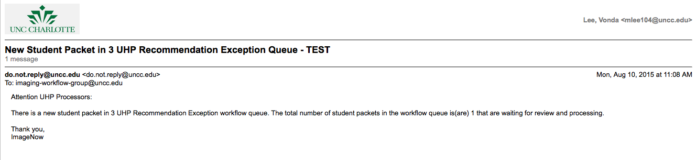

Processing in the UHP Recommendation Exception Workflow Queue:

- Open to the workflow queue identified in the email, as shown below:
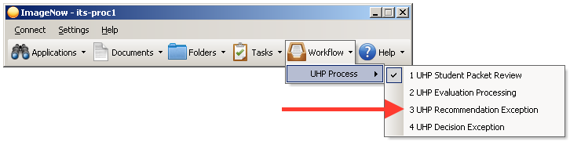

- A window will display a list of UHP Letter of Recommendation documents to be processed:
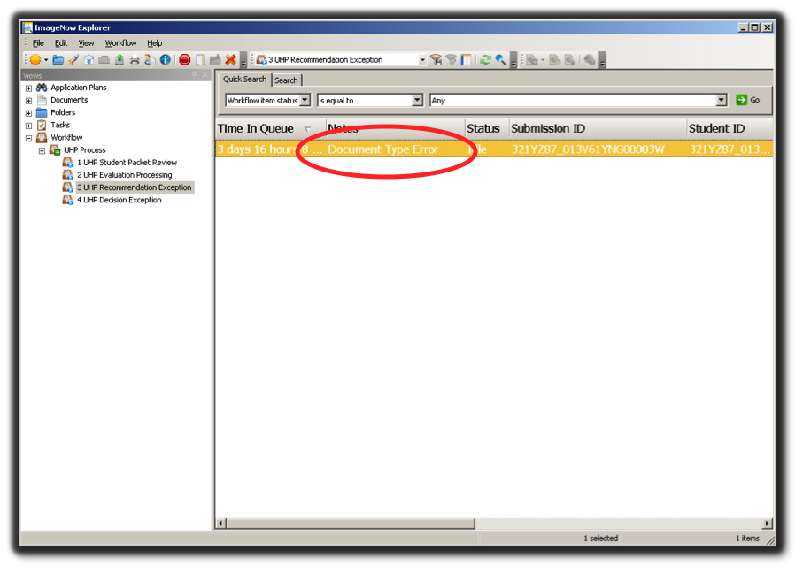
- In the NOTES field, the error will be displayed with information about the reason the document was added to this exception workflow queue, as shown above.
- To correct the document for processing, double-click the selected document.
- Take note of the student’s Submission ID within the document. You may want to copy this Submission ID because you can copy and paste the submission ID number from this document into the Submission ID document key.

- Enter the student’s Submission ID number and select the appropriate Document Type, as shown below:
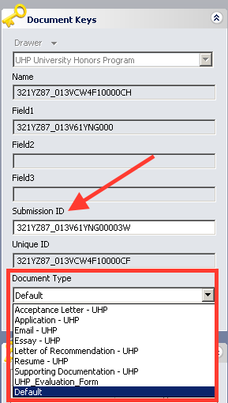
- Click the SAVE button to save changes to the document.
- Click the Route Forward icon to route the document to Archive. The document will be re-indexed and added to the appropriate student folder.
- If there are additional documents in the list, the next document will open
- Repeat the above steps to process the next Letter of Recommendation exception document.

Notification of A UHP Decision Exception:

Folders are added to the UHP Decision Exception workflow queue when the student application folder has an invalid decision value (PENDING REVIEW) at the conclusion of the folder processing. The UHP Processor must open the folder and change the UHP Decision field to either ACCEPTED or DENIED.

- The UHP Processor will receive an email stating a new student application packet has been added to the UHP Decision Exception workflow queue, as shown below:

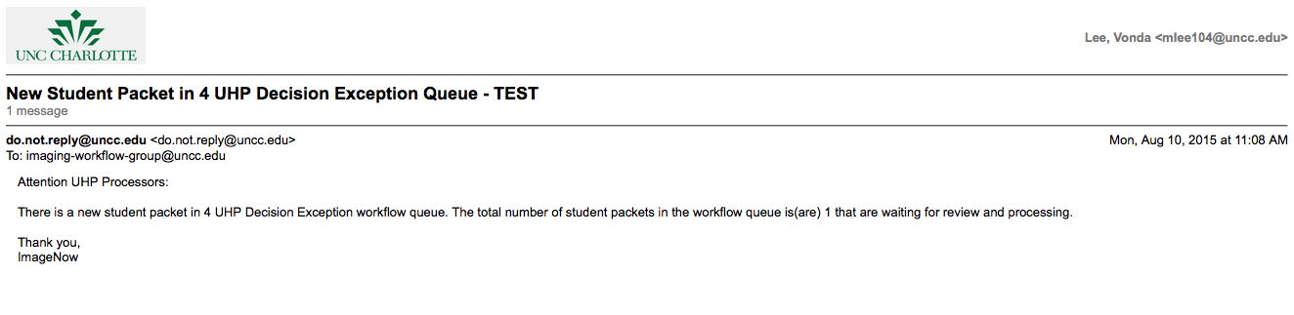

Processing in the UHP Decision Exception Workflow Queue:

- Open the workflow queue identified in the email notification, as shown below:
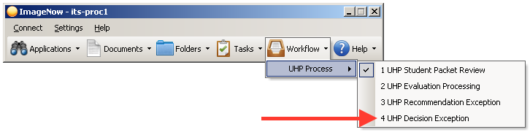

- A window will display a list of UHP student application folders to be processed, as shown below:
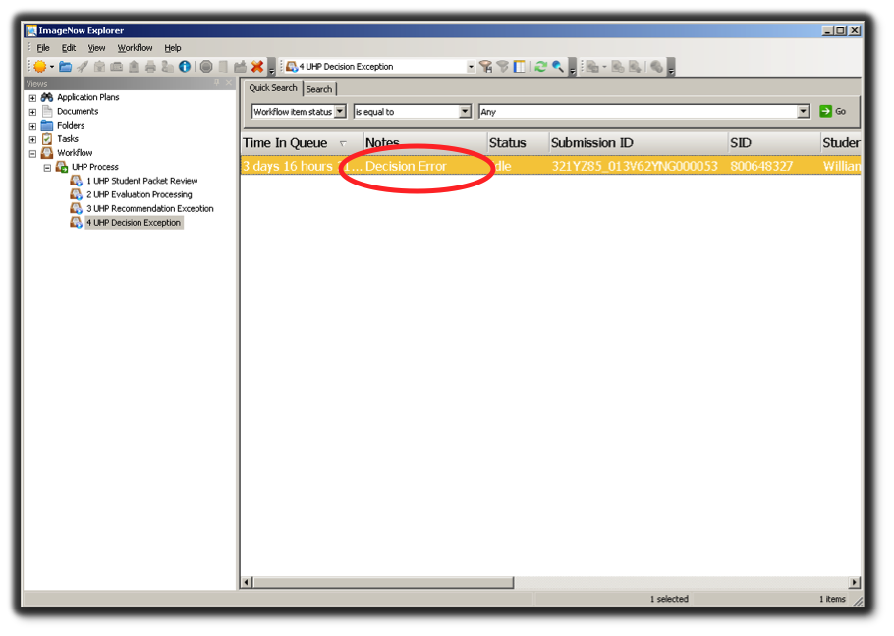
- In the NOTES field, the error will be displayed display with the reason why the folder was added to this exception workflow queue, as shown above.
- To make corrections, double-click the selected folder.

- Select the appropriate UHP Decision, as shown below:
- Click the SAVE button to save changes to the folder.
- Click the Route Forward icon to route the folder to Archive.
- If there are additional documents in the list, the next folder in the list will open.
- Repeat the above steps to process the next student application folder.

Drag and Drop Feature

Using the Drag and Drop feature, a user can select a document from the desktop and drop the document into a particular ImageNow workflow queue or document.

Drop as a New Page

- Open a document by double-clicking the document item in the ImageNow Explorer window grid.
- Ensure the THUMBNAILS view is evoked.
- Drag and drop a document from your desktop or selected drive into the whitespace in the THUMBNAILS view as show below:
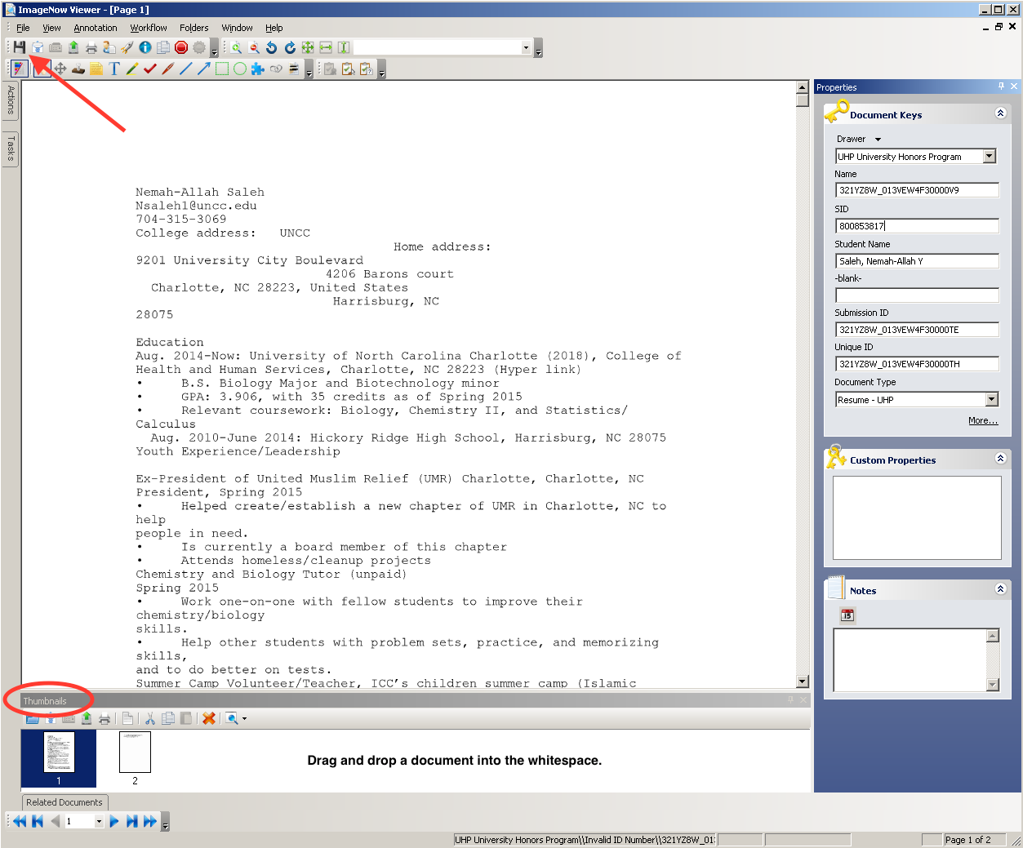
- Click the SAVE icon to save the added document as a new page.

Drop as a New Document within a Folder

- In the ImageNow Folder Viewer window, drag and drop a document from your desktop, or selected drive, into the whitespace in the grid as show below:
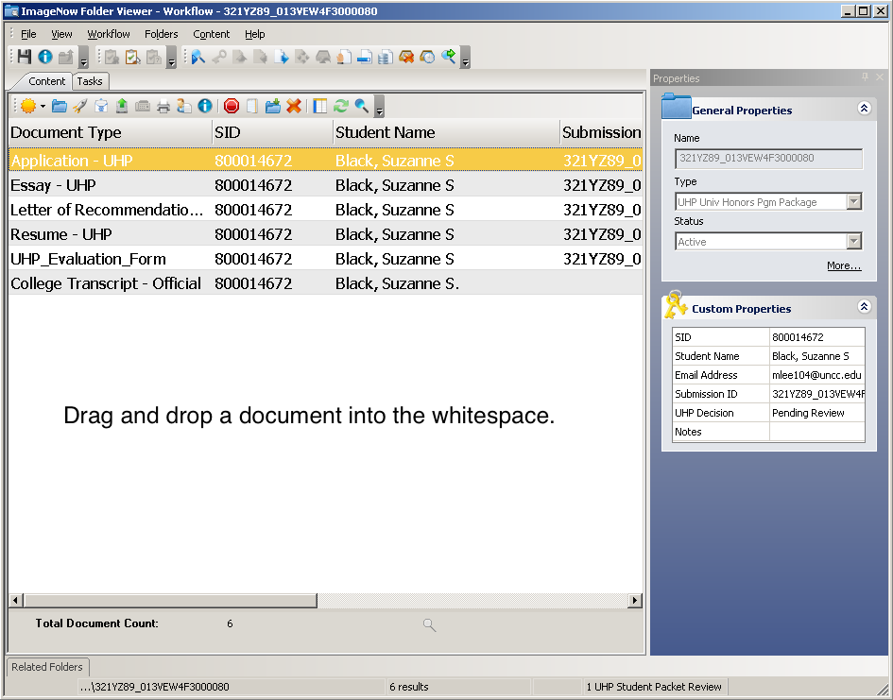

- A New Document window will display, as shown below:
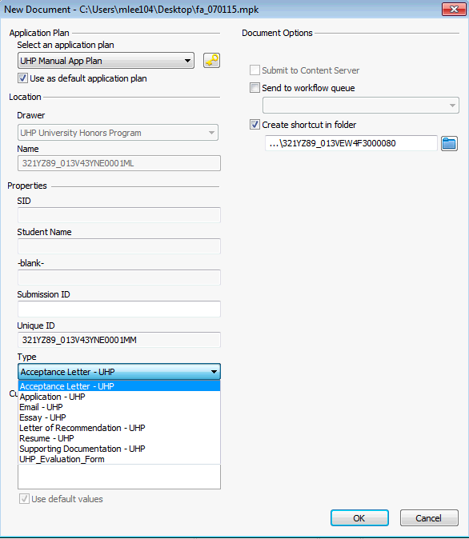
- Select UHP Manual App Plan.
- Enter the Submission ID for the student folder.
- Select the document Type.
- Select the OK button to add the document to the student application folder. The document will open automatically.
- Exit the document by selecting the button.
- Refresh the folder viewer by selecting the Refresh icon. The document will be displayed in the list.
- Double-click the UHP_Evaluation_Form in the folder.
- Verify the student’s 800# in the form ID Number field, and then click the REFRESH button to update the form.
Note: Do not press the SAVE Button.
- Clicking the EXIT icon, .
- Press the REFRESH button, to view updates to the SID and Name for all the documents in the folder list.

Searching for Folders:

Search for FOLDERS in UHP University Honors Program folder view. There is one (1) document view filter to assist in the search called By Student Name.

- Click the FOLDERS view filter, BY STUDENT NAME.
- Enter the student name or partial name and click the OK button.
- ImageNow will display a list of UHP student folders that meet the selection criteria, as shown below:

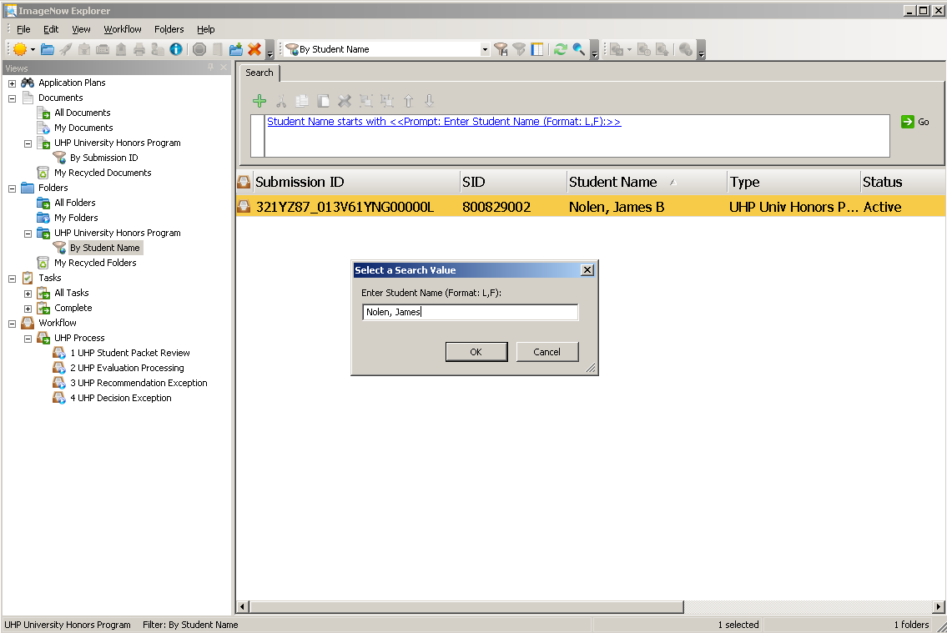

Searching for Documents:

Search for DOCUMENTS in the UHP University Honors Program document view. There is one (1) document view filter to assist in the search called By Submission ID.

- Click the DOCUMENTS view filter, BY SUBMISSION ID.
- Enter in the appropriate search criteria and click the OK button.
- ImageNow will display a list of UHP documents that meet the selection criteria.
- Below is an example using the By Submission ID document view filter. ImageNow will display the document for the entered.

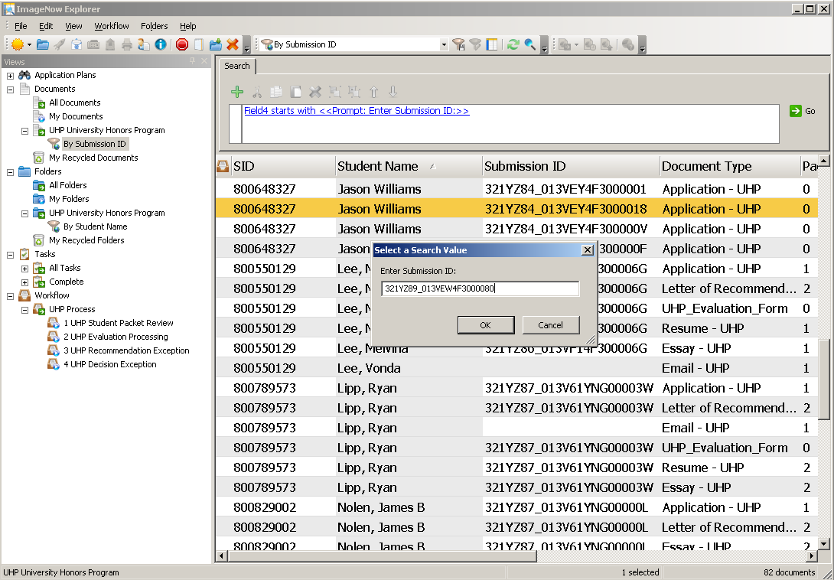

- You can search for documents using the Quick Search feature, as shown below:

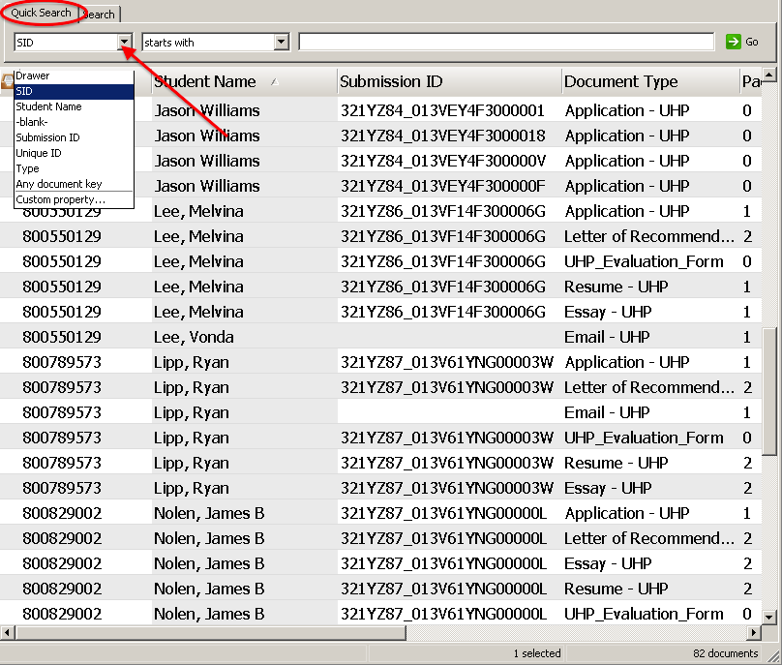
- Type in your search criteria. Click the GO button to run the search. An ImageNow Explorer view will display a list of documents that meet the criterion.

