User Navigation Manual
(WebNow Version)

Written By: Vonda Lee
December 2, 16

This document will assist with navigating your way around WebNow, customizing WebNow, and understanding the WebNow terminology. Login to WebNow using your NinerNet credentials to perform the following customization steps.

Customizing WebNow:

- Select Options, then Explorer Options as seen below to customize WebNow:

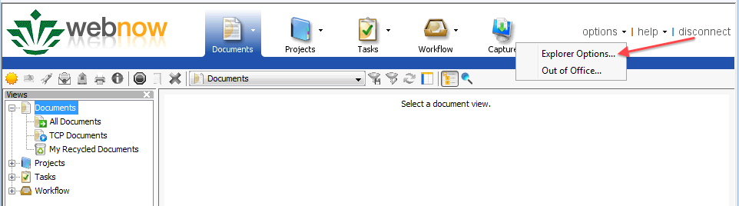
- The WebNow Explorer Options window will appear (see below) on the General option, ensure that the Remember Last Profile and Email via SMTP boxes are checked.
- You can customize the Date and Time format and Document Key Labels by selecting an Application Plan most used.
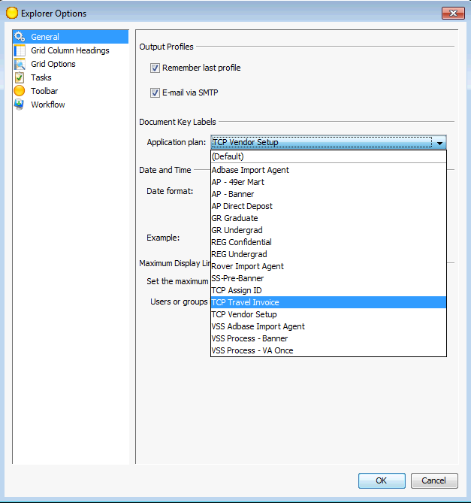

- Click the Grid Column Headings option (see below); this is where you can change the colors of your headings, text, background, and fonts.

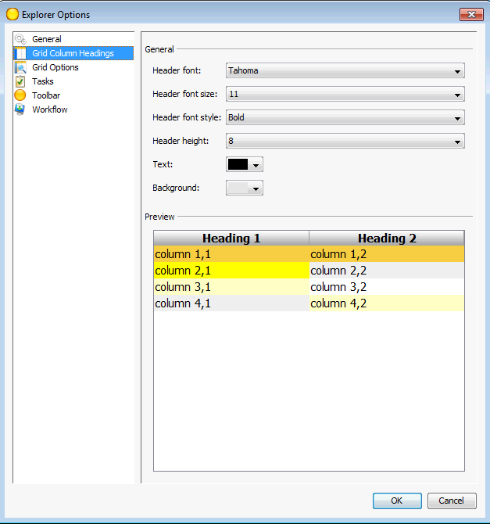

- Click the Grid Options option (see below); this is where you can change the colors of your headings, text, background, and fonts for each grid line item.

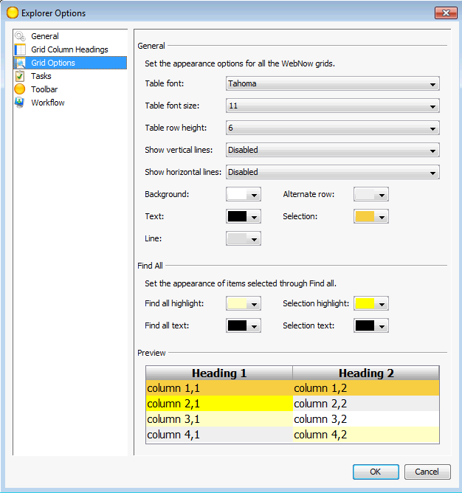

- Click the Tasks option (see below); here you can customize how tasks should startup and how you will process each task. *Note: Only certain processors will have this option.

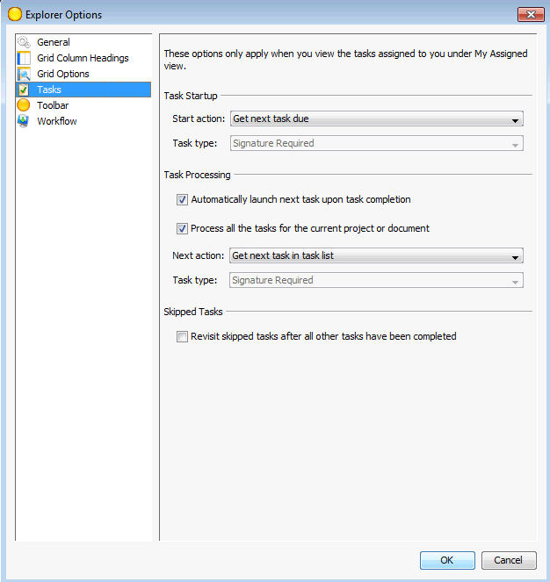

- Click the Toolbar option (see below); you can customize what Application Plan, Documents, Projects, Tasks, and Workflow default values.

For example, if you process Vendor names A – E, you can default your Workflow to 2 TCP A-E workflow queue as seen below. Also, if you would like for the Workflow Explorer Window to launch when you logon, set the Initial State Action to Workflow Default as seen below, other significant actions include Application Default, Documents Default, Projects Default, Tasks Default, and Capture Default:

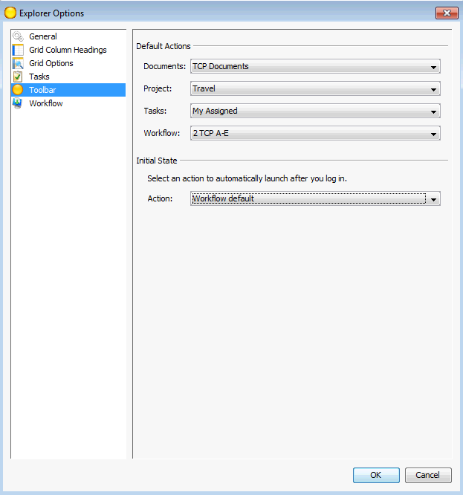

- Click the Workflow option (see below); you can customize how workflow startup, workflow processing, and set workflow grid color for document items that have been in the queue more than once (route-back documents that may have had an issue):

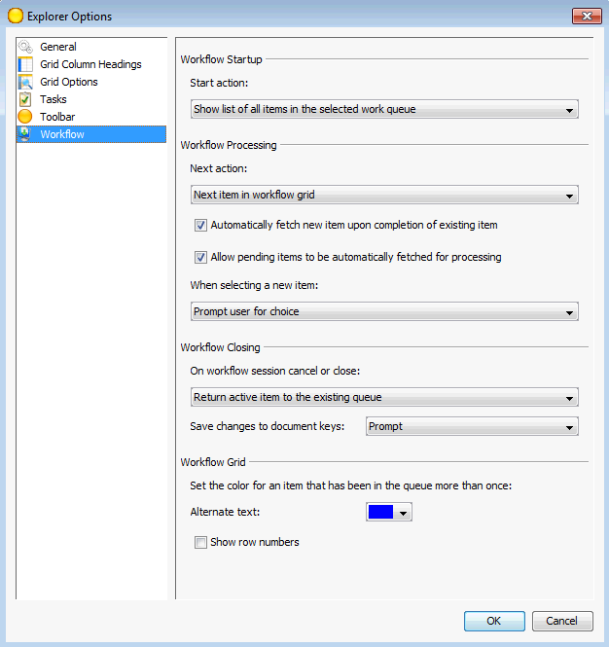

- Press the OK button to save all WebNow Options.

- Open an WebNow Viewer for a desired document, to customize the viewer so that you can route, email, edit document properties or link, apply document hold, delete page, view document thumbnails (pages), related documents, document keys, custom properties, and notes; Click View Option at the top of the viewer and select items as seen below:

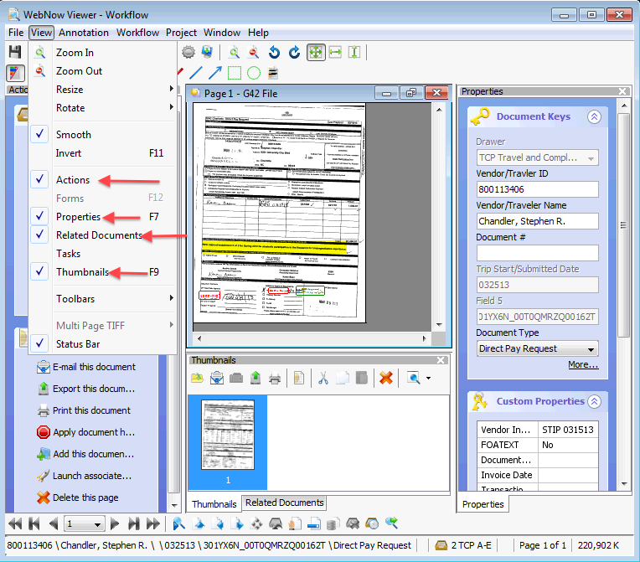

To ensure the above view when opening/viewing/linking another document, press the save button. These settings should be set for future viewing.

- Follow the above steps for opening an WebNow Project Viewer and WebNow Task Viewer.

WebNow Terminology:

- WebNow Toolbar - The WebNow toolbar lets you configure the appearance such as toolbar size, button size, and button text. All of the functions and documents you need are only one mouse click away. The options below change depending on your security privileges. The WebNow toolbar provides access to all WebNow functions.

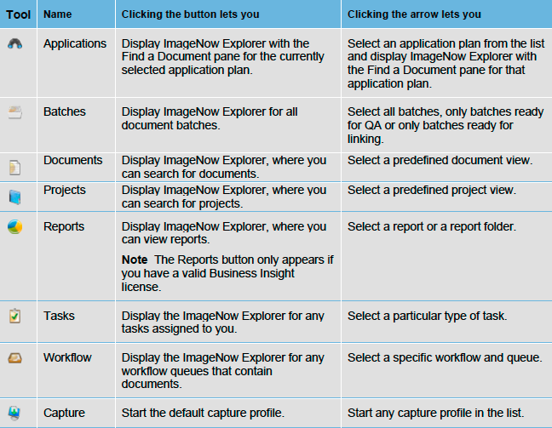
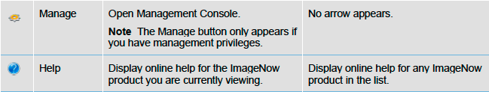

- WebNow Explorer Window (see below) - The Explorer windows display document, tasks, workflow and project information in grids. In the Views pane, you can switch between following types of grids:
  - Documents view displays the documents that satisfy the document views and filters defined for your user account.
  - Projects view displays the projects that satisfy the project views and filters defined for your user account. Double-clicking a project row displays the documents in the project.
  - Reports view displays the folders and reports accessible to you. Clicking a report folder displays the reports and subfolders associated with it.
  - Tasks view displays the documents associated with the various task types that a manager assigns to you, for example, To Review, Returned to Me, or Complete.
  - Workflow view displays any documents that reside in the workflow and queue you select in the tree.

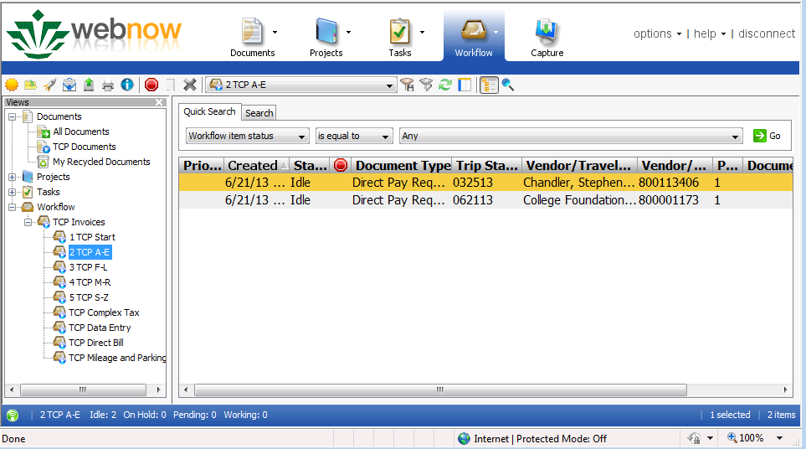

- WebNow Viewer (see below) - The Viewer enables you to see the content of your documents. The viewer appears when you double-click a document in the WebNow Explorer window.

In addition to displaying the document, WebNow Viewer can also display information about the document in the following panes that appear when you select them in the View menu:
- In the Actions pane, you can perform actions on the document such as emailing the document, exporting the document to a file, faxing or printing the document, editing the documents properties, digitally signing the document, adding the document to a project or workflow, or launching the application that is associated to the document.
- In the Properties pane, you can display and update the document keys and custom properties that describe and define the document. You can also add a note to the document or update an existing note.
- In the Related Documents pane, you can select a view in the Relationship list. The relationship view then runs automatically and shows all of the documents in WebNow that satisfy the conditions defined in the related view.
- In the Tasks pane, you can view the document-related tasks assigned to you as well as complete, return, or temporarily skip a task.
- In the Thumbnails pane, you can double-click a different page of a multiple-page document to display it in the Page pane.

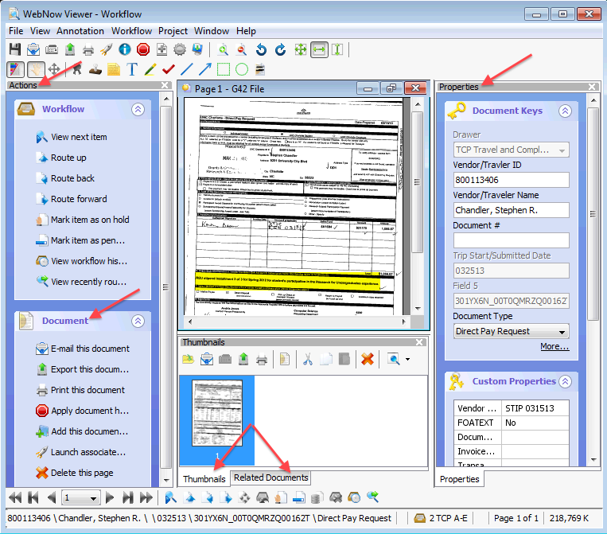

- Documents – A document is a set of scanned images or imported files or both, along with the metadata (such as index keys) that make it easy to search for the document. A document can contain many different file formats. TIFF, DOCX, and PNG are just a few of the accepted file types. A document appears in WebNow Viewer.
- Projects – Projects group related documents independently of the index keys assigned to them.
- Tasks - A task is work that you assign to one or more users for documents and projects. There are three (3) task types: document deficiency, pointer, and signature required.
- Views - a view is a subset of all WebNow items tailored for you. The view can hide dozens, hundreds, or even thousands of documents that might otherwise clutter your WebNow Explorer window. Views display only the columns you need to see or work with, including custom property columns. Your view is customized so that the appearance, name, and width of columns in WebNow Explorer fit your needs.

Types of Views:
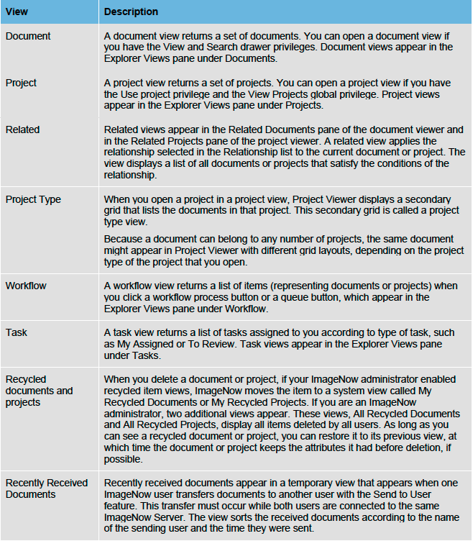

Below is an example of a TCP Invoice Processors views:

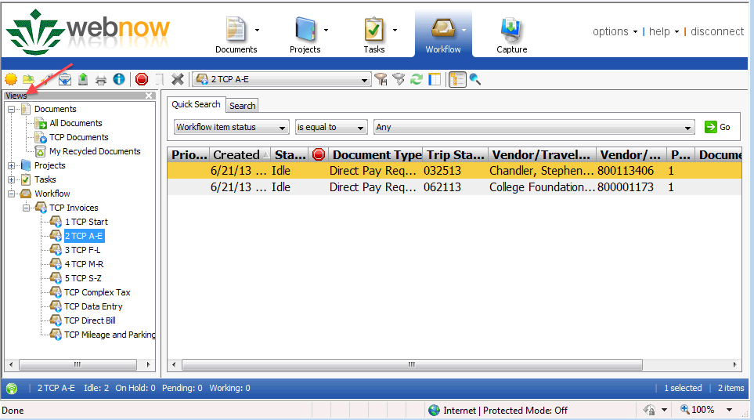

- Filters - A filter lets you select a predefined subset of documents or projects from its parent view and simplifies the task of processing a large number of rows in a view. As soon as you click a filter, WebNow applies the filter to the view and displays the results in the grid.

Create a private filter
You must have the Filter privilege for any view for which you save a filter.
- On the WebNow toolbar, click Documents, Projects, Tasks, or Workflow, depending on the kind of view you want to filter.
- In WebNow Explorer, in the left pane under Documents, Projects, Tasks, or Workflow, select the view to which you will apply the new filter.
- Perform a search for a document
- Optional. If your search returned the documents, projects, or items you wanted, click the Save private filter button.
- Optional. In the Save Filter dialog box, give the filter a name and an optional description and then click OK.

